Decision No. C03-1260
BEFORE THE PUBLIC UTILITIES COMMISSION OF THE STATE OF COLORADO
DOCKET NO. 03A-484G
IN THE MATTER OF THE JOINT APPLICATION OF ATMOS ENERGY CORPORATION AND COMFURT GAS, INC. FOR THE APPROVAL OF THE TRANSFER OF CERTAIN FACILITIES AND PROPERTIES FROM COMFURT GAS, INC. TO ATMOS ENERGY CORPORATION AND AUTHORIZING THE TRANSFER OF ALL CERTIFICATES OF PUBLIC CONVENIENCE AND NECESSITY ISSUED TO COMFURT GAS, INC. FOR SAID NATURAL GAS FACILITIES AND PROPERTIES ON AN EXPEDITED BASIS PURSUANT TO THE COMMISSION'S MODIFIED PROCEDURES.
order granting motion for
shortened notice period
Mailed Date: November 10, 2003
Adopted Date: November 5, 2003

BY THE COMMISSION

Statement
- On November 4, 2003, Atmos Energy Corporation (Atmos) and ComFurT Gas, Inc. (ComFurT), filed a joint application to transfer certain facilities and properties from ComFurT to Atmos. ComFurT and Atmos also filed a joint motion to shorten the notice period for the application to ten days.
- Now being duly advised in the matter, the Commission finds good cause has been stated and will grant the motion to shorten the notice period.

ORDER

The Commission Orders That:
- The motion for shortened notice period filed by Atmos Energy Corporation and ComFurT Gas, Inc., on November 4, 2003 is granted. The notice period shall be shortened to ten days.
- The Commission waives response time to the motion.
- This Order is effective on its Mailed Date.

ADOPTED IN COMMISSIONERS’ WEEKLY MEETING
November 5, 2003.

THE PUBLIC UTILITIES COMMISSION
OF THE STATE OF COLORADO
GREGORY E. SOPKIN
________________________________
POLLY PAGE
________________________________
JIM DYER
________________________________
Commissioners
(S E A L)


ATTEST: A TRUE COPY
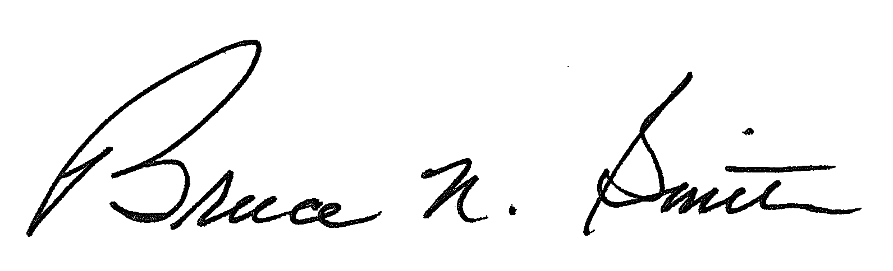
Bruce N. Smith
Director
/tmp/in/input.doc

