Decision No. C02-0082-E
BEFORE THE PUBLIC UTILITIES COMMISSION OF THE STATE OF COLORADO
DOCKET NO. 01A-551CP-Transfer
the application of Odd Lyngholm, DOING BUSINESS AS Estes Park Shuttle & Mountain Tours, FOR APPROVAL TO transfer CERTIFICATE OF PUBLIC CONVENIENCE AND NECESSITY PUC NO. 54696 to Estes Park Express, Ltd.
errata notice
COMMISSION ORDER APPROVING transfer of
certificate of public convenience
and necessity
Mailed Date: February 4, 2002
Decision No. C02-0082
(Mailed Date: January 30, 2002)

    - The following changes to Decision No. C02-0082 are made to grant the encumbrance requested in Docket No. 01A-551CP-Transfer:
    - The caption is amended to read:
THE APPLICATION OF ODD LYNGHOLM, DOING BUSINESS AS ESTES PARK SHUTTLE & MOUNTAIN TOURS, FOR APPROVAL TO TRANSFER CERTIFICATE OF PUBLIC CONVENIENCE AND NECESSITY PUC NO. 54696 TO ESTES PARK EXPRESS, LTD., AND FOR AN ORDER OF THE COMMISSION AUTHORIZING AN ENCUMBRANCE OF CERTIFICATE OF PUBLIC CONVENIENCE AND NECESSITY PUC NO. 54696.
    - The Decision Title is amended to read:
COMMISSION ORDER APPROVING TRANSFER AND ENCUMBRANCE OF
CERTIFICATE OF PUBLIC CONVENIENCE
AND NECESSITY
    - The following ordering paragraph No. 2 is added to Part I of the Order:
2. Odd Lyngholm, doing business as Estes Park Shuttle & Mountain Tours and Estes Park Express, Ltd. also request that CPCN PUC No. 54969 be encumbered for the entirety of the sale price, in accordance with the terms and conditions named in the sales agreement included with the application.
    - The following ordering paragraph No. 4 is added to Part II of the Order:
4. Odd Lyngholm, doing business as Estes Park Shuttle & Mountain Tours and Estes Park Express, Ltd. are authorized to encumber CPCN PUC No. 54696 for the entirety of the sale price, in accordance with the terms and conditions named in the sales agreement included with this application. Odd Lyngholm, doing business as Estes Park Shuttle & Mountain Tours and Estes Park Express, Ltd. shall notify the Commission in writing of the full satisfaction of the above mentioned indebtedness and release of the authorized encumbrance within ten days after it has been effected.

TRANSFEROR:
THE PUBLIC UTILITIES COMMISSION
OF THE STATE OF COLORADO

BRUCE N. SMITH
Director
Dated at Denver, Colorado this
4th day of February, 2002.
S E A L

i:\trans\orders\01A-551-e

Odd Lyngholm
dba Estes Park Shuttle & Mountain Tours
481 West Elkhorn Avenue
Estes Park, CO 80517

TRANSFEROR'S ATTORNEY:
Charles M. Williams
Charles M. Williams, P.C.
1700 Broadway
Denver, CO 80203

TRANSFEREE:
Estes Park Express, Ltd.
875 Moraine Avenue
Estes Park, CO 80517

TRANSFEREE'S ATTORNEY:
Richard L. Fanyo
Dufford & Brown, P.C.
1700 Broadway
Suite No. 1700
Denver, CO 80517

ROUTE:
60; 6; all PUC staff, including staff that may be listed as parties, received this decision electronically.

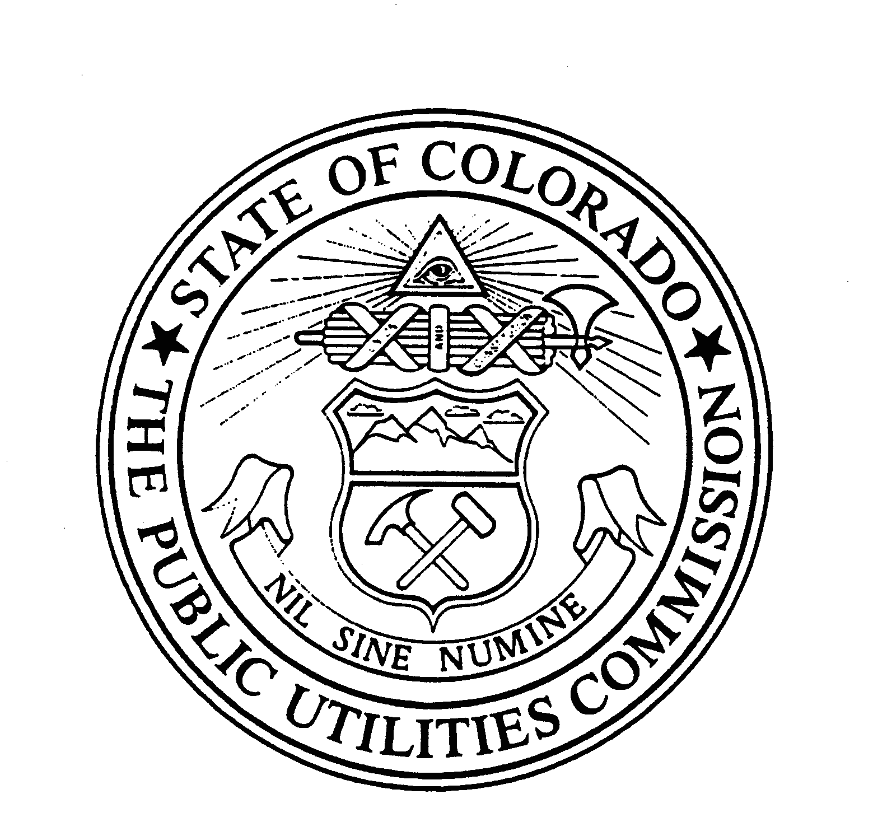 | WITNESS MY HAND AND THE SEAL OF THE PUBLIC UTILITIES COMMISSION OF THE STATE OF COLORADO

