Decision No. C02-0040-E
BEFORE THE PUBLIC UTILITIES COMMISSION OF THE STATE OF COLORADO
DOCKET NO. 01A-561T
[Corrected Caption]
IN THE MATTER OF the application of png telecommunications, inc., doing business as powernet global communications for a certificate of public convenience and necessity to provide local exchange telecommunications services and for a letter of registration to provide emerging competitive Telecommunications services.
ERRATA NOTICE
ORDER granting application
Mailed Date: January 11, 2002
Adopted Date: January 4, 2002
Errata Mailed Date: January 9, 2004

The caption of Decision No. C02-0040 shows an incorrect d/b/a for PNG Telecommunications, Inc. Correct the caption of Decision No. C02-0040, by replacing "DOING BUSINESS AS POWERNET GLOBAL TELECOMMUNICATIONS" with "DOING BUSINESS AS POWERNET GLOBAL COMMUNICATIONS" so that the caption reads:
IN THE MATTER OF THE APPLICATION OF PNG TELECOMMUNICATIONS, INC., DOING BUSINESS AS POWERNET GLOBAL COMMUNICATIONS FOR A CERTIFICATE OF PUBLIC CONVENIENCE AND NECESSITY TO PROVIDE LOCAL EXCHANGE TELECOMMUNICATIONS SERVICES AND FOR A LETTER OF REGISTRATION TO PROVIDE EMERGING COMPETITIVE TELECOMMUNICATIONS SERVICES.
A corrected first page of Decision No. C02-0040 is attached.

THE PUBLIC UTILITIES COMMISSION
OF THE STATE OF COLORADO
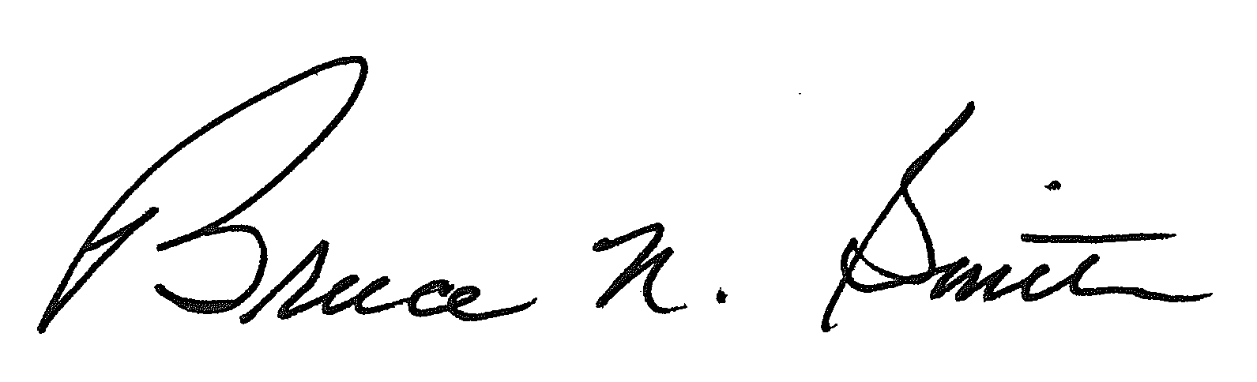
_________________________________________________
BRUCE N. SMITH
Director
Dated at Denver, Colorado this
9th day of January, 2004.
S E A L


/tmp/in/input.doc

