Decision No. C01-1292
BEFORE THE PUBLIC UTILITIES COMMISSION OF THE STATE OF COLORADO
DOCKET NO. 01A-543CP-Extension-TA
THE APPLICATION OF W W Stage Lines, Inc. FOR TEMPORARY AUTHORITY TO EXTEND OPERATIONS UNDER CERTIFICATE OF PUBLIC CONVENIENCE AND NECESSITY PUC NO. 53809.
COMMISSION ORDER DENYING
TEMPORARY AUTHORITY
Mailed Date: December 21, 2001
Adopted Date: December 19, 2001

BY THE COMMISSION:

Statement

    - On November 27, 2001, W W Stage Lines, Inc. (“W W Stage Lines”), filed an application for temporary authority to extend operations under Certificate of Public Convenience and Necessity “CPCN” PUC No. 53809 as follows: Transportation of passengers and their baggage, in scheduled service, between all points in Grand Junction, on the one hand, and Telluride, on the other hand, with service to the intermediate points of Delta, Montrose, and Ridgway, State of Colorado. This application is restricted to providing service to points in the carriers' filed schedule.
    - The Commission gave notice of the application on December 3, 2001.
    - San Miguel Mountain Ventures, LLC dba Telluride Express (“Telluride Express”) filed an intervention to this application on December 7, 2001. Telluride Express has authority under CPCN PUC No. 1648 to provide charter and call-and-demand limousine service between all points within a 100-mile radius of the U. S. Post Office in Telluride, Colorado. The geographic area named in CPCN PUC No. 1648 includes the area named in this application. However, Telluride Express does not have authority to provide scheduled service in this area.
    - Pursuant to § 40-6-120(1), C.R.S., the Commission is authorized to grant temporary authority when "there appears to be an immediate and urgent need to any point or within a territory having no carrier service capable of meeting such need."
    - W W Stage Lines must meet a two-fold test: first, that there is an immediate and urgent need for the transportation services, and second, that there is no existing carrier capable of meeting the need. If W W Stage Lines fails to meet either test, the application must be denied.

Findings of Fact

    - The support filed on behalf of the application consists of seventy-two form letters signed by residents from Delta, Montrose, and other cities in Colorado along the route between Grand Junction and Telluride. The letters are dated from June 18, 2001, to July 5, 2001. The form letter does not name any circumstance that indicates an immediate and urgent need exists for the transportation service named in this application. Four months elapsed from the date the form letters were signed and the date the application was submitted to the Commission. The four-month period of time from the date the letters were signed and the filing of the application greatly reduces the ability of the letters to support an immediate and urgent need for the service named in this application.

Conclusions

    - An immediate and urgent need for the requested transportation services has not been shown to exist.
    - This application for temporary authority is not in the public interest.
    - The denial of this application creates no presumption about the final disposition of the permanent authority application. The permanent authority application will be determined on the evidence presented using the statutory criteria.

ORDER

The Commission Orders That:

    - The application for temporary authority filed by W W Stage Lines, Inc. is denied.
    - The 20-day time period provided by § 40-6-114(1), C.R.S., to file an application for rehearing, reargument, or reconsideration shall begin on the first day after the Commission mails or serves this Order.
    - This Order is effective on its Mailed Date.

ADOPTED IN THE COMMISSIONERS' WEEKLY MEETING
December 19, 2001.

THE PUBLIC UTILITIES COMMISSION
OF THE STATE OF COLORADO
RAYMOND L. GIFFORD
________________________________
POLLY PAGE
________________________________
JIM DYER
________________________________
Commissioners

(S E A L)


ATTEST: A TRUE COPY


Bruce N. Smith
Director
i:\trans\orders\01A-543CP-Ext-TA

APPLICANT:
W W Stage Lines, Inc.
1098 21 1/2 Road
Grand Junction, CO 81505

ROUTE:
60; 6; all PUC staff, including staff that may be listed as parties, received this decision electronically.

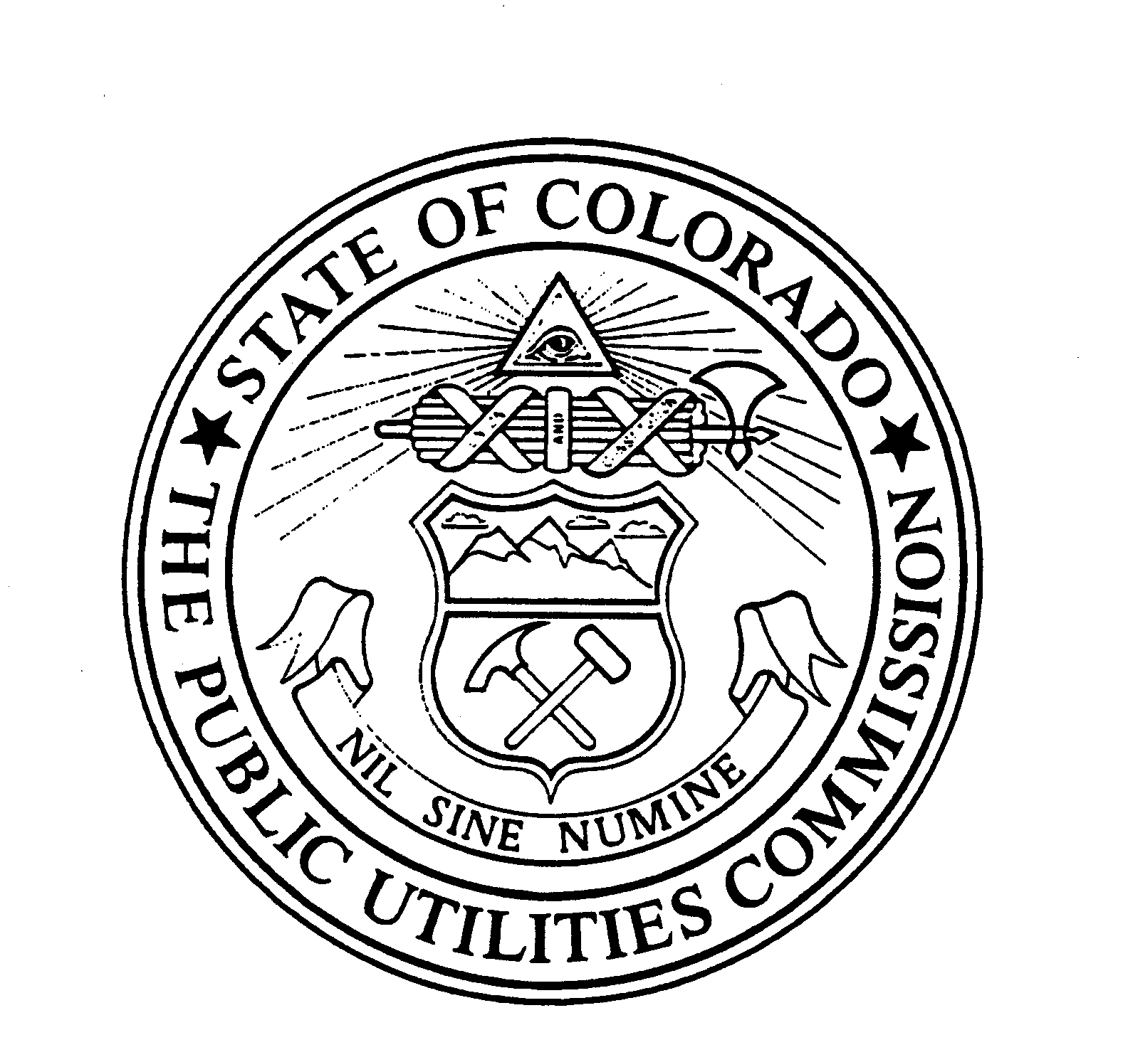 | WITNESS MY HAND AND THE SEAL OF THE PUBLIC UTILITIES COMMISSION OF THE STATE OF COLORADO  Director

