Decision No. C01-0778
BEFORE THE PUBLIC UTILITIES COMMISSION OF THE STATE OF COLORADO
DOCKET NO. 01A-265CP
THE APPLICATION OF Mountain Wave Snowboards, Inc. FOR AUTHORITY TO CONDUCT OPERATIONS AS A COMMON CARRIER BY MOTOR VEHICLE FOR HIRE.
COMMISSION ORDER GRANTING
PERMANENT AUTHORITY
Mailed Date: July 26, 2001
Adopted Date: July 24, 2001

BY THE COMMISSION:

Statement, Findings and Conclusions

    - On June 13, 2001, Mountain Wave Snowboards, Inc. ("Mountain Wave"), filed an application for permanent authority to conduct operations as a common carrier by motor vehicle for hire as follows: Transportation of passengers and their baggage in call-and-demand limousine service between Mountain Wave Snowboards, Inc., 600 South Park Avenue, Breckenridge, Colorado, and the intersection of Interstate 70 and Main Street, Frisco, Colorado, and between said points, on the one hand, and the rest area on Interstate 70 at the top of Vail Pass, on the other hand.
    - The Commission noticed this application to all interested persons, firms, and corporations pursuant to § 40-6-108(2), C.R.S., on June 18, 2001. The Commission set this matter for hearing on September 6, 2001.
    - No petition to intervene or otherwise participate in this proceeding has been filed. This proceeding is noncontested. Under § 40-6-109(5), C.R.S., this matter may be determined without a hearing.
    - The submitted evidence warrants the grant of the requested authority.
    - The present or future public convenience and necessity requires, or will require, the transportation service as requested.
    - Mountain Wave is ready, willing, and able to properly perform the service as requested.
    - This application for permanent authority is in the public interest.

ORDER

The Commission Orders That:

    - The hearing set for September 6, 2001, is vacated.
    - This application was deemed complete on July 23, 2001, within the meaning of § 40-6-109.5, C.R.S.
    - Mountain Wave Snowboards, Inc. is granted a Certificate of Public Convenience and Necessity to operate as a common carrier by motor vehicle for hire with authority as set forth in the Appendix. This Order is a CERTIFICATE OF PUBLIC CONVENIENCE AND NECESSITY.
    - Mountain Wave Snowboards, Inc. shall operate in accordance with all applicable Commission rules and regulations.
    - Mountain Wave Snowboards, Inc. shall cause to be filed with the Commission certificates of insurance as required by Commission rules. Mountain Wave Snowboards, Inc. shall file a proper tariff and pay the issuance fee and annual vehicle identification fee. Mountain Wave Snowboards, Inc. may not begin operations until these requirements have been completed and written notice has been received from the Commission that it is in compliance and may begin service.
    - If Mountain Wave Snowboards, Inc. does not comply with the requirements of this Order within 60 days of its effective date, then the authority to conduct operations shall be void. For good cause shown, the Commission may grant additional time for compliance if the request for additional time is filed within the 60 days.
    - This Order is effective on its Mailed Date.

ADOPTED IN THE COMMISSIONERS' WEEKLY MEETING July 24, 2001.

THE PUBLIC UTILITIES COMMISSION
OF THE STATE OF COLORADO
RAYMOND L. GIFFORD
________________________________
POLLY PAGE
________________________________
JIM DYER
________________________________
Commissioners

(S E A L)


ATTEST: A TRUE COPY

Bruce N. Smith
Director
o:\trans\orders\01A-265CP-PA.DOC

Appendix
Page 1 of 1 Page

Docket No. 01A-265CP
Decision No. C01-0778
July 24, 2001

Transportation of passengers and their baggage in call-and-demand limousine service between Mountain Wave Snowboards, Inc., 600 South Park Avenue, Breckenridge, Colorado, and the intersection of Interstate 70 and Main Street, Frisco, Colorado, and between said points, on the one hand, and the rest area on Interstate 70 at the top of Vail Pass, on the other hand.

APPLICANT:
Mountain Wave Snowboards, Inc.
P. O. Box 7251
Breckenridge, CO 80424

ROUTE:
1,2,3,4
6/Docketing
10,10.1,11,12,13,20,23
31,40/4 copies
50,60
Black Book
DMS (plus certificate)

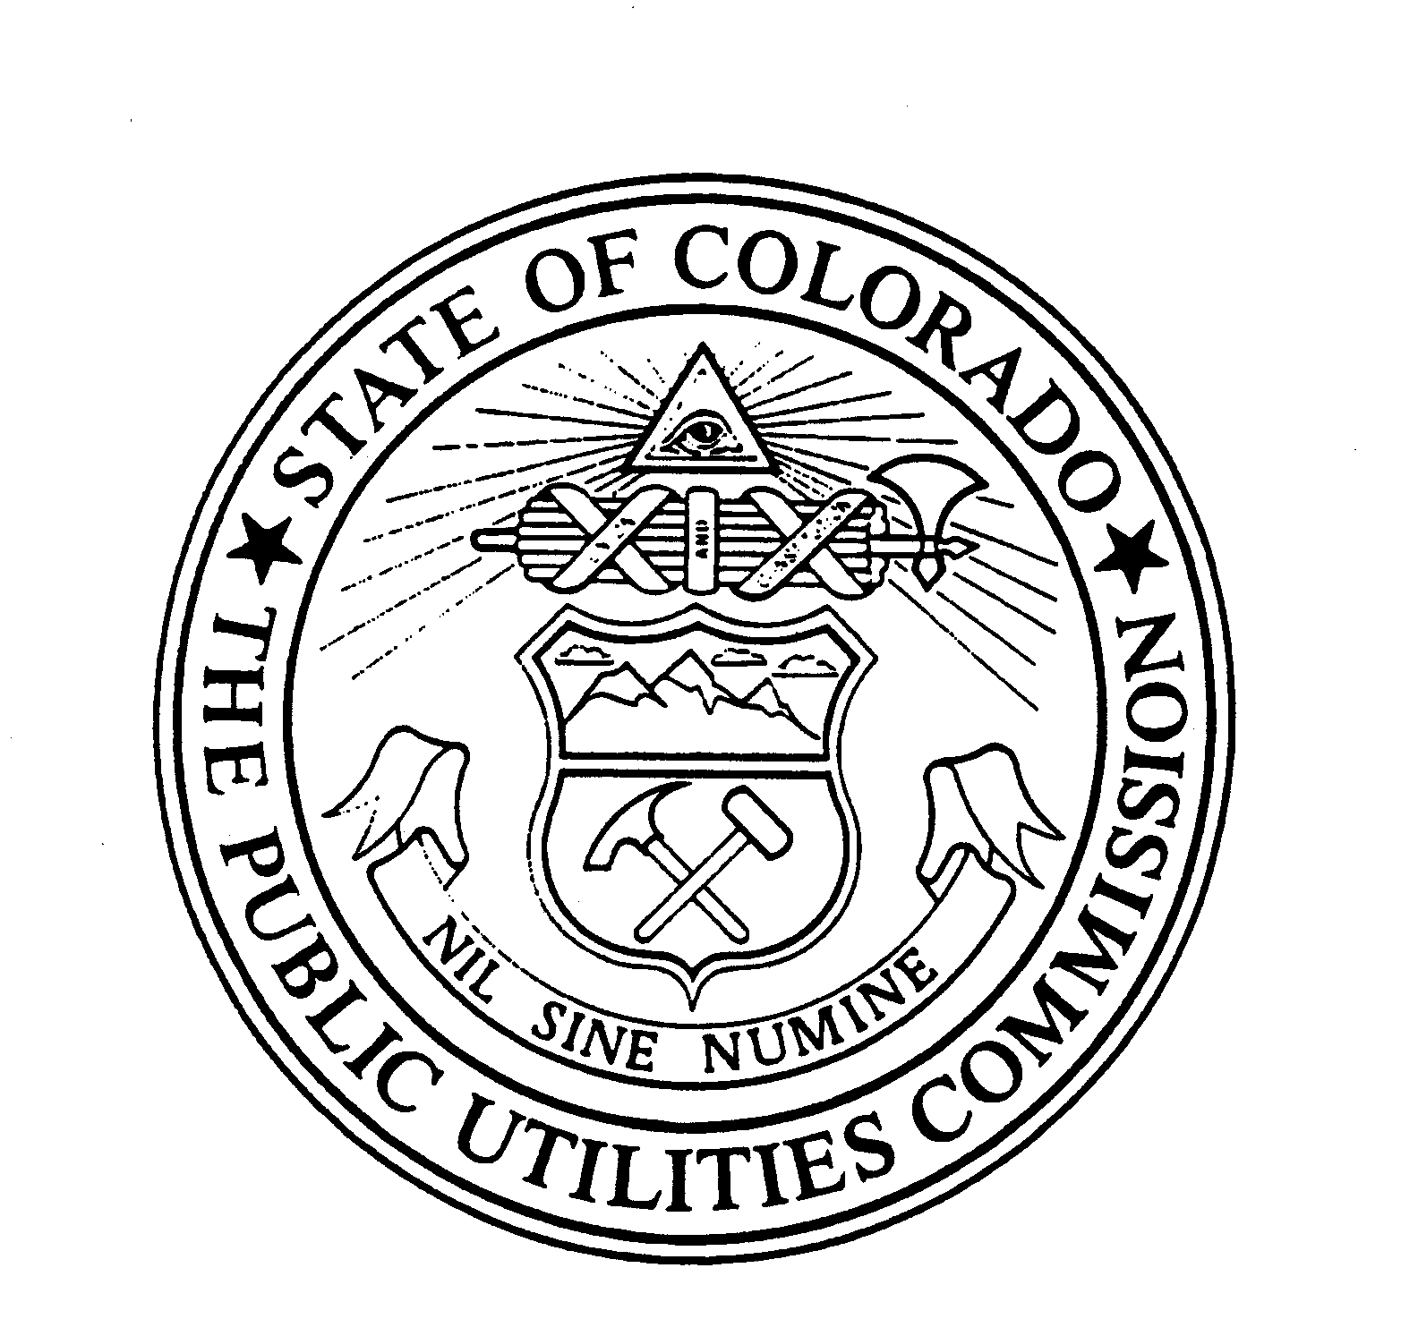 | WITNESS MY HAND AND THE SEAL OF THE PUBLIC UTILITIES COMMISSION OF THE STATE OF COLORADO  Director

