Decision No. C01-0434
BEFORE THE PUBLIC UTILITIES COMMISSION OF THE STATE OF COLORADO
DOCKET NO. 01A-082BP
THE APPLICATION OF Abba's Limo Service, LLC FOR AUTHORITY TO CONDUCT OPERATIONS AS A CONTRACT CARRIER BY MOTOR VEHICLE FOR HIRE.
COMMISSION ORDER GRANTING
PERMANENT CONTRACT CARRIER PERMIT
Mailed Date: April 27, 2001
Adopted Date: April 25, 2001

BY THE COMMISSION:

Statement, Findings and Conclusions

    - On February 23, 2001, Abba's Limo Service, LLC filed an application for permanent authority to conduct operations as a contract carrier by motor vehicle for hire as follows: transportation of passengers and their baggage between all points in El Paso County, State of Colorado. This application is restricted to providing transportation services for: (1) Morning Star Mobility, Inc., 109 North Iowa Avenue, Colorado Springs, Colorado, 80909; El Paso County Department of Human Services, 105 North Spruce, Colorado Springs, Colorado, 80901; and Summit Medical Clinic, P.C., 1605 North Union Boulevard, #200, Colorado Springs, Colorado, 80909; and (2) to passengers who are recipients of Medicaid.
    - The Commission noticed this application to all interested persons, firms, and corporations pursuant to § 40-6-108(2), C.R.S., on March 12, 2001. The Commission set this matter for hearing on May 24, 2001.
    - No petition to intervene or otherwise participate in this proceeding has been filed. This proceeding is noncontested. Under § 40-6-109(5), C.R.S., this matter may be determined without a hearing.
    - The submitted evidence warrants the grant of the requested authority.
    - A present and special need for the requested transportation service exists. A grant of the requested authority will not impair the efficient public service of any authorized common carrier providing a similar service.

ORDER

The Commission Orders That:

    - The hearing set for May 24, 2001, is vacated.
    - This application was deemed complete on April 16, 2001, within the meaning of § 40-6-109.5, C.R.S.
    - Abba's Limo Service, LLC is granted authority to operate as a Class B contract carrier by motor vehicle for hire with authority as set forth in the Appendix. This Order is a PERMIT.
    - Abba's Limo Service, LLC shall operate in accordance with all applicable Commission rules and regulations.
    - Abba's Limo Service, LLC shall cause to be filed with the Commission certificates of insurance as required by Commission rules. Abba's Limo Service, LLC shall file a proper tariff and pay the issuance fee and annual vehicle identification fee. Operations may not begin until these requirements have been met and written notification has been received from the Commission.
    - If Abba's Limo Service, LLC does not comply with the requirements of this Order within 60 days of its effective date, then the authority to conduct operations shall be void. For good cause shown, the Commission may grant additional time for compliance if the request for additional time is filed within the 60 days.
    - This Order is effective on its Mailed Date.

ADOPTED IN THE COMMISSIONERS' WEEKLY MEETING April 25, 2001.

THE PUBLIC UTILITIES COMMISSION
OF THE STATE OF COLORADO
RAYMOND L. GIFFORD
________________________________
ROBERT J. HIX
________________________________
POLLY PAGE
________________________________
Commissioners

(S E A L)


ATTEST: A TRUE COPY

Bruce N. Smith
Director
i:\trans\orders\o1A082BP

Transportation of passengers and their baggage between all points in El Paso County, State of Colorado.

This permit is restricted to providing transportation services for: (1) Morning Star Mobility, Inc., 109 North Iowa Avenue, Colorado Springs, Colorado, 80909; El Paso County Department of Human Services, 105 North Spruce, Colorado Springs, Colorado, 80901; and Summit Medical Clinic, P.C., 1605 North Union Boulevard, #200, Colorado Springs, Colorado, 80909; and (2) to passengers who are recipients of Medicaid.

APPLICANT:
Abba's Limo Service, LLC
4822 Trailmark Loop
Colorado Springs, CO 80916

ROUTE:
1,2,3,4
6/Docketing
10,10.1,11,12,13,20,23
31,40/3 copies
50,60
Black Book
Operating Rights Unit
DMS (plus certificate)

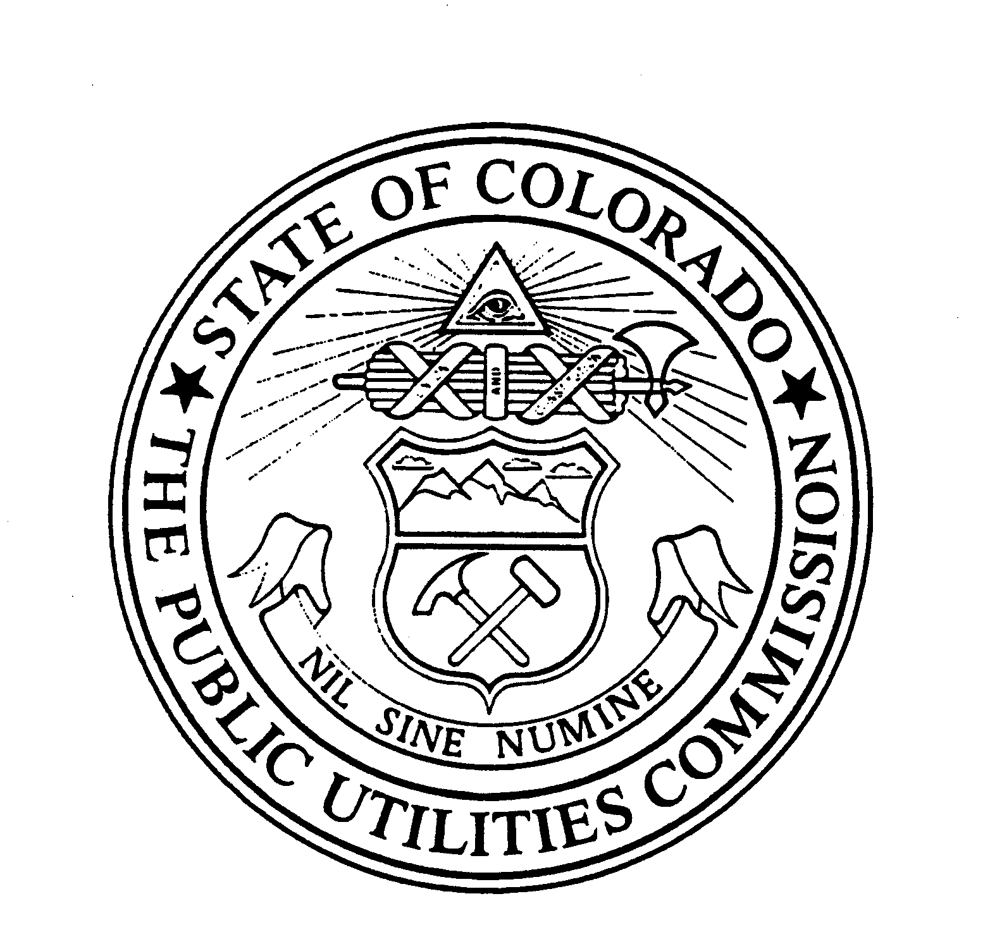 | WITNESS MY HAND AND THE SEAL OF THE PUBLIC UTILITIES COMMISSION OF THE STATE OF COLORADO  Director

