Decision No. R25-0409-I
BEFORE THE PUBLIC UTILITIES COMMISSION OF THE STATE OF COLORADO
PROCEEDING NO. 24A-0442E
IN THE MATTER OF THE APPLICATION OF PUBLIC SERVICE COMPANY OF COLORADO FOR APPROVAL OF ITS 2024 JUST TRANSITION SOLICITATION.
INTERIM DECISION
shortening response time
Issued Date: July 29, 2026

STATEMENT
- On May 23, 2025, Public Service Company of Colorado (“Public Service” or the “Company”) filed the Second Motion of Public Service Company of Colorado for Extraordinary Protection of Highly Confidential Information. Based upon reported conferral, it is unclear the extent to which the motion may be opposed.
- In light of the quickly approaching hearing scheduled in this matter, the undersigned will sua sponte shorten response time, as ordered below.
- ORDER

It Is Ordered That:
- Response time to the Second Motion of Public Service Company of Colorado for Extraordinary Protection of Highly Confidential Information filed by Public Service Company of Colorado (“Public Service” or the “Company”) on May 23, 2025, is shortened to June 2, 2025.
- Any response that a party desires to file must be filed on or before June 2, 2025.
- This Decision shall be effective immediately.
(S E A L)    ATTEST: A TRUE COPY  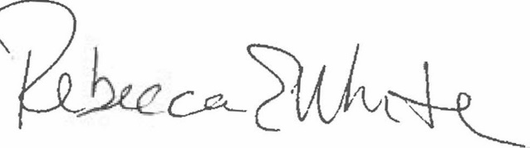  Rebecca E. White,  Director | THE PUBLIC UTILITIES COMMISSION  OF THE STATE OF COLORADO  AVIV SEGEV  ________________________________  Administrative Law Judge

