Decision No. R25-0165
BEFORE THE PUBLIC UTILITIES COMMISSION OF THE STATE OF COLORADO
PROCEEDING NO. 25F-0035E
JON ETHAN KAPLAN,
COMPLAINANT,
V.
PUBLIC SERVICE COMPANY OF COLORADO,
RESPONDENT.
RECOMMENDED decision ACKNOWLEDGING WITHDRAWAL OF COMPLAINT, VACATING HEARING, AND CLOSING PROCEEDING
Issued Date: March 10, 2025

STATEMENT
- On January 6, 2025, Jon Ethan Kaplan filed a Formal Complaint (“Complaint”) against Public Service Company of Colorado (“Public Service”). In the Complaint, Mr. Kaplan alleged that Public Service improperly billed him for electric service.
- On January 7, 2025, the Commission entered its Order to Satisfy or Answer and issued an Order Setting Hearing and Notice of Hearing on March 24, 2025 at 9:00 a.m.
The Commission served Respondents with the Orders and Notice (including a copy of the Complaint) and an Order to Satisfy or Answer within 20 days from service of the Orders and Notice.
- On January 15, 2025, the Commission referred the matter by minute entry to an Administrative Law Judge (“ALJ”). The proceeding was subsequently assigned to the undersigned ALJ.
- On January 27, 2025, Public Service filed on Mr. Kaplan’s behalf a Notice of Withdrawal of Formal Complaint stating that the parties “have fully and amicably resolved the above-captioned complaint and that the Complainant is therefore withdrawing the Formal Complaint with prejudice.”
- Pursuant to § 40-6-109, C.R.S., the ALJ hereby transmits to the Commission the record of this proceeding, a written recommended decision, and a recommended order.

ORDER

The Commission Orders That:
- The Notice of Withdrawal of the Complaint filed on January 27, 2025 is acknowledged.
- The hearing scheduled for March 24, 2025 is vacated.
- The Formal Complaint filed on January 6, 2025 is dismissed with prejudice.
- Proceeding No. 25F-0035E is closed.
- This Recommended Decision shall be effective on the day it becomes the Decision of the Commission, if that is the case, and is entered as of the date above.
- As provided by §40-6-109, C.R.S., copies of this Recommended Decision shall be served upon the parties, who may file exceptions to it.
  - If no exceptions are filed within 20 days after service or within any extended period of time authorized, or unless the decision is stayed by the Commission upon its own motion, the Recommended Decision shall become the decision of the Commission and subject to the provisions of §40-6-114, C.R.S.
  - If a party seeks to amend, modify, annul, or reverse basic findings of fact in its exceptions, that party must request and pay for a transcript to be filed, or the parties may stipulate to portions of the transcript according to the procedure stated in § 40-6-113, C.R.S. If no transcript or stipulation is filed, the Commission is bound by the facts set out by the administrative law judge and the parties cannot challenge these facts. This will limit what the Commission can review if exceptions are filed.
- If exceptions to this Decision are filed, they shall not exceed 30 pages in length, unless the Commission for good cause shown permits this limit to be exceeded.

(S E A L)    ATTEST: A TRUE COPY  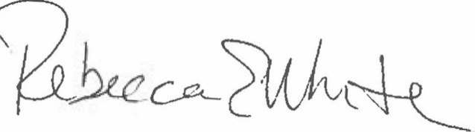  Rebecca E. White,  Director | THE PUBLIC UTILITIES COMMISSION  OF THE STATE OF COLORADO  CONOR F. FARLEY  ________________________________  Administrative Law Judge

