Decision No. R25-0130-I
BEFORE THE PUBLIC UTILITIES COMMISSION OF THE STATE OF COLORADO
PROCEEDING NO. 24F-0236CP
mountain star transportation, llc doing business as red rocks shuttle,
complainant,
v.
on location events, llc doing business as shuttles to red rocks, and ace express coaches, llc and ramblin’ express, inc.,
respondents
INTERIM DECISION
granting unopposed MOtion to accept late filing of exhibits by mountain star
Issued Date: February 24, 2025

STATEMENT
- On May 24, 2024, Mountain Star Transportation, LLC (“Mountain Star”) doing business as Red Rocks Shuttle filed a formal complaint against On Location Events, LLC, doing business as Shuttles to Red Rocks; Ace Express Coaches, LLC; and Ramblin’ Express, Inc.
- On June 12, 2024, the Commission referred this proceeding to an administrative law judge (“ALJ”) by minute entry.
- On February 13, 2025, Mountain Star filed an Unopposed Motion to Accept Late Filing of Exhibits (“Motion”) requesting that the ALJ accept its late-filed hearing exhibits.
The exhibits were due on no later than February 11, 2025, pursuant to Interim Decision No.
R25-0037-I, and were ultimately filed on February 13, 2025.
- As no party opposes Mountain Star’s Motion, no party will be prejudiced by the late filing of the hearing exhibits.
- Since the Motion is unopposed, the ALJ will waive response time to the Motion in accordance with Rule 1400(b) of the Rules of Practice and Procedure, 4 Code of Colorado Regulations 723-1.
- Good cause having been shown for the unopposed Motion, the hearing exhibits filed on February 13, 2025, will be accepted and the Motion will be granted.

order

It Is Ordered That:
- Response time to the Unopposed Motion to Accept Late Filing of Exhibits by Mountain Star Transportation, LLC (“Motion”) filed on February 13, 2025, is waived.
- The Motion is granted.
- The hearing exhibits filed on February 13, 2025, are accepted as timely filed.
- This Decision is effective immediately.

(S E A L)    ATTEST: A TRUE COPY  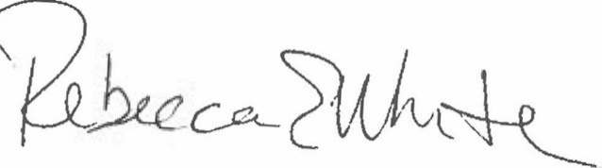  Rebecca E. White,  Director | THE PUBLIC UTILITIES COMMISSION  OF THE STATE OF COLORADO  G. HARRIS ADAMS  ________________________________  Administrative Law Judge

Decision No. R25-0037-I was issued in this proceeding on January 21, 2025.

