Decision No. C25-0498
BEFORE THE PUBLIC UTILITIES COMMISSION OF THE STATE OF COLORADO
PROCEEDING NO. 25M-0257ALL
IN THE MATTER OF FISCAL YEAR 2025-2026 STATUTORY AUDIT POWERS DESIGNATION.
COMMISSION DECISION OPENING A MISCELLANEOUS PROCEEDING AND DESIGNATING COMMISSION STATUTORY AUDIT POWERS TO COMMISSION STAFF
Issued Date: July 1, 2025
Adopted Date: June 25, 2025

By the Commission

Statement
- This matter comes before the Commission for a decision designating its statutory audit authority to Staff of the Commission for fiscal year 2025-2026. The Commission's audit authority comes from various statutory provisions, namely §§ 40-3-102, 40-3-110, 40-6-106,
40-6-107, and 40-15-107, C.R.S. A review of these statutes indicates that the authority to audit a company's books, records, and accounts lies with the Commission and not directly with Commission Staff. For example, § 40-6-106, C.R.S., states in pertinent part, "[a]ny person other than a commissioner demanding such inspection shall produce under the hand and seal of the commission his authority to make such inspection…" Further, § 40-6-107(1), C.R.S., states, "…an examination of the records or documents may be made by the commission or under its direction."
- Historically, the Commission has approached this designation of authority in a variety of ways. We determine that a fiscal year designation of power to Commission Staff to conduct all audits necessary for the completion of its business, is the most efficient approach. This designation will then be reviewed each subsequent fiscal year to determine the benefits of continuing this approach and to review any concerns. Since the 2012-2013 fiscal year, we have approached audit designation in this manner. We find that it is an efficient and appropriate method to designate the Commission’s audit authority.
- Therefore, we designate the statutory audit authority of the Commission to Commission Staff for fiscal year 2025-2026. Commission Staff may conduct all audits necessary to complete its business in proceedings and non-proceeding investigations and in accordance with the Commission's internal audit policy.

ORDER

The Commission Orders That:
- The Commission's statutory audit authority pursuant to §§ 40-3-102, 40-3-110, 40-6-106, 40-6-107, and 40-15-107, C.R.S., is designated to Staff of the Commission to conduct all necessary audits for fiscal year 2025-2026.
- This Decision is effective upon its Issued Date.
  - ADOPTED IN COMMISSIONERS' WEEKLY MEETING
June 25, 2025.

(S E A L)    ATTEST: A TRUE COPY  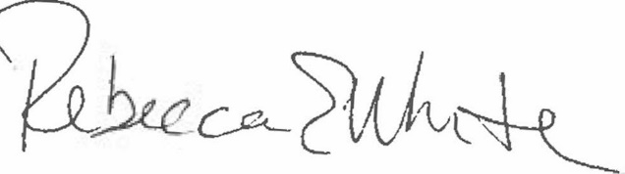  Rebecca E. White,  Director | THE PUBLIC UTILITIES COMMISSION  OF THE STATE OF COLORADO  ERIC BLANK  ________________________________  MEGAN M. GILMAN  ________________________________  TOM PLANT  ________________________________  Commissioners

