Decision No. R24-0496-I
BEFORE THE PUBLIC UTILITIES COMMISSION OF THE STATE OF COLORADO
PROCEEDING NO. 23A-0585E
IN THE MATTER OF THE APPLICATION OF TRI-STATE GENERATION AND TRANSMISSION ASSOCIATION, INC. FOR APPROVAL OF ITS 2023 ELECTRIC RESOURCE PLAN.

INTERIM DECISION
Vacating Hearing and Deadline for the filing of Statements of Posision

Issued Date: July 10, 2024

STATEMENT
- On December 1, 2023, Tri-State Generation and Transmission Association, Inc. (“Tri-State”) filed an Application for Approval of its 2023 Electric Resource Plan (“Application”). The filing of the Application commenced this Proceeding.
- By Decision No. R24-0138-I, issued March 5, 2024, the undersigned Administrative Law Judge, among other things, adopted a procedural schedule and scheduled an evidentiary hearing in this matter for July 16-19, 2024. According to Decision No. R24-0138-I, the deadline for the submission of Statements of Position is August 1, 2024.
- On June 27, 2024, Tri-State filed its Unopposed Motion to Approve Unopposed Comprehensive Settlement Agreement, Amend the Procedural Schedule, and Waive Response Time (“Motion”). In the Motion, Tri-State, Highline Electric Association, Poudre Valley Rural Electric Association, Inc., Y-W Electric Association, Inc., Interwest Energy Alliance, Trial Staff of the Colorado Public Utilities Commission, The Office of the Utility Consumer Advocate, The Colorado Energy Office, Moffat County and the City of Craig, Colorado, the Office of Just Transition, the Colorado Independent Energy Association, the Colorado Solar and Storage Association and Solar Energy Industries Association, Sierra Club and the Natural Resources Defense Council, and Western Resource Advocates request Commission approval of their Unopposed Comprehensive Settlement Agreement (“Settlement Agreement”).
- Based upon good cause shown for the unopposed requests in the Motion, it is appropriate that response time to the Motion the waived, and the scheduled hearing and Statements of Positions filing deadline be vacated.
- The remainder of the requested relief in the Motion will be addressed by a separate decision.

ORDER

It is Ordered That:
- Response time to Tri-State Generation and Transmission Association, Inc.’s Unopposed Motion to Approve Unopposed Comprehensive Settlement Agreement, Amend the Procedural Schedule, and Waive Response Time (“Motion”), filed June 27, 2024 is waived.
- Consistent with the discussion above, the evidentiary hearing scheduled for July 16-19, 2024 and the deadline for the filing of Statements of Position are vacated.
- Any additional relief sought in the Motion is taken under advisement and will be ruled upon by separate Decision.
- This Decision is effective immediately.
(S E A L)    ATTEST: A TRUE COPY  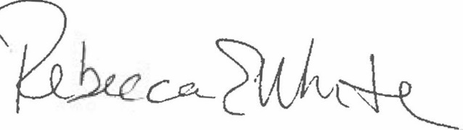  Rebecca E. White,  Director | THE PUBLIC UTILITIES COMMISSION  OF THE STATE OF COLORADO  AVIV SEGEV  ________________________________  Administrative Law Judge

See Settlement Agreement, attached to the Motion as Attachment A.

