Decision No. R24-0443-I
BEFORE THE PUBLIC UTILITIES COMMISSION OF THE STATE OF COLORADO
PROCEEDING NO. 24M-0110TO
IN THE MATTER OF THE PETITION OF GOLDEN EAGLES TOWING LLC TO REVERSE AN INITIAL TOWING PERMIT DENIAL PURSUANT TO 40-10.1-401(2)(a), C.R.S., AND RULE 6504(d).
INTERIM DECISION
VACATING HEARING
Issued Date: June 24, 2024

STATEMENT

Background
- On March 6, 2024, Golden Eagle Towing LLC (“Golden Eagle or Petitioner”), filed the Petition described in the caption above (“Petition”).
- On March 27, 2024, the Commission referred the proceeding to an Administrative Law Judge (ALJ) by minute entry. The proceeding was subsequently assigned to the undersigned ALJ.
- On April 10, 2024, Trial Staff of the Commission (“Staff”) noticed its intervention by right in this Proceeding.
- By Decision No. R24-0307-I, the ALJ, among other things, scheduled an evidentiary hearing in this Proceeding for June 27, 2024.
- On May 29, 2024, Staff’s Motion for Summary Judgment (“Motion”) was filed by Staff.
- The ALJ finds and concludes that it is appropriate to vacate the evidentiary hearing scheduled for June 27, 2024, so that the Motion can be addressed by the ALJ in advance of the evidentiary hearing. Therefore, the evidentiary hearing will be vacated, as ordered below.
- The Motion will be addressed by a separate Decision.

ORDER

It Is Ordered That:
- Consistent with the discussion above, the evidentiary hearing scheduled for
June 27, 2024, at 9:00 a.m., is vacated.
- This Decision is effective immediately.
(S E A L)    ATTEST: A TRUE COPY  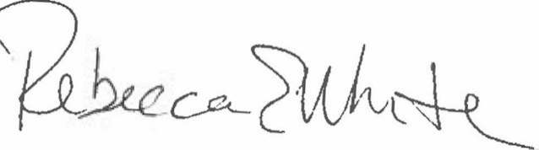  Rebecca E. White,  Director | THE PUBLIC UTILITIES COMMISSION  OF THE STATE OF COLORADO  AVIV SEGEV  ________________________________  Administrative Law Judge

