November 6, 2024

To: All Telecommunications Providers with Filed Tariffs, Terms of Service, or Interconnection Agreements at the Colorado Public Utilities Commission (PUC)

RE: Interest Rate to be Paid on Customer Deposits for the Year 2025.

Telecommunications Providers in the State of Colorado that have provisions in their filed tariffs, Terms of Service (TOS), or Interconnection Agreements (ICAs) at the PUC that allow the provider to require customers to maintain a deposit to ensure payment of services are required to pay simple interest on those customer deposits as prescribed by Commission Rule (4 Code of Colorado Regulations 723-2-2302(f)(I)).

For calendar year 2024, the rate is 4.93 percent.
For calendar year 2025, the rate will remain at 4.93 percent.

(The basis point differential is more than 25 points)

Telecommunications Providers are reminded that it might be necessary to file an advice letter, amend their tariffs, or update their TOS and or ICA proceedings to reflect the change in the interest rate to be paid on their customers’ deposits. Filings or updates to implement a tariff or Terms of Service must be made on or before December 27, 2024, with an effective date of January 1, 2025, as applicable. Appropriate changes must also be made so that ICAs incorporate the revised customer deposit interest rate.

A Telecom provider’s failure to file the required compliance on or before December 27, 2024, will be viewed as an intentional violation of Commission fining Rules 4 Code of Colorado Regulations 723-2-2011. The company could be subject to a fine of up to $2,000.00.

For additional information and to facilitate any tariff changes, the Commission entered the corresponding Decision. Please reference the Commission Decision Number if submitting an advice letter. The advice letter filing is a compliance filing.

Please note that for tariff updates this is a NEW Advice Letter filing. DO NOT file in the miscellaneous Proceeding or use the decision number found on the Decision. Use Decision No. C24-0801, which is the specific telecom decision.

If you have any questions regarding the applicability of the interest rate on deposits, the manner in which the rate is calculated, or any other issues relating to this letter, please contact Gladys Rey at gladys.rey@state.co.us or Meghan Ruwet at meghan.ruwet@state.co.us.

Sincerely,

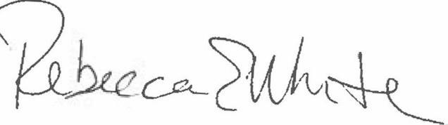
Rebecca E. White,
Director

