Decision No. C24-0463
BEFORE THE PUBLIC UTILITIES COMMISSION OF THE STATE OF COLORADO
PROCEEDING NO. 24A-0064CP-EXT
IN THE MATTER OF THE APPLICATION OF ARAMARK FOOD AND SUPPORT SERVICES GROUP, INC. DOING BUSINESS AS ARAMARK, FOR AUTHORITY TO EXTEND OPERATIONS UNDER CERTIFICATE OF PUBLIC CONVENIENCE AND NECESSITY NO. 7465.
COMMISSION DECISION REOPENING PROCEEDING AND GRANTING EXTENSION OF TIME
Issued Date: July 1, 2024
Adopted Date: June 26, 2024

BY THE COMMISSION

Statement, Findings, and Conclusions
- This matter comes before the Commission for consideration of a motion submitted on June 20, 2024, by Aramark Food and support Services Group, Inc. (“Aramark”) requesting that the Commission grant a 30-day extension to comply with the terms of Decision No. C24-0192 (“Decision”).
- On February 8, 2024, Aramark filed an application for new permanent authority to extend operations under Certificate of Public Convenience and Necessity (“CPCN”) PUC No. 7465.
- Aramark’s CPCN PUC No. 7465 currently authorized:
- Transportation on schedule of passengers between Cortez, Colorado, and Mesa Verde National Park, Colorado over U.S. Highway 160. (II) Transportation in charter service of passengers between the Durango, Colorado Municipal Airport and Mesa Verde National Park, serving no intermediate points. (III) Transportation in sightseeing service of passengers between points in the area comprised of the Counties of Montezuma, Dolores, San Miguel, La Plata, and San Juan, State of Colorado.

RESTRICTIONS:
This certificate is restricted as follows: (A) Item (III) is restricted as follows: (1) To roundtrip sightseeing trips which both originate and terminate at Mesa Verde National Park or Cortez, Colorado; (2) To trips involving a minimum of six passengers per trip; (B) Item (I) is restricted to operating only between the dates of April 15th and November 1st of each year.
- In this application, Aramark requested authority to extend CPCN PUC No. 7465 such that the extended CPCN will authorize:
Transportation of passengers in call-and-demand sightseeing service between all points in Mesa Verde National Park, Colorado.
- The Commission noticed this application to all interested persons, firms, and corporations pursuant to § 40-6-108(2), C.R.S., on February 12, 2024, for a period of thirty days.
- The notice period expired on March 13, 2024. No petition to intervene or otherwise participate in this proceeding was filed. The proceeding was uncontested and pursuant to § 40-6-108(2), C.R.S., was determined without a hearing.
- On March 22, 2024, the Commission issued the Decision and granted the permanent authority, subject to Aramark’s full compliance with the requirements contained in Ordering Paragraph No. 3 of the Decision.
- Ordering Paragraph No. 5 of the Decision gave Applicant 60 days from its effective date of March 22, 2024, to comply with the requirements contained in Ordering Paragraph No. 3, or the requested extension will be deemed denied and Aramark will not be granted the requested permanent authority. Therefore, Aramark had until May 21, 2024, to complete the requirements of the Decision. Aramark did not comply with all the requirements by that date, and the proceeding was closed without the CPCN being issued.
- In the Motion filed on June 20, 2024, the general manager of Aramark included the following statement to support the request for additional time:
This is in response to proceeding 24A-0064CP-EXT regarding the $5.00 fee for the issuance of the authority. Requesting an extension of 30 days to pay the fee. This is the first application that has been filed by Aramark Mesa Verde since 2017. Property is under new management, and we are learning these processes and inadvertently didn't submit the $5.00.
- In consideration of the information provided by the manager of Aramark, the Commission finds that good cause exists to reopen the proceeding and grant the request for a 30-day extension to complete the requirements named in the Decision.

ORDER

The Commission Orders That:
- The Motion of Aramark Food and support Services Group, Inc. (“Aramark”), filed on June 20, 2024, requesting that the Commission grant a 30-day extension to comply with the terms of Decision No. C24-0192 (“Decision”) is granted.
- The 20-day time period provided by § 40-6-114(1), C.R.S., to file an application for rehearing, reargument, or reconsideration shall begin on the first day after the effective date of this Decision.
- This Decision is effective on its Issued Date.

ADOPTED IN COMMISSIONERS' WEEKLY MEETING
June 26, 2024.
(S E A L)    ATTEST: A TRUE COPY  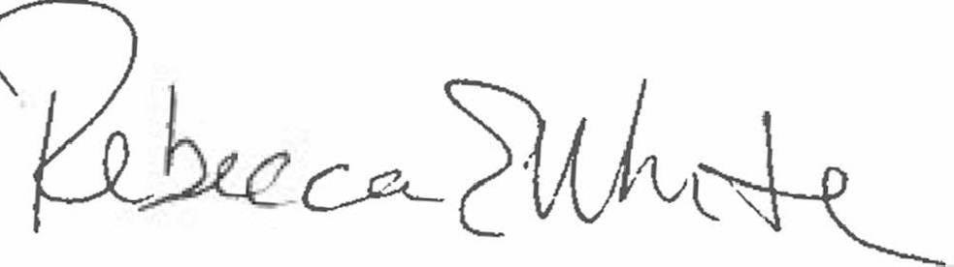  Rebecca E. White,  Director | THE PUBLIC UTILITIES COMMISSION  OF THE STATE OF COLORADO  MEGAN M. GILMAN  ________________________________  TOM PLANT  ________________________________  Commissioners  COMMISSIONER ERIC BLANK  ABSENT

