Decision No. C24-0073-E
BEFORE THE PUBLIC UTILITIES COMMISSION OF THE STATE OF COLORADO
PROCEEDING NO. 23A-0619T
IN THE MATTER OF THE APPLICATION OF IM TELECOM, LLC D/B/A INFINITI MOBILE FOR DESIGNATION AS AN ELIGIBLE TELECOMMUNICATIONS CARRIER IN THE STATE OF COLORADO.
ERRATA NOTICE FOR
COMMISSION DECISION DEEMING APPLICATION COMPLETE, GRANTING APPLICATION, IN PART,
AND GRANTING REQUEST FOR WAIVERS
Errata mailed February 8,2024
Original Decision No. C24-0073 mailed February 5, 2024

- The original Decision title does not indicate that the Commission Decision deemed the application complete, and reads as follows:
COMMISSION DECISION GRANTING APPLICATION,
IN PART, AND GRANTING REQUEST FOR WAIVERS
The Decision title is Amended to read as titled for this Errata Decision, and as follows:
COMMISSION DECISION DEEMING APPLICATION COMPLETE, GRANTING APPLICATION, IN PART,
AND GRANTING REQUEST FOR WAIVERS

- Ordering Paragraph No. 1 currently reads as follows:
- INFINITI’s Application for designation as a Lifeline-only Eligible Telecommunications Carrier (ETC) is granted.
Ordering Paragraph No. 1 is Amended to read as follows:
- INFINITI’s Application for designation as a Lifeline-only Eligible Telecommunications Carrier (ETC) filed on December 21, 2023, is deemed complete within the meaning of § 40-6-109.5, C.R.S., and is granted.
(S E A L)    ATTEST: A TRUE COPY  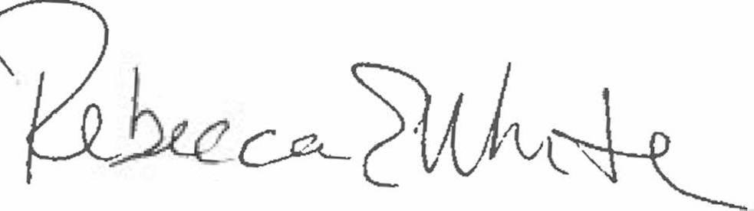  Rebecca E. White,  Director | THE PUBLIC UTILITIES COMMISSION  OF THE STATE OF COLORADO  REBECCA E. WHITE  ________________________________  Director

