Decision No. C24-0046-E
BEFORE THE PUBLIC UTILITIES COMMISSION OF THE STATE OF COLORADO
PROCEEDING NO. 23A-0618FG
IN THE MATTER OF THE VERIFIED APPLICATION OF BLACK HILLS COLORADO GAS, INC. D/B/A BLACK HILLS ENERGY FOR AN ORDER GRANTING TO IT A CERTIFICATE OF PUBLIC CONVENIENCE AND NECESSITY TO EXERCISE NATURAL GAS FRANCHISE RIGHTS IN THE CITY OF OURAY, COLORADO.
commission decision DEEMING APPLICATION COMPLETE and GRANTING APPLICATION
Errata mailed January 26, 2024
Original Decision No. C24-0046 mailed January 24, 2024

- Statement Paragraph No. 8 currently reads as follows:
According to the franchise agreement, as consideration for the franchise rights granted and in recognition of Black Hills’ right to use the City streets, the City requires Black Hills to collect and remit to the City a franchise fee equal to $0.0215 per therm for all revenues received from the sale of natural gas service within the City, excluding revenues received from the City for the sale of natural gas service to the City.
Statement Paragraph No. 8 is Amended to read as follows:
According to the franchise agreement, as consideration for the franchise rights granted, and in recognition of Black Hills’ right to use the City streets, the City requires Black Hills to collect and remit to the City a franchise fee equal to $0.0215 per therm of natural gas delivered within the city.
(S E A L)    ATTEST: A TRUE COPY  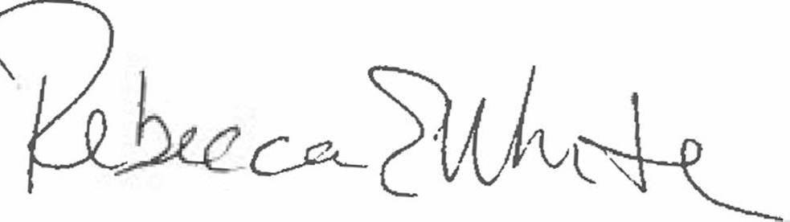  Rebecca E. White,  Director | THE PUBLIC UTILITIES COMMISSION  OF THE STATE OF COLORADO  REBECCA E. WHITE  ________________________________  Director

