Decision No. C24-0040-E
BEFORE THE PUBLIC UTILITIES COMMISSION OF THE STATE OF COLORADO
PROCEEDING NO. 23A-0580R
IN THE MATTER OF THE APPLICATION OF BNSF RAILWAY COMPANY FOR AUTHORITY TO UPGRADE SIGNALS, LIGHTS, GATES AND BUNGALOW AT THE COUNTY ROAD 3 CROSSING IN WIGGINS, MORGAN COUNTY, COLORADO (DOT #057229S).
ERRATA NOTICE FOR
COMMISSION DECISION DEEMING APPLICATION COMPLETE AND GRANTING APPLICATION
Errata mailed January 22, 2024
Original Decision No. C24-0040 mailed January 19, 2024

- The current Caption reads as follows:
IN THE MATTER OF THE APPLICATION OF THE CITY OF FORT COLLINS FOR AUTHORITY TO ADD ONE DETACHED SIDEWALK AT THE CHERRY STREET CROSSING OF TRACKS OWNED BY BNSF RAILWAY COMPANY, USDOT NO. 244-642N, IN LARIMER COUNTY, STATE OF COLORADO.
The Caption is Amended to read as follows:
IN THE MATTER OF THE APPLICATION OF BNSF RAILWAY COMPANY FOR AUTHORITY TO UPGRADE SIGNALS, LIGHTS, GATES AND BUNGALOW AT THE COUNTY ROAD 3 CROSSING IN WIGGINS, MORGAN COUNTY, COLORADO (DOT #057229S).

- The Ordering Section of the Decision refers to the City of Fort Collins. Ordering Paragraph Nos. 1 through 7 currently read as follows:
- The application (Application) filed by the City of Fort Collins (Fort Collins) on November 30, 2023, requesting authority to add an additional detached sidewalk to the south side of the roadway at the crossing of Cherry Street crossing with the tracks of the BNSF Railway (BNSF) at railroad milepost 74.52 of the Front Range Subdivision, National Inventory No. 244642N in Fort Collins, County of Larimer, in the State of Colorado is deemed complete.
- The intervention by BNSF is granted.
- The Application is granted.
- Fort Collins is authorized and ordered to proceed with the proposed construction of the detached pedestrian and bicycle sidewalk on the south side of Cherry Street crossing in Fort Collins, Colorado.
- Fort Collins shall file a copy of the signed Construction and Maintenance Agreements for this project by March 30, 2024, prior to starting work at the crossing.
- Fort Collins shall inform the Commission in writing that the crossing changes are complete and operational within ten days of completion. We shall expect this letter by
June 30, 2024. However, we understand this letter may be provided earlier or later than this date depending on changes or delays to the construction schedule.
- The 20-day period provided for in § 40-6-114, C.R.S., within which to file applications for rehearing, reargument, or reconsideration, begins on the first day following the effective date of this Decision.

The Ordering Section of the Decision should refer to the Town of Wiggins. Ordering Paragraph Nos. 1 through 7 is Amended to read as follows:
- The application (Application) filed by the BNSF Railway Company (BNSF) on November 30, 2023, requesting to replace the existing flashing lights, gates, bells, signal bungalow, and upgrading the crossing detection circuitry to newer constant warning time at the crossing of Morgan County Road 3 (MCR 3) with the tracks of the BNSF Brush Subdivision, railroad milepost 480.19, National Inventory No. 057229S near the Town of Wiggins, Morgan County, in the State of Colorado is deemed complete within the meaning of § 40-6-109.5, C.R.S.
- The Application is granted.
- BNSF is authorized and ordered to upgrade the active warning equipment and train detection circuitry at the crossing of MCR 3 near Wiggins, Colorado.
- BNSF shall inform the Commission in writing when the project is complete within ten days of completion. The Commission will expect the letter by March 30, 2024. However, the Commission understands this letter may be provided earlier or later than this date depending on changes or delays to the construction schedule.
- BNSF shall update the National Inventory Form for this crossing and file a copy of the updated crossing inventory forms in this proceeding by March 30, 2024.
- The 20-day period provided for in § 40-6-114, C.R.S., within which to file applications for rehearing, reargument, or reconsideration, begins on the first day following the effective date of this Decision.
- The Commission retains jurisdiction to enter further decisions as necessary.
(S E A L)    ATTEST: A TRUE COPY  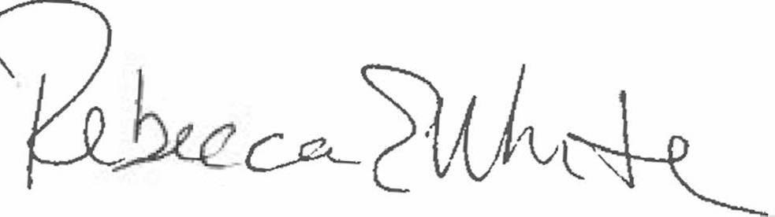  Rebecca E. White,  Director | THE PUBLIC UTILITIES COMMISSION  OF THE STATE OF COLORADO  REBECCA E. WHITE  ________________________________  Director

