Decision No. R23-0601-I-e
BEFORE THE PUBLIC UTILITIES COMMISSION OF THE STATE OF COLORADO
PROCEEDING NO. 23A-0150CP-EXT
IN THE MATTER OF THE APPLICATION OF MOUNTAIN TAXI, LLC FOR AUTHORITY TO EXTEND OPERATIONS UNDER CERTIFICATE OF PUBLIC CONVENIENCE AND NECESSITY NO. 55979.
PROCEEDING NO. 23A-0152CP-EXT
IN THE MATTER OF THE APPLICATION OF MOUNTAIN TAXI, LLC FOR AUTHORITY TO EXTEND OPERATIONS UNDER CERTIFICATE OF PUBLIC CONVENIENCE AND NECESSITY NO. 55979.
______________________________________________________________________________
PROCEEDING NO.
______________________________________________________________________________
IN THE MATTER OF THE APPLICATION OF MOUNTAIN TAXI, LLC FOR AUTHORITY TO EXTEND OPERATIONS UNDER CERTIFICATE OF PUBLIC CONVENIENCE AND NECESSITY NO. 55979.
PROCEEDING NO. 23A-0160CP-EXT
IN THE MATTER OF THE APPLICATION OF MOUNTAIN TAXI, LLC FOR AUTHORITY TO EXTEND OPERATIONS UNDER CERTIFICATE OF PUBLIC CONVENIENCE AND NECESSITY NO. 55979.
ERRATA NOTICE FOR
INTERIM DECISION OF
ADMINISTRATIVE LAW JUDGE
ALENKA HAN
GRANTING MOTION TO WITHDRAW APPLICATIONS
AND VACATING EVIDENTIARY HEARING
Errata Mailed: September 19, 2023
Original Decision No. R23-0621-I mailed: September 15, 2023

- The decision title currently reads as follows:
INTERIM DECISION OF
ADMINISTRATIVE LAW JUDGE
ALENKA HAN
GRANTING MOTION TO WITHDRAW APPLICATIONS
AND VACATING EVIDENTIARY HEARING
Decision title should be amended to read as follows:
RECOMMENDED DECISION OF
ADMINISTRATIVE LAW JUDGE
ALENKA HAN
GRANTING MOTION TO WITHDRAW APPLICATIONS
AND VACATING EVIDENTIARY HEARING

(S E A L)    ATTEST: A TRUE COPY  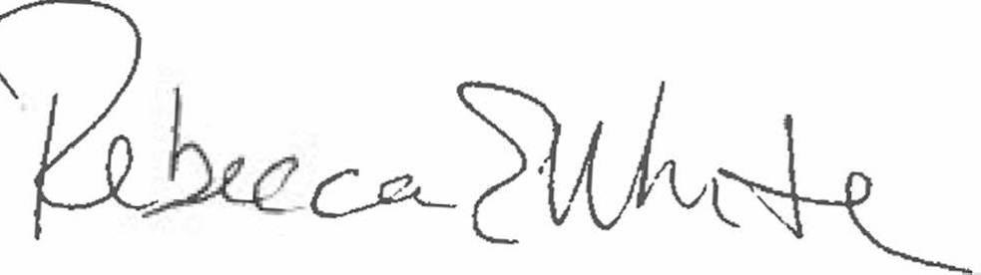  Rebecca E. White,  Director | THE PUBLIC UTILITIES COMMISSION  OF THE STATE OF COLORADO  REBECCA E. WHITE  ________________________________  Director

