Decision No. R23-0564-I
BEFORE THE PUBLIC UTILITIES COMMISSION OF THE STATE OF COLORADO
PROCEEDING NO. 23A-0242E
IN THE MATTER OF THE APPLICATION OF PUBLIC SERVICE COMPANY OF COLORADO FOR APPROVAL OF ITS 2024-2026 TRANSPORTATION ELECTRIFICATION PLAN.
INTERIM DECISION OF
ADMINISTRATIVE LAW JUDGE
G. Harris Adams
shortening response time
Mailed Date: July 31, 2026

STATEMENT
      - On August 18, 2023, Trial Staff’s Motion to Compel Public Service Company of Colorado to Produce Documents and Information in Response to Staff’s Fourth, Fifth, and Eighth Sets of Data Requests (Motion to Compel) and to Shorten Response Time was filed by Trial Staff of the Colorado Public Utilities Commission (Staff).
      - Between July 7 and July 26, 2023, Staff propounded it’s Fourth, Fifth, and Eight Sets of Data Requests. Staff found the Company’s answers to CPUC 4-3 and CPUC 5-7 substantially deficient and lacking a valid objection. After conferring with Public Service, the parties were unable to reach a resolution.
      - As the September 29, 2023, deadline approaches for Staff to file Answer Testimony, Staff requests shortened response time so that production might be timely reviewed and incorporated Staff’s testimony. Staff requests that response time to the Motion to Compel be shortened to seven days.
      - Public Service of Colorado (Public Service) opposes the Motion to Compel and the Motion to Shorten Response Time.
      - Based upon good cause shown, the request to shorten response time will be granted, in part.

ORDER

It Is Ordered That:
- The Motion to Shorten Response Time to Trial Staff’s Motion to Compel Public Service Company of Colorado to Produce Documents and Information in Response to Staff’s Fourth, Fifth, and Eighth Sets of Data Requests filed on August 18, 2023, is shortened to
August 28, 2023. Any response that Public Service of Colorado desires to file must be filed on or before August 28, 2023.
- This Decision shall be effective immediately.
(S E A L)    ATTEST: A TRUE COPY  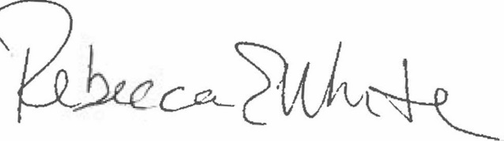  Rebecca E. White,  Director | THE PUBLIC UTILITIES COMMISSION  OF THE STATE OF COLORADO  G. HARRIS ADAMS  ________________________________  Administrative Law Judge

