______________________________________________________________________________
ATTACHMENT A
REQUIREMENTS AND INFORMATION
ON USING ZOOM TO ATTEND PUBLIC COMMENT HEARING
______________________________________________________________________________
- This Attachment directs members of the public on certain aspects of their participation in the remote public comment hearing in this matter using Zoom (https://zoom.us/) and provides information which will aid participants in doing so. Additional information about the Zoom platform and various tips on how to use the Zoom platform are available at: https://zoom.us. This is not intended to provide full and complete instructions on how to use Zoom to participate in a hearing.
- Those persons interested in providing public comment during the scheduled public comment hearing must register by clicking on the registration link included on the scheduled hearing on the calendar of events page of the Public Utilities Commission’s (PUC or Commission) website, which can be found at https://puc.colorado.gov/puccalendar. After an interested person registers for the public comment hearing, Zoom will email information to join the session.
- To minimize the potential that the video-conference hearing may be disrupted by non-participants, the link, telephone number, meeting ID or access code to attend the hearing will only be provided to those who register to participate in the public comment hearing; and will not be posted on the Commission’s website.
- Participants are responsible for ensuring they have familiarized themselves with Zoom and are able to use it for the hearing. All are strongly encouraged to participate in a test meeting prior to the scheduled hearing. See https://zoom.us/test.
- Registered participants in a Zoom hearing by video-conference are strongly encouraged to use a computer, smart phone, or tablet with internet access, an operational microphone, camera, and a speaker. A few minutes prior to the start of the hearing, participants must enter the Zoom link for the hearing in their internet browser.
- Registered participants will be taken to the screen where they may join the hearing. The registered participants’ browser should prompt them to “Open Zoom Meetings,” which the registered participant should click. If the browser prompt does not appear, the registered participant may click “Launch Meeting” as shown in the image below.
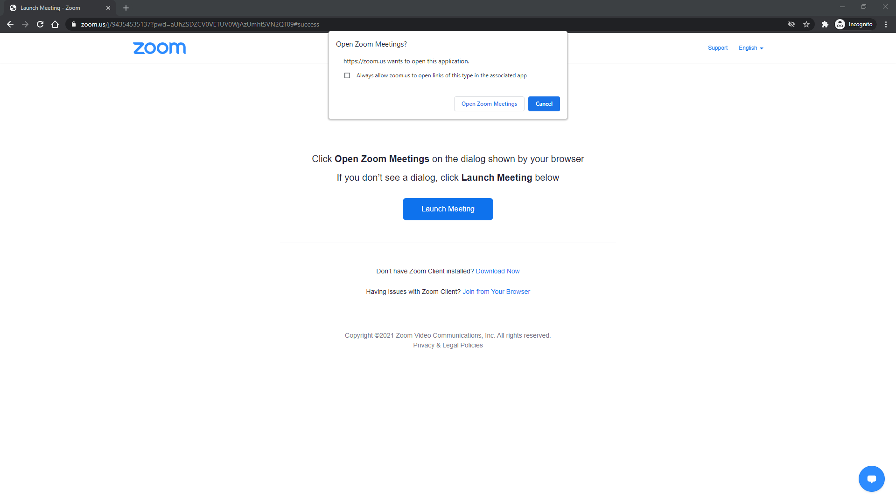
- The Zoom program will then open on the registered participant’s computer. A video preview window will open automatically. Registered participants should click “Join with Video.” If registered participants are prompted to allow the session to access their computers’ microphone and camera, they should allow access and should click “Join With Computer Audio.” Registered participants will be able to modify their settings during the session should they need to mute their microphone or turn off their cameras. These steps are shown in the images below.
Step 1:
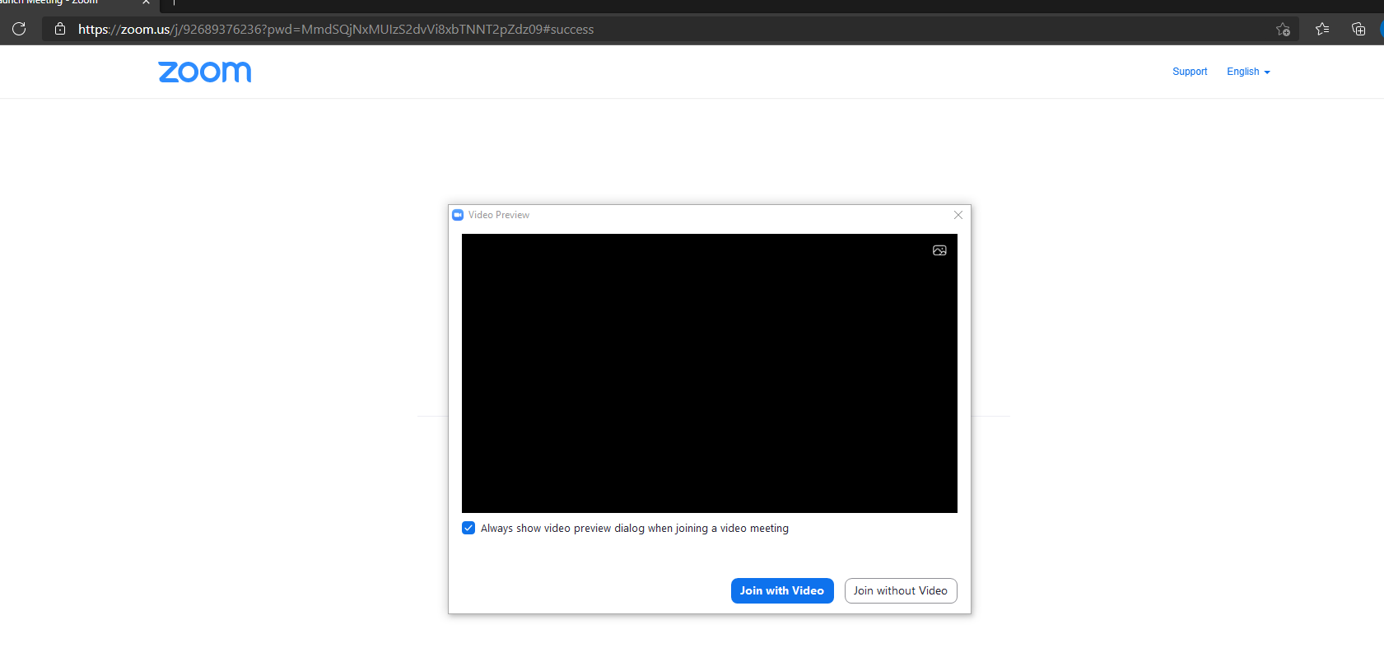
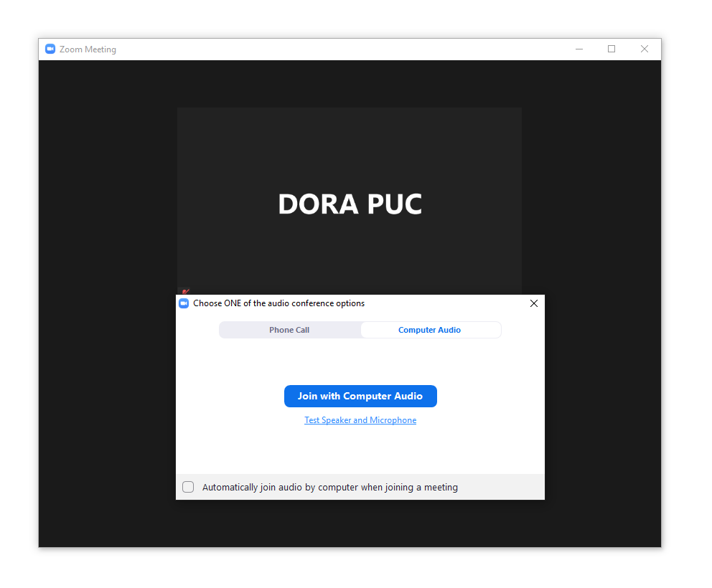
Step 2:

- When prompted by Zoom, registered participants in the public comment hearing must enter their name for identification during the session. Among other reasons, this is required for identification and because the presiding official may close the meeting if necessary.
- Those registered to participate in the public comment hearing may control the audio volume using their computer’s audio controls. Those who do not want their picture displayed for others in the meeting may select the camera icon labeled “Stop Video” at the bottom left of the Zoom window at any point. A slash will appear over the camera icon, indicating that the camera has been turned off. Likewise, to mute or turn off the microphone, select the microphone icon at the bottom left of the Zoom window and visually confirm that there is a slash over the microphone icon. Illustratively, the below image shows the microphone turned on and the camera turned off.
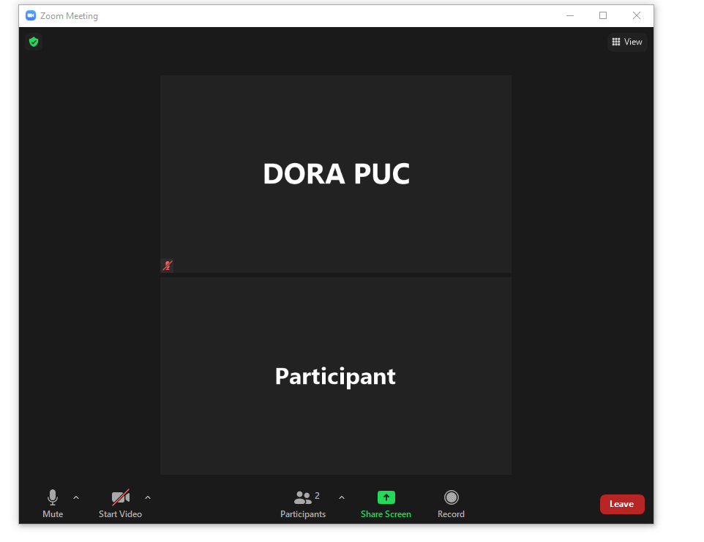
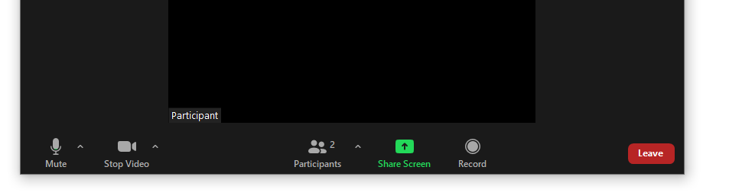
- Conversely, the below image shows the microphone and camera icons turned on and ready to transmit video and audio upon joining the hearing.
- When the presiding official signals that it is time to receive public comments, registered participants must use the “raise hand” feature to signal that they wish to provide public comment. The “raise hand” feature may be accessed by clicking on the “reactions” icon. The below image shows how to access the “raise hand” feature.
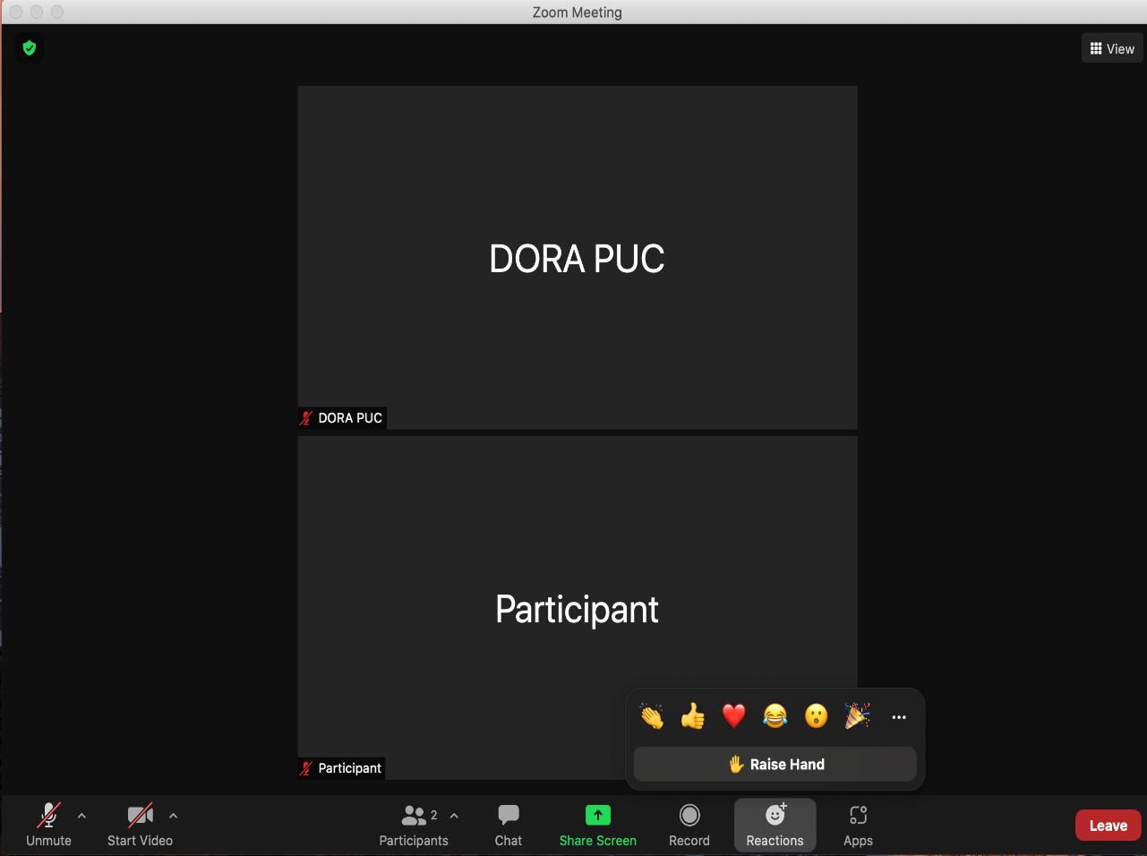
- The below image illustrates the “raise hand” feature turned on.
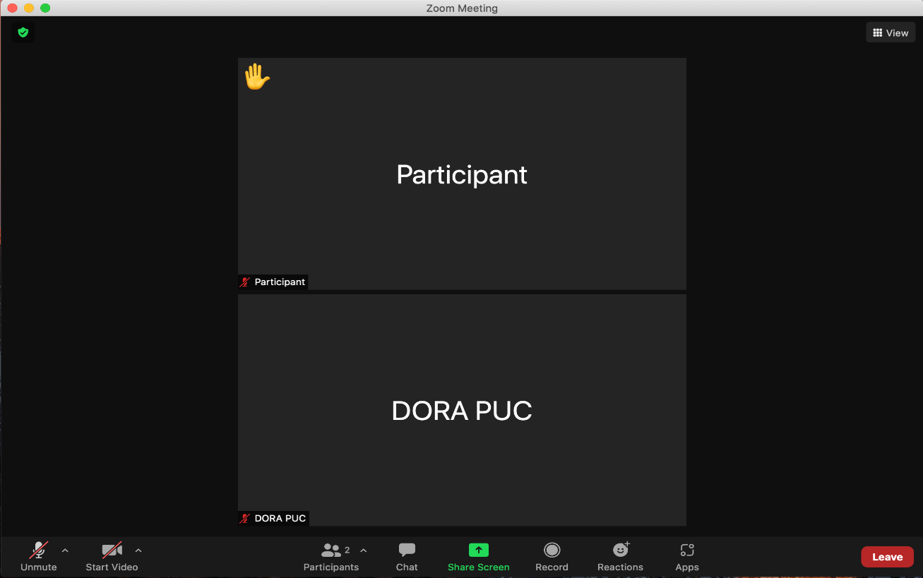
- The presiding official will call on each person who has turned on the “raise hand” feature to provide public comment. Those registered participants wishing to provide public comment should leave the “raise hand” feature on until they have provided public comment or no longer wish to do so. After a commenter has finished presenting comments or no longer wishes to do so, the commenter should turn off the “raise hand” feature.

- The below image shows how to turn off the “raise hand” feature.
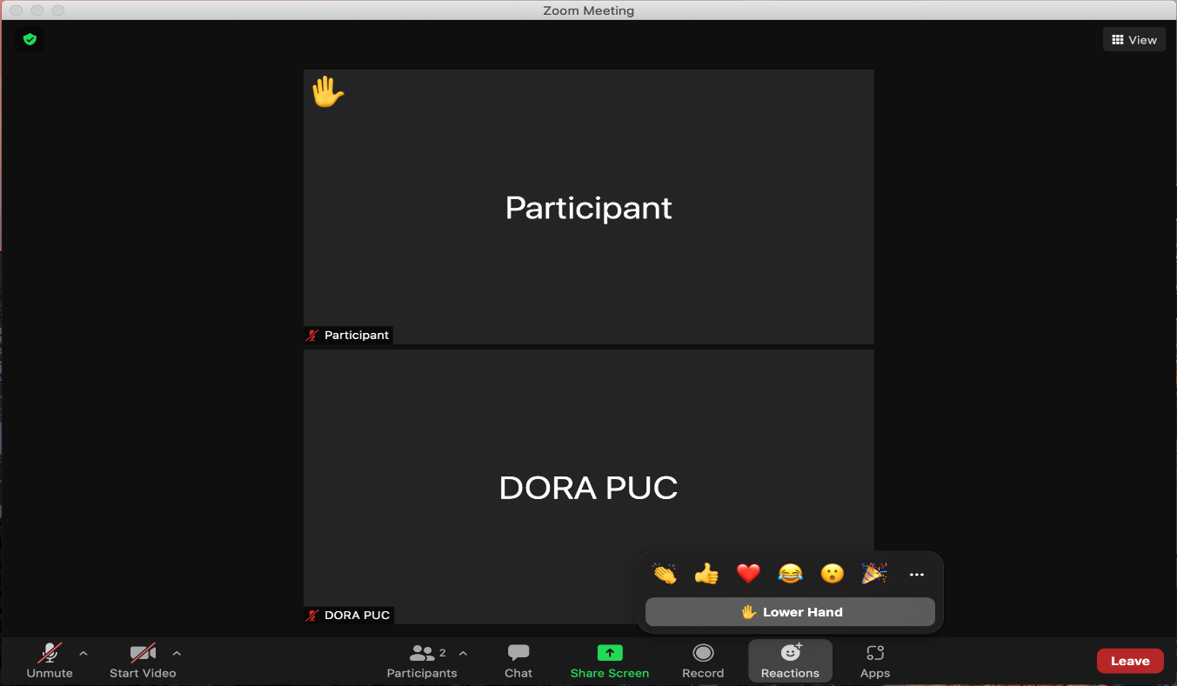
- A full and complete record and all testimony will be stenographically or electronically recorded. To facilitate this, those registered to participate in the public comment hearing must minimize feedback and background noise. First, all registered participants are required to mute their microphones and cameras during the hearing until called upon by the presiding official. Second, all registered participants must ensure that they are in a location with minimal or no background noise while participating in the hearing. Registered participants must also avoid connecting to the hearing with multiple computers or devices located in the same room, as this will cause echos and audio feedback. Although not mandatory, those registered to participate in the public comment hearing are encouraged to participate using headphones connected to their computers to help reduce audio feedback.
- The Commission has enabled the Zoom “Live Transcript” feature, which allows participants to view subtitles using automatic speech recognition technology. To access this feature, registered participants can select the “Live Transcript” icon on the bottom of the screen and then choose “Show Subtitle.” To hide the subtitles, click on the “Live Transcript” icon again and choose “Hide Subtitle.”
- A Zoom hearing may or may not have a functional chat feature active during a particular hearing. Any information provided in the chat will not be part of the record of the proceeding. In addition, the presiding official and Commission Staff who administer the hearings do not actively monitor Zoom’s chat function and thus may not be aware of, or respond to, any information provided in chat. Therefore, registered participants should not use the chat function.
- To terminate participation in the hearing, select the “Leave” button then select “Leave Meeting” in the pop-up box, as shown below. A registered participant who inadvertently selects the “Leave” button may instead click anywhere else on the screen to stay in the meeting.
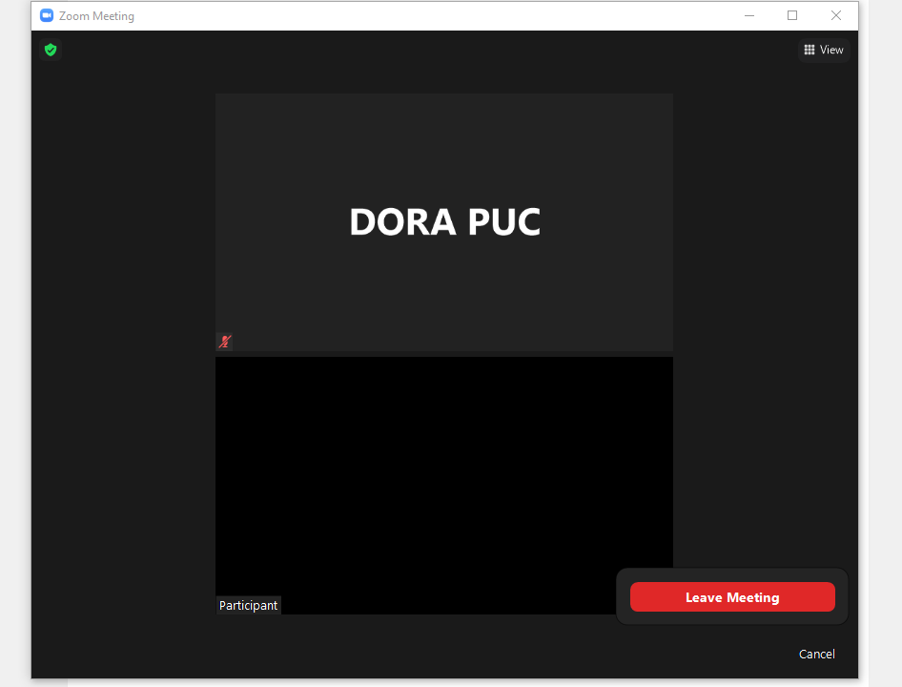

This Attachment A was modified and revised February 22, 2023, to incorporate instructions for registration.
These links are provided for the parties’ convenience; the Public Utilities Commission does not warrant that the information contained in these links is accurate or that it provides all the information participants may need to use Zoom.
These instructions are not directed at using a tablet or smartphone to participate in a Zoom video conference. Using a smartphone or tablet may limit a participant’s ability to view documents that may be displayed during the hearing due to screen size. As such, participation by computer is encouraged. Participants who chose to use a smartphone or tablet are responsible for ensuring they are able to fully participate in the hearing.
If a registered participant is unable to participate by computer or mobile device, participation by telephone only will be accommodated.
If the registered participant has never used Zoom before, a download in the browser may start and participant will need to click the Zoom icon in the bottom of the browser to open the program.
Participants can also click the link for “Test Speaker and Microphone” to ensure their audio is properly connected.
Note, closing the meeting does not affect the availability of the webcast of the proceeding.

