Decision No. R23-0009-I
BEFORE THE PUBLIC UTILITIES COMMISSION OF THE STATE OF COLORADO
PROCEEDING NO. 22M-0171ALL
IN THE MATTER OF THE COMMISSION'S IMPLEMENTATION OF Senate bill 21-272 REQUIRING IT TO PROMULGATE RULES IN WHICH IT CONSIDERS HOW BEST TO PROVIDE EQUITY IN ALL OF ITS WORK.
INTERIM DECISION OF HEARING COMMISSIONER MEGAN M. GILMAN SCHEDULING A WORKSHOP ON DEFINING DISPROPORTIONATELY IMPACTED COMMUNITIES AND USING ENVIROSCREEN
Mailed Date: January 6, 2023

Table of Contents
I. BY THE COMMISSION 2
A. Statement 2
B. Context for Discussion 3
1. Colorado EnviroScreen 4
2. Organization of § 40-2-108(3)(d) 4
a. Demographic Factors in Defining Disproportionately Impacted Communities 5
b. Historical Racism Factor in Defining Disproportionately Impacted Communities 7
c. Cumulative Impacts Factor in Defining Disproportionately Impacted Communities 8
C. Statutory Provisions 10
D. Objectives of Upcoming Workshop 10
E. Scope and Format of Workshop 11
F. Filings Requested From Regulated Electric and Gas Utilities 12
G. Questions and Comments Requested 12
II. ORDER 16
A. It Is Ordered That: 16

BY THE COMMISSION

Statement
- By Decision No. C22-0239, issued in this Proceeding on April 28, 2022, the Colorado Public Utilities Commission (Commission) opened this Miscellaneous Proceeding to gather information, host workshops, collect comments, and otherwise prepare to implement Senate Bill (SB) 21-272, including initiating the rulemaking contemplated under § 40-2-108(3)(a)-(d), C.R.S.
- Decision No. C22-0239 not only set objectives for this pre-rulemaking proceeding (¶38), but also directed Commission Staff (Staff) to host initial informational meetings or workshops with stakeholders as appropriate and to bring forward a proposal for a work plan that is intentional and responsive to input received in comments and meetings, and with consideration to ways in which impacted communities may participate effectively (¶¶39-42).
- On November 14, 2022, Staff filed in this Proceeding the Final Report of the Environmental Justice Action Task Force (EJATF) (Final Report). The Final Report includes recommendations from the EJATF to the General Assembly for future legislation. The Director of the Commission at the time, Doug Dean, was appointed to the EJATF and supported by Staff.
- Recognizing that robust and unique coordination between the agency and the Commissioners may be required to fully implement SB 21-272, the agency is in the process of developing a work plan, of which the workshops and activities the Hearing Commissioner intends to host are a part. Given the complexity of this subject and the Commission’s aggressive case schedule, as well as the process to transition agency leadership given the retirement of the Division Director, this overall work plan is not yet complete. However, at Staff-led workshops, participants expressed an interest in early activities within this Proceeding focusing on the definition of disproportionately impacted community and the practice of equitable stakeholder engagement, with the idea that these concepts are critical to scoping future steps. Accordingly, a workshop will be scheduled prior to the release of an overall work plan. This Decision sets objectives for and schedules a virtual technical workshop on defining disproportionately impacted communities, understanding the significance of the term as it is used at other agencies, and the use of mapping tools. The following procedural dates will be set:
    - January 19, 2023: Filings from regulated entities on maps and data
    - January 26, 2023: Technical Workshop
    - February 23, 2023: Initial comments requested from participants
    - March 9, 2023: Responsive comments requested from participants

Context for Discussion
- Senate Bill 21-272 sets forth a definition of disproportionately impacted community at § 40-2-108(3)(d), C.R.S., and directs the Commission to identify disproportionately impacted communities in the course of making rules. Given that SB 21-272 also directs the Commission’s rules to minimize impacts and prioritize benefits to disproportionately impacted communities, understanding this term is critical.
- Several state agencies have statutory definitions for the term disproportionately impacted community that are similar to the definition set forth for the Commission by SB 21-272. This includes the Air Pollution Control Division of the Colorado Department of Public Health and Environment (CDPHE), the Colorado Department of Transportation (CDOT), and the Colorado Oil and Gas Conservation Commission (COGCC). These definitions and how legislation directs their use by those agencies and commissions was summarized by staff of the Environmental Justice (EJ) Program at CDPHE in the course of facilitating the EJATF (see Attachment A). While such actions have not yet been taken legislatively, the Final Report of the EJATF recommends that the General Assembly consider creating a single, standardized legislative definition of disproportionately impacted community for all state agencies.

Colorado EnviroScreen
- The EJ Program created EnviroScreen to be a mapping tool that state agencies and other stakeholders can use to understand the locations of disproportionately impacted communities as that term was defined under House Bill 21-1266, otherwise known as the Environmental Justice Act. The EJ Program worked with Colorado State University to conduct stakeholder interviews, compile data, and otherwise develop the tool. Staff were consulted in those initial interviews, and version 1.0 of the tool was released to the public in June 2022. User guides, video tutorials, and frequently asked questions are available on the EnviroScreen website. While EnviroScreen has been referenced in several recent Commission proceedings, the Commission has not made a decision regarding the use of the tool on a more permanent basis.

Organization of § 40-2-108(3)(d)
- Three subsections in § 40-2-108(3)(d) describe disproportionately impacted communities: a trio of demographic factors, a historical racism factor, and a cumulative impacts factor. Each of these factors will be described below, along with relevant information regarding EnviroScreen and the Final Report. While legislative recommendations from the Final Report are provided below for context, no such legislative changes have been made at the time of this Decision.

Demographic Factors in Defining Disproportionately Impacted Communities
- A disproportionately impacted community is defined by § 40-2-108(3)(d)(II) in part as a community that is within a census block group (CBG) with certain percentages of households meeting one of three demographic factors based on the most recent U.S. Census. These three factors are income, race, and housing cost burden.
- As to income, a CBG is considered disproportionately impacted if the proportion of households that are “low income” is greater than 40 percent. “Low income” is further defined by § 40-2-108(3)(d)(III), which provides the following criteria:
- Median household income less than or equal to 200 percent of the Federal Poverty Guideline;
- Median household income less than or equal to 80 percent of Area Median Income (AMI); or
- Qualification under income guidelines adopted by the Department of Human Services (DHS) pursuant to Section 40-8.5-105.
- The EJATF sought comments on whether to standardize the definition of disproportionately impacted community between state agencies. As Attachment A shows, the Commission is currently the only agency for which a “low income” CBG has three separate income criteria by statute. In its Final Report, the EJATF recommended the General Assembly simplify the Commission’s definition and make it consistent with other agencies by removing additional criteria related to AMI and DHS qualification, because the additional income criteria do not meaningfully change the total number of CBGs that would be identified in the context of all demographic criteria.
- As to race, a CBG is considered disproportionately impacted if the proportion of households that “identify as minority” is greater than 40 percent. The Task Force recommended that the General Assembly modify the language from “minority” to “people of color.”
- Finally, as to cost burden, A CBG is considered disproportionately impacted if the proportion of households that spend more than 30 percent of income on housing is greater than 40 percent. The Final Report recommends retaining this factor but suggests the General Assembly consider modifications to the legislative language, such as excluding CBGs that are above statewide median income, which would reduce the potential for CBGs that contain affluent communities to be identified as disproportionately impacted communities.
- EnviroScreen includes a map layer that can be toggled on and off that demonstrates disproportionately impacted communities based on demographic factors (see Figure 1).
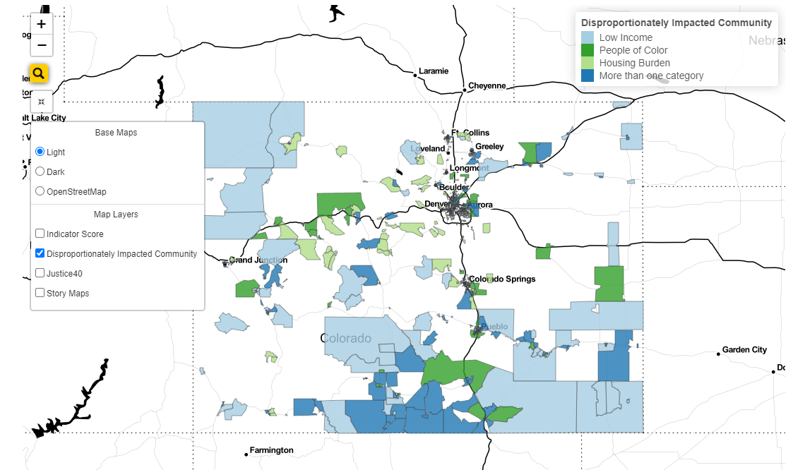
Figure 1: Disproportionately Impacted Community Map Layer of EnviroScreen

Historical Racism Factor in Defining Disproportionately Impacted Communities
- Disproportionately impacted community is defined at § 40-2-108(3)(d)(II)(A) in part as a community with “a history of environmental racism perpetuated through redlining, anti-Indigenous, anti-immigrant, anti-Hispanic, or anti-Black laws.”
- EnviroScreen does not currently define communities that have experienced historic environmental racism by CBGs. However, it does include a map layer that can be toggled on and off to present story maps which link to historical and modern-day information about certain communities, developed by the Environmental Justice Storytelling Project at the University of Colorado-Boulder.
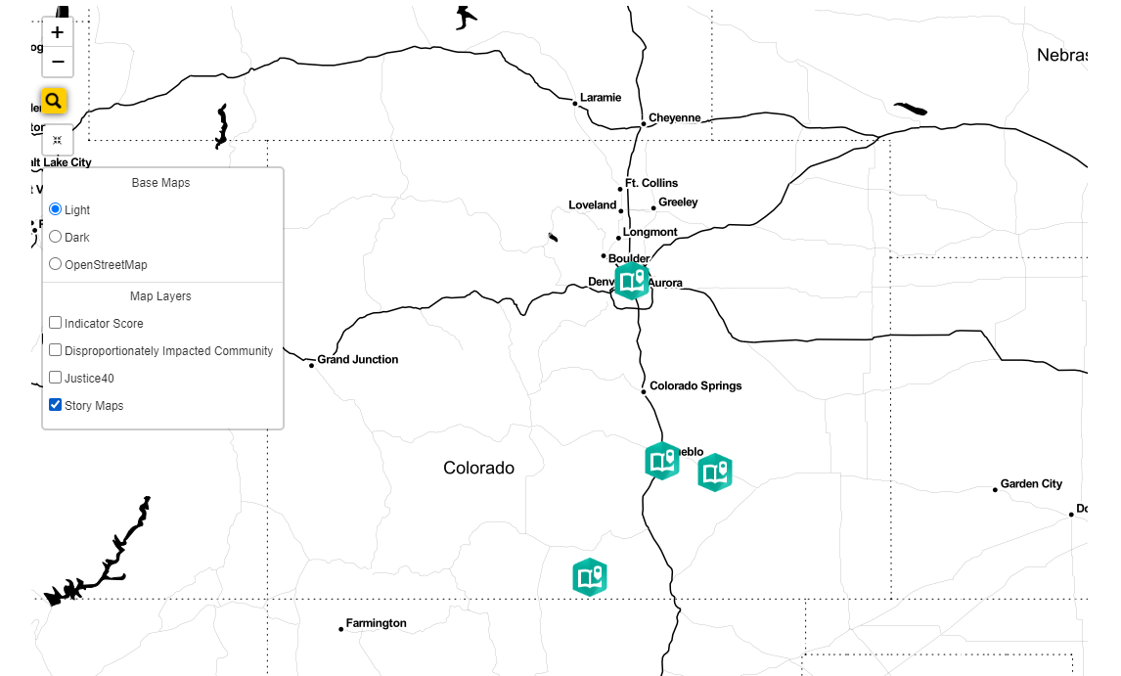
Figure 2: Story Map Layer of EnviroScreen

Cumulative Impacts Factor in Defining Disproportionately Impacted Communities
- A disproportionately impacted community is defined by § 40-2-108(3)(d)(II)(B) in part as a community that is one “where multiple factors, including socioeconomic stressors, disproportionate environmental burdens, vulnerability to environmental degradation, and lack of public participation, may act cumulatively to affect health and the environment and contribute to persistent disparities.”
- The Final Report recommends adding “vulnerable populations” to the list of multiple factors that act cumulatively, and suggests that state agencies use EnviroScreen, and specifically the EnviroScreen score, to identify communities that meet the cumulative impacts prong of the definition. The EnviroScreen score combines individual indicators, such as life expectancy and proximity to hazardous waste facilities, into a composite score, where higher scoring areas are more cumulatively burdened than lower scoring areas. EnviroScreen includes an indicator layer that can be toggled on and off that demonstrates the EnviroScreen score for each CBG in Colorado (see Figure 3).
- The Final Report specifically recommends using an 80th percentile threshold of the EnviroScreen score as a baseline for agency decisions. Analysis from the EJ Program suggests that an 80th percentile or top 20 percent EnviroScreen score overlaps significantly with, but adds to, the CBGs considered disproportionately impacted based on the demographic factor of income.
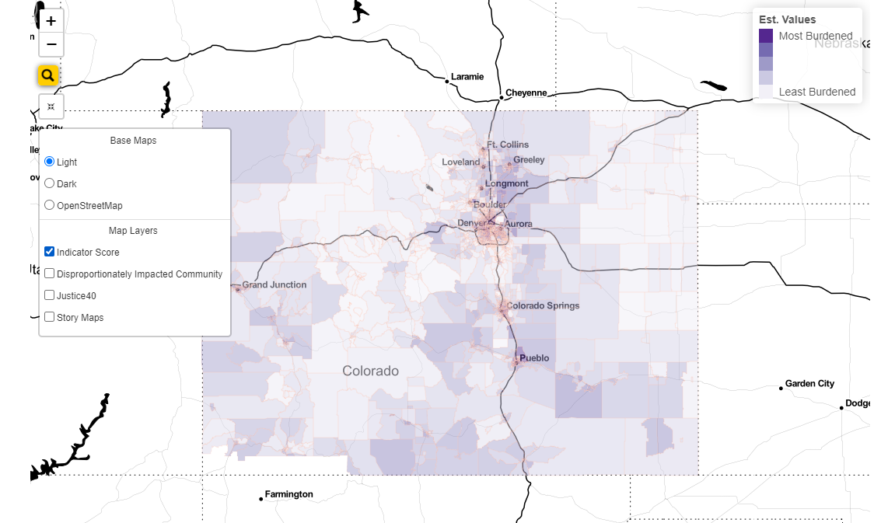
Figure 3: Indicator Map Layer of EnviroScreen

Statutory Provisions
- To further inform discussion at the workshop and in comments, Attachment B has been compiled and will be referenced in questions below. Attachment B excerpts Title 40 statutes that reference the terms income-qualified, low-income, disproportionately impacted communities, and similar terms, and organizes them into categories.

Objectives of Upcoming Workshop
- This Decision schedules a technical workshop with the following objectives:
- To provide a high-level overview of data inputs for EnviroScreen and how that tool is used;
- To understand the update cycle and data archiving for EnviroScreen; and
- To understand how other state agencies are applying the definition of disproportionately impacted communities and using EnviroScreen or similar mapping tools in the context of their adjudicated cases, administrative proceedings, grantmaking, or other activities.
- Based on the presentations and discussion at the workshop, it is anticipated that participants’ written comments will help meet these additional objectives which are necessary to better understand prior to the Commission initiating rulemakings:
- To understand options for applying the historical racism and cumulative impacts prongs of the definition of disproportionately impacted communities in Commission contexts;
- To understand how the EnviroScreen score or indicators making up that score could be applied to refine or prioritize disproportionately impacted communities in cases;
- To understand the distinction between the Commission approaching its activities more equitably, and identifying a disproportionately impacted community; and
- To understand whether household income, energy burden, or other factors suggested by participants should be used to further define disproportionately impacted communities or whether such factors should be considered as part of an equity analysis.

Scope and Format of Workshop
- The virtual technical workshop will be held as follows:
DATE: Thursday, January 26, 2023
TIME: 1:00 p.m. to no later than 4:00 p.m.
PLACE: By video conference using Zoom
- Participants should register using the following link, which will also be added to the Commission’s public calendar:
https://us06web.zoom.us/meeting/register/tZ0vcuqhrjsuE9KkARgGXfWC2zCJkVjZp3nc
- The workshop will be streamed and recorded, and individuals who do not wish to participate can view the workshop on the webcast page for Hearing Room B.
- Staff will post an agenda for the workshop in E-Filings.
- This workshop is open to any interested person (member of the public). However, the workshop is anticipated to include presentations by other state agencies on how they are interpreting legal language to make changes to outreach, applicant requirements, grant distribution, and other activities, to help the Commission visualize how these activities could be enacted within its own cases and processes. Accordingly, the subject of the workshop may be technical at times, and panelists may discuss Commission rules and issues related to evidentiary records, as well as nuances of statutory language.
- The Commission strives to accommodate all members of the public at its hearings and meetings by providing services for foreign language users and persons with disabilities upon receipt of a reasonable accommodation request. Requests for interpretation are preferred by January 19, 2023, and can be submitted using the Language Access Form or by contacting Holly Bise directly at 303-894-2024 or PUC_SB272equity@state.co.us.

Filings Requested From Regulated Electric and Gas Utilities
- To provide further grounding for this workshop, regulated electric and gas distribution utilities shall submit the following data in this Proceeding:
- A map that shows the entity’s service territory and marks CBGs that are disproportionately impacted communities and shows whether they are disproportionately impacted based on the demographic income factor, the demographic race factor, the demographic housing burden factor, or the top 20 percent of EnviroScreen scores.
- The total number of customers that are located within disproportionately impacted communities versus not within disproportionately impacted communities, for the overall service territory. Please provide this information by type of disproportionately impacted community and by customer class.
- If the regulated entity is not able to provide this information or do so by the date requested, please explain why and when it could be produced.
- Regulated utilities shall file information in this Proceeding one week ahead of the workshop, or by January 19, 2023.

Questions and Comments Requested
- Participants are requested to submit initial comments on the topics discussed in this Decision by February 23, 2023. Responsive comments may be filed within two weeks, or March 9, 2023. While participants may comment on any issue, including the background provided in this Decision, of particular interest are comments responding to the following questions:
Use of EnviroScreen in Rules and Cases
- If the Commission were to promulgate rules adopting EnviroScreen by reference as a tool to identify disproportionately impacted communities, how should it address potential evidentiary issues, such as data updates that result in new or different Census block groups being depicted on EnviroScreen as disproportionately impacted communities, if they occur during the pendency of an adjudicated proceeding?
      - If EnviroScreen were adopted to identify disproportionately impacted communities, should the Commission further specify how to manage evidentiary issues through rules, a guidance document, or some other mechanism?
      - Should the Commission consider working with CDPHE on a verification process for the use of EnviroScreen, to confirm that applicants and other stakeholders are using correct data in the context of proceedings?
- Is there specific information that the Commission should request that CDPHE archive when updating EnviroScreen, to promote clarity in evidentiary records?
- As part of the Environmental Justice Action Task Force process, Commission staff worked with CDPHE staff to identify data that could be used to interpret approaches for determining whether a CBG is disproportionately impacted based on income under § 40-2-108(3)(d)(III), as area median income and DHS income guidelines are not included in EnviroScreen. As was discussed above, the Task Force Report recommended eliminating these additional low-income criteria and retaining the federal poverty level for the Commission and other state agencies. Under current legislation, what data is available to determine whether a CBG should be considered disproportionately impacted under the income levels listed at § 40-2-108(3)(d)(III)(B)-(C)? Is that data available at the CBG level? Who are the custodians of this data? Please provide analyses identifying CBGs that could be considered disproportionately impacted based on low-income criteria other than federal poverty level if such analyses are available.
- Comments are invited from any individual, organization, or agency that has used EnviroScreen on the purposes for which it was used, how it worked, and any lessons learned that are relevant to the Commission.
Demographic, Historic Racism, and Cumulative Impacts Factors
- Attachment B includes several statutory provisions that reference programs or investments being directed to low-income customers and/or disproportionately impacted communities. Should disproportionately impacted communities only cover geographic areas like CBGs, or could a group of similarly situated customers, such as income-qualified utility customers or energy-burdened utility customers, be considered a “population level” disproportionately impacted community regardless of their location?
- Should utilities have the flexibility to define additional disproportionately impacted communities that meet the statutory definition in the context of cases, or should the Commission set forth an exclusive definition when it makes rules? How would a utility demonstrate that a community that is not otherwise considered disproportionately impacted should be considered as disproportionately impacted in the context of a specific case?
Additional Paths to Identify Disproportionately Impacted Communities
- SB 21-272 directs the Commission to identify disproportionately impacted communities in the course of making rules. In identifying these communities, the statute adds:
“…the Commission shall consider minority, low-income, Tribal, or Indigenous populations in the state that experience disproportionate environmental harm and risks resulting from such factors as increased vulnerability to environmental degradation, lack of opportunity for public participation, or other factors. Increased vulnerability may be attributable to an accumulation of negative or a lack of positive environmental, health, economic, or social conditions within these populations.”
Should (c)(I) read to be additive to (d)? Please explain how the Commission should interpret these provisions in conjunction with each other.
- Participants’ comments suggested that the Commission consider intersectional identities in enhancing procedural equity and invite the participation of affinity groups that have not previously been involved in proceedings. It is advisable for the Commission to take important steps to increase its outreach to communities it has not previously engaged with so that it can be more responsive and respectful of their unique perspectives and needs. Is there a distinction between the Commission and/or regulated entities acting more equitably, and identifying a disproportionately impacted community? For example, would the former be best addressed through an equity framework that sets goals and standards for equitable outreach and participation, whereas the latter would be best addressed through rules?
- Participants’ comments suggest that a community that is not recognized as a disproportionately impacted community should be permitted to seek recognition as such under the Commission’s rules. What would be the mechanism and process for the community to make that request and what information should a community be asked to provide? How would the Commission determine whether to grant that request?
- EnviroScreen includes a layer that shows Census tracts that are considered disadvantaged communities under the federal Justice40 initiative. Are there activities the Commission regulates that might be impacted by the Justice40 initiative, for example, because a regulated entity receives federal funding? If so, are there ways to meaningfully align the definitions of disproportionately impacted community and disadvantaged community to reduce potential confusion or duplicative reporting?
Application of Disproportionately Impacted Community Status
- When the Commission makes rules that identify disproportionately impacted communities, should the same treatment apply to communities regardless of how they are identified (e.g., based on a high EnviroScreen score or based on meeting a demographic factor)? Alternatively, should the Commission prioritize, or require regulated entities to prioritize, disproportionately impacted communities identified using high EnviroScreen scores in some proceedings or for some industries, and disproportionately impacted communities based on income, race, or housing cost burden in others? Are there regulated activities for which individual indicators that comprise the EnviroScreen score may be particularly relevant?
- Given that statutes refer to communities within CBGs, how is a tool like EnviroScreen useful or not for the Commission, regulated entities, and parties or participants in Commission proceedings to enhance outreach to disproportionately impacted communities?
- As participants’ prior comments raised, CBGs that are defined as disproportionately impacted communities could include not only residential households but also commercial, industrial, or institutional entities, which are not included within EnviroScreen. Are there federal, state, or local designations like minority-owned business enterprise which the Commission should consider when making rules related to non-residential customers in disproportionately impacted communities? What entities are the custodians of this information?
- Stakeholders are encouraged to continue to submit comments regarding the implementation of SB 21-272, including proposed rules language, at any time this Proceeding is open. An attorney is not required to participate. Information about how to participate in this Proceeding can be found at:
https://puc.colorado.gov/equity

ORDER

It Is Ordered That:
- A virtual technical workshop is scheduled to be conducted as follows:
DATE: Thursday, January 26, 2023
TIME: 1:00 p.m. to no later than 4:00 p.m.
PLACE: By video conference using Zoom
- Objectives for the workshop include understanding how to define disproportionately impacted communities, the significance of the term as it is used at other agencies, and the use of mapping tools. Participants may register to participate using the Zoom registration link provided in ¶25. Staff will file a detailed agenda in advance of the workshop.
- Regulated electric and gas utilities shall file maps of their service territories and corresponding data as relevant to this Proceeding by January 19, 2023, consistent with ¶30.
- Written comments in response to the workshop and the specific questions set forth in this Decision are requested by February 23, 2023. Responsive comments are requested by March 9, 2023. Interested participants are encouraged to submit draft rules language.

- This Decision is effective immediately.

(S E A L)    ATTEST: A TRUE COPY  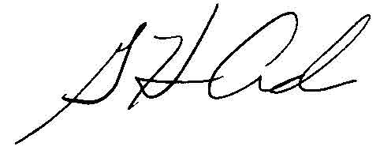  G. Harris Adams,  Interim Director | THE PUBLIC UTILITIES COMMISSION  OF THE STATE OF COLORADO  MEGAN M. GILMAN  ________________________________  Hearing Commissioner

Colorado Environmental Justice Action Task Force, Final Report of Recommendations [Final Report] (November 14, 2022), available at https://www.dora.state.co.us/pls/efi/EFI.Show_Filing?p_fil=G_796552&p_session_id=.
See, e.g., Summary of Work Plan Workshop Discussions (October-November 2022) at 6, filed November 14, 2022.
Final Report at 31.
See: https://cdphe.colorado.gov/enviroscreen.
§ 24-4-109(2)(b)(II), C.R.S.
A census block group is smaller than a census tract.
Final Report at 31, fn. 5.
Final Report at 30.
Final Report at 32.
Available at https://teeo-cdphe.shinyapps.io/COEnviroScreen_English/ (last visited December 7, 2022).
Available at https://teeo-cdphe.shinyapps.io/COEnviroScreen_English/ (last visited December 7, 2022).
Final Report at 30-31.
Colorado EnviroScreen v. 1.0 Technical Documentation (June 2022) 15, available at https://drive.google.com/file/d/1aZfZnLeEPxvpFBILOFGpYGKLQbDxhMMF/view.
Final Report at 31.
EJ Program Presentation to the EJATF (November 9, 2022), slide 20, available at https://drive.google.com/drive/folders/1botPhknzZpjK9R8a8NfGZPEFwu8dbPWC.
Available at https://teeo-cdphe.shinyapps.io/COEnviroScreen_English/ (last visited December 7, 2022).
Available at: https://docs.google.com/forms/d/e/1FAIpQLSe8o_Uh3OiAEN6RTGs0b7YEfLpjv3boUAnFCpz8a-PjzDN4yQ/viewform.
For purposes of this analysis, please only use 200 percent federal poverty level.
See footnote 7.
§ 40-2-124(1)(e)(IV), C.R.S.
§ 40-3.2-108(4)(c)(V), C.R.S.
§ 40-2-108(c)(I), C.R.S.
§ 40-2-108(c)(I), C.R.S.

