Decision No. R20-0379-I
BEFORE THE PUBLIC UTILITIES COMMISSION OF THE STATE OF COLORADO
PROCEEDING NO. 19AL-0687E
IN THE MATTER OF ADVICE LETTER NO. 1814 filed by PUBLIC SERVICE COMPANY OF COLORADO TO implement the modified residential
energy time-of-use schedule to become effective january 2, 2020.
interim decision OF
ADMINISTRATIVE LAW JUDGE
CONOR F. FARLEY
CONVERTING IN-PERSON HEARING
INTO REMOTE HEARING, scheduling
prehearing conference, AND PROVIDING INSTRUCTIONS FOR PARTICIPATing REMOTELY
Mailed Date: May 20, 2020

TABLE OF CONTENTS
I. BY THE COMMISSION 2
A. Statement 2
B. Impact of Subsequent Developments on Hearings 2
C. Instructions for Participating in Remote Hearing 3
1. Instructions for Participating by Telephone 4
2. Instructions for Participating by Computer 5
3. Instructions for Observing the Remote Hearing 10
D. Remote Prehearing Conference 11
II. ORDER 11
A. It Is Ordered That: 11

BY THE COMMISSION

Statement
- A more comprehensive summary of the background of this proceeding is included in Decision Nos. C19-1015 and R20-0202-I. The facts relevant to this Decision are stated below.
- On February 21, 2020, the undersigned Administrative Law Judge (ALJ) issued Decision No. R20-0121-I that, among other things, scheduled an in-person hearing for June 16 through 19, 2020. Decision No. R20-0121-I also scheduled in-person public comment hearings for April 8, 2020 in Grand Junction and April 16, 2020 in Denver, Colorado.
- On March 27, 2020, the ALJ issued Decision No. R20-0202-I that consolidated the public comment hearings, converted the consolidated public comment hearing into a remote public comment hearing scheduled for April 16, 2020, and provided instructions for participating in that remote public comment hearing.
- On April 10, 2020, the ALJ issued Decision No. R20-0243-I that included revised instructions for participating in the consolidated public comment hearing by computer or telephone.

Impact of Subsequent Developments on Hearings
- On March 10, 2020, Colorado Governor Jared Polis declared a state of emergency over the novel coronavirus pandemic (COVID-19). Since then, Colorado State government and the Commission have been working diligently to address how to safely and effectively manage the challenges presented by COVID-19. These efforts have focused on limiting the disruption to the services delivered by the Commission (and other State agencies), while attempting to mitigate the risks to State employees and the public. For example, the Commission has been conducting its Weekly Meetings remotely, and the Commission has asked members of the public not to attend meetings in person, but to view them by webcast. Finally, public access to the building containing the Commission’s offices and hearing rooms has been restricted and it is unclear when the restriction will be lifted.
- Under these circumstances, the hearing scheduled for June 16 through 19, 2020 shall be converted into a remote hearing in which the participants will appear from remote locations, as provided below. The ALJ finds that holding a remote hearing is consistent with current public health advisories to prevent the spread of COVID-19. The ALJ concludes that it is in the parties’ and the public interest to hold the hearing in this proceeding as a remote hearing.

Instructions for Participating in Remote Hearing
- The Commission uses the web-hosted video conferencing service, GoToMeeting, to hold video conferences, and in this case, a remote hearing. Parties and witnesses may participate in the remote hearing by computer, or telephone. Attending the hearing by computer allows for video-conference participation in the hearing. Participating by video-conference allows parties wishing to present evidence to display exhibits on the video-conference screen and allows others participating by video-conference to view the displayed exhibits as they are presented in a manner most similar to that which occurs during in-person hearings.
- The ALJ strongly encourages all parties and witnesses to participate in the hearing using a computer, especially any party wishing to present documents for consideration during the hearing. Parties joining the hearing by telephone may view exhibits by either providing an email address where the exhibits may be sent at the time of the hearing, or by accessing the exhibits within the administrative record for this proceeding through the Commission’s free E-Filing System. Parties may register for the Commission’s E-Filing System at no charge at the following website: https://www.dora.state.co.us/pls/efi/EFI.homepage.
- The following are general instructions for how to participate by telephone or by computer. Additional information and tutorials for using GoToMeeting are available at:
https://www.gotomeeting.com/meeting/resources/gotomeeting-quick-and-helpful-guide-for-attendees.

These links are only provided for convenience and are not intended to guarantee that the information on the link is accurate or that it provides all the information the parties may need to use GoToMeeting. Those parties and individuals who plan to participate in the remote hearing by computer are strongly advised to familiarize themselves with GoToMeeting before the hearing.

Instructions for Participating by Telephone
- The ALJ will send an email to the parties and their counsel containing the call-in information (telephone number and the Meeting ID/Access code). The parties, their counsel, and witnesses who will participate by telephone during the remote hearing must call the phone number included in the email when the hearing takes place. When prompted, the parties, their counsel, and witnesses must input the Meeting ID/Access Code to join the hearing.

Instructions for Participating by Computer
- The email noted above that will be sent by the ALJ will also contain the URL necessary to participate in the hearing by computer. Any party, counsel, or witnesses who wish to participate in the remote hearing by computer must use a computer that is connected to the internet and has a microphone and a speaker. At the time of the hearing, please input the URL included in the email sent by the ALJ and the webpage below will appear.
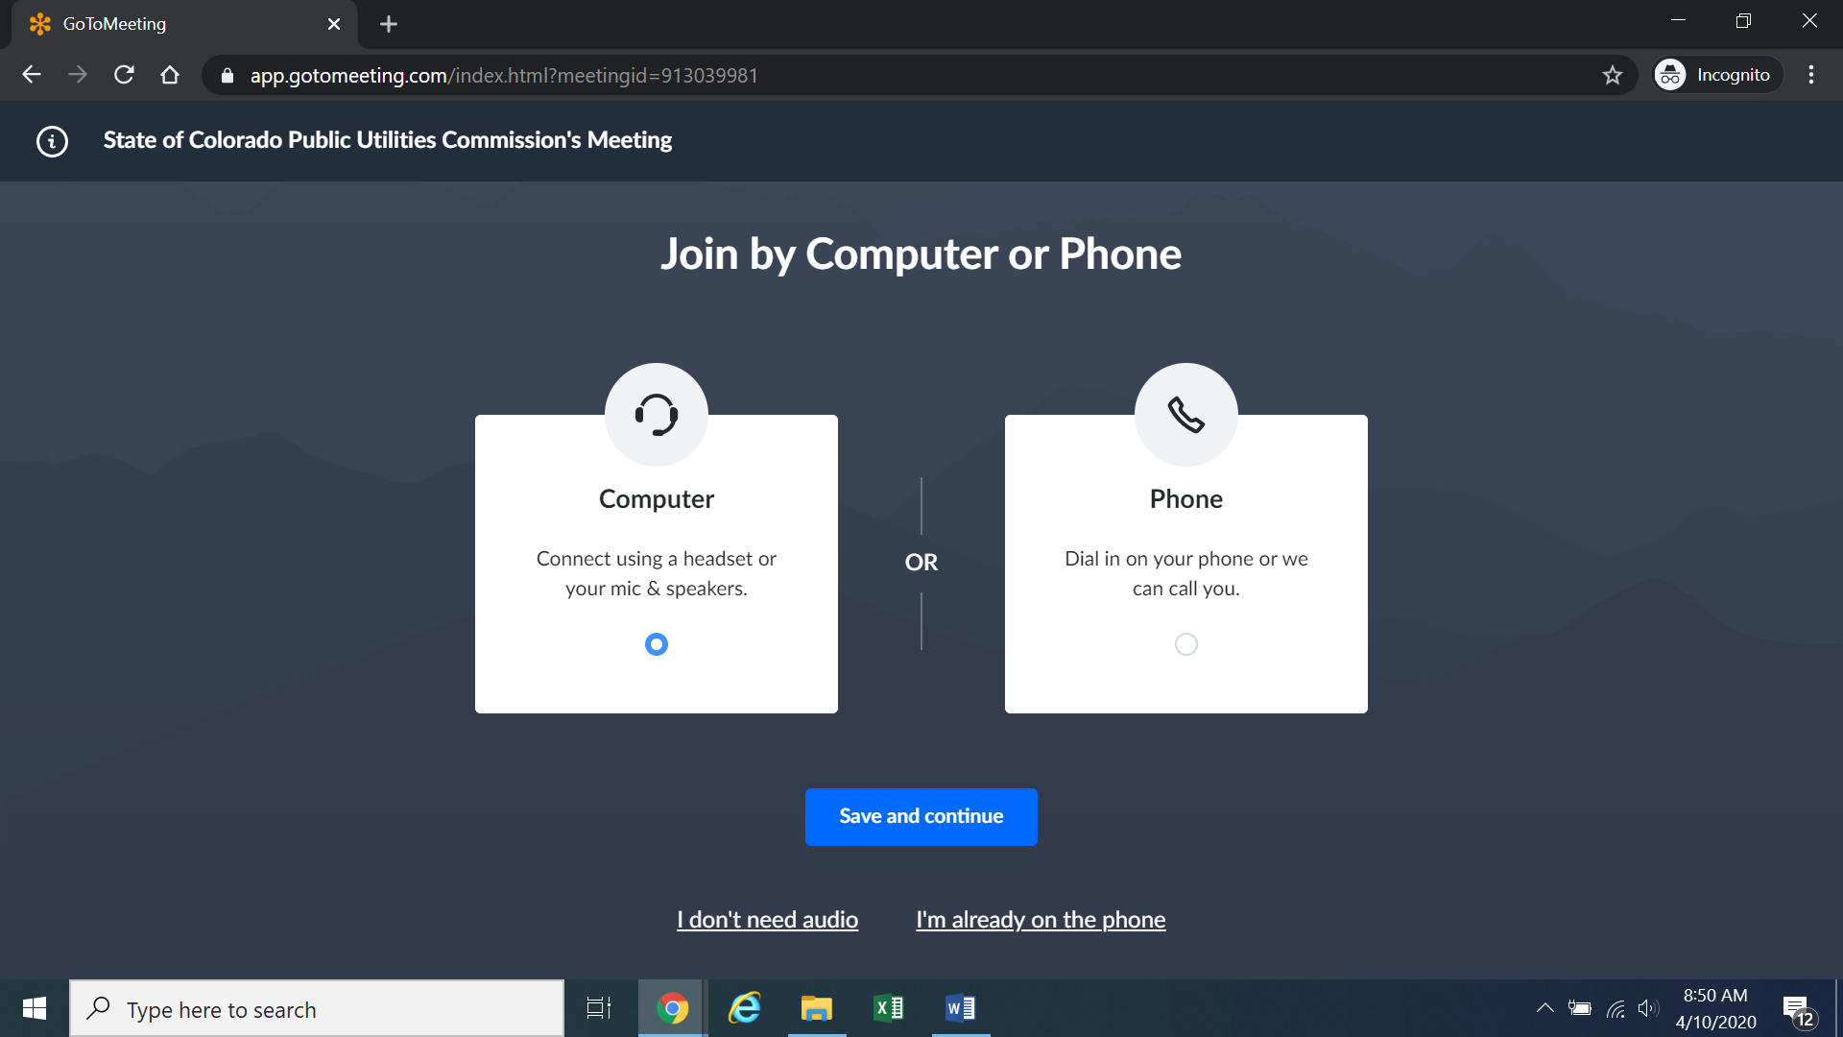
Confirm your audio settings and click “Save and continue.” Note: You may be prompted to allow the session to access your microphone and/or camera. Finally, you will be prompted to enter your name for identification during the session:
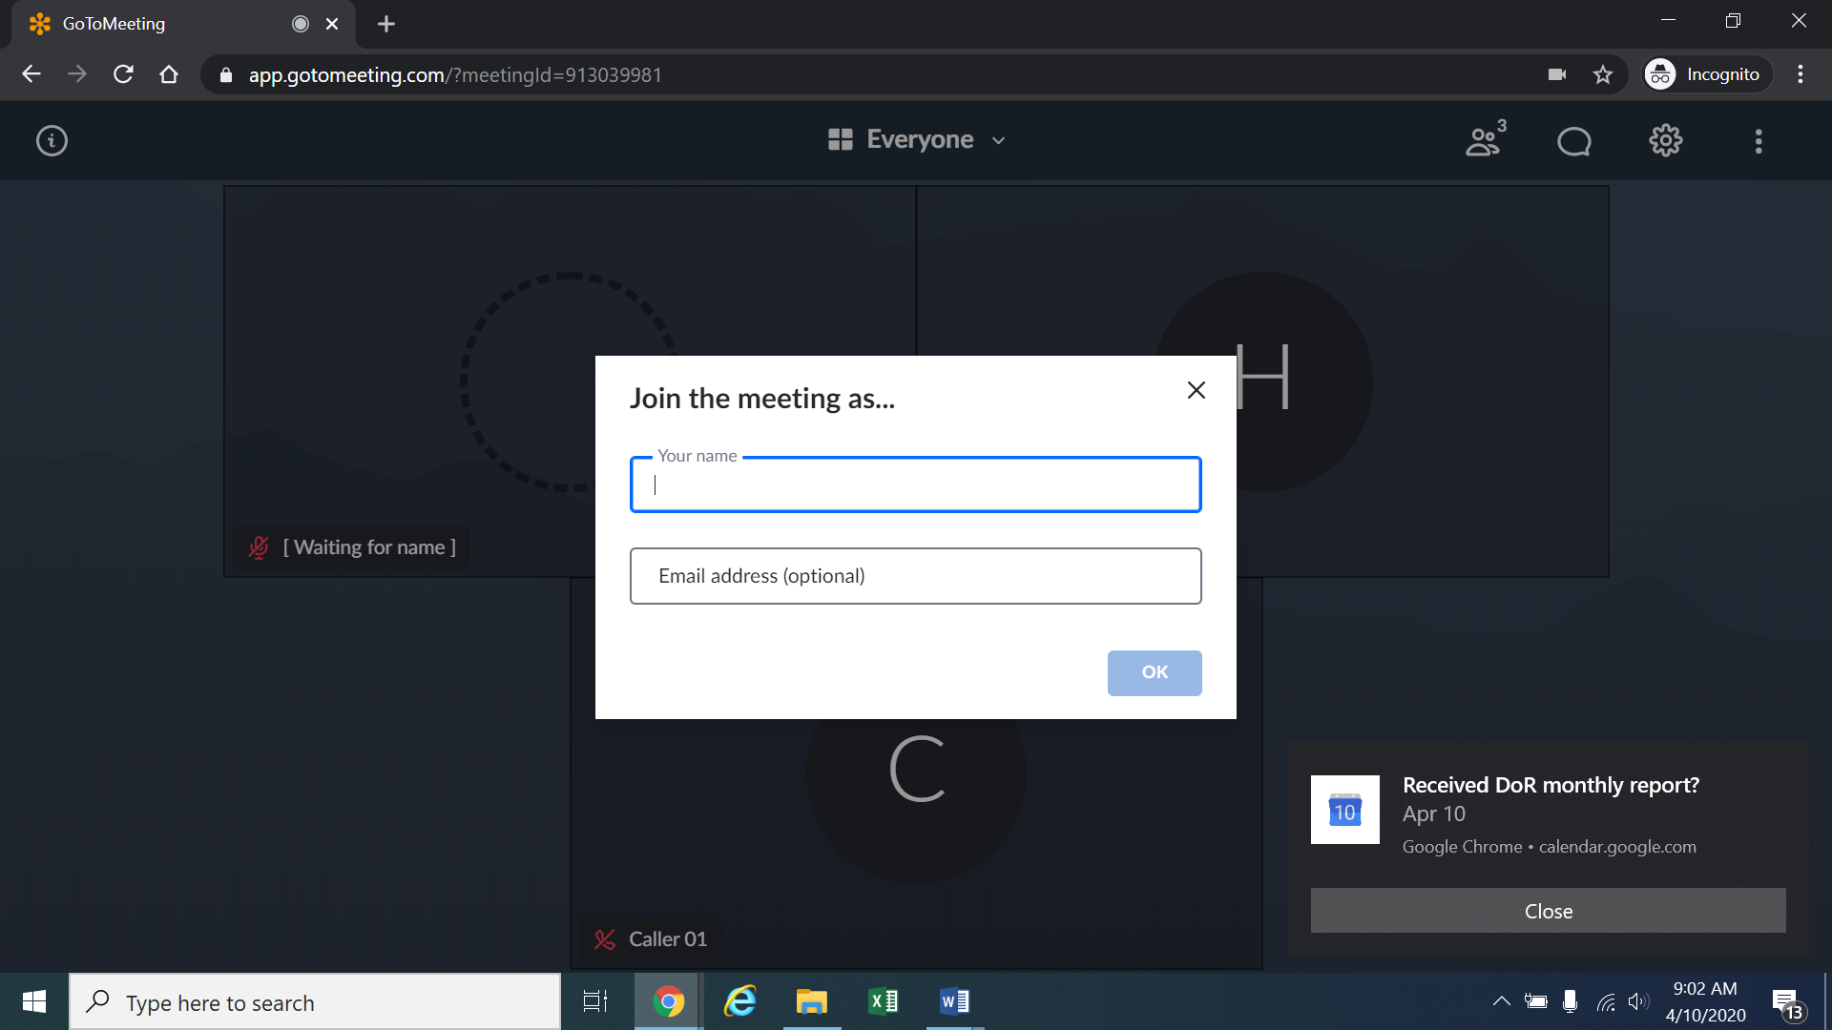
Alternatively, if there is any problem with the link provided above, please go to https://app.gotomeeting.com/home.html and enter the nine-digit Meeting ID/Access Code included in the email.
- If you do not want others participating in the hearing to see you, please click on the camera icon contained in the green circle at the bottom of the video screen. The icon will turn white and a slash will be placed over the camera icon indicating that your camera has been turned off. Likewise, if you do not want others participating in the hearing to hear you, confirm that there is a slash over the microphone icon contained in the red circle indicating that your
- microphone has been turned off. In the screenshot of the webpage below, the microphone is turned off while the camera is turned on:
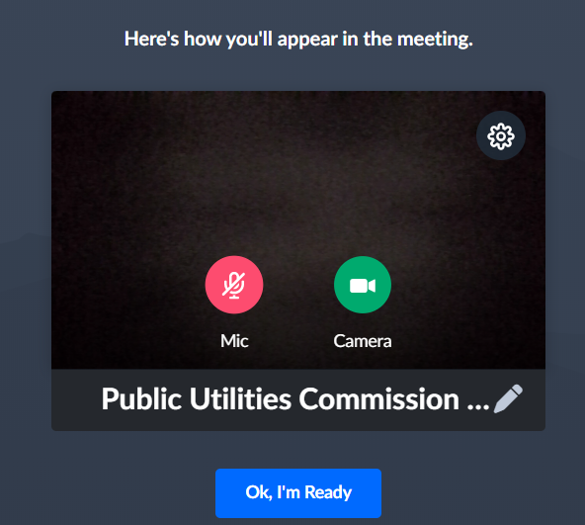
Conversely, the screenshot of the webpage below shows the microphone and video icons turned on and are ready to transmit video and audio when you join the hearing.
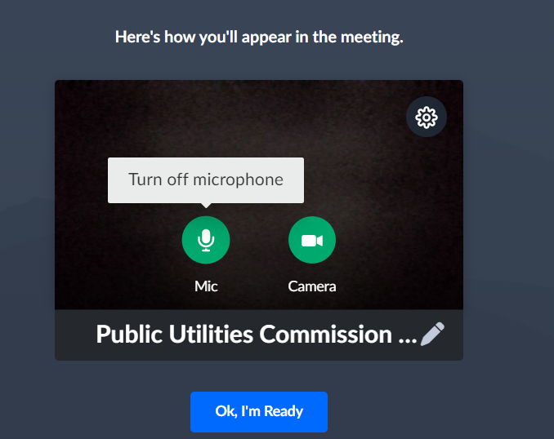
You can control the volume of the audio through the volume controls on your computer. The screenshot below shows the screen after joining the hearing with the camera turned on and the microphone turned off.
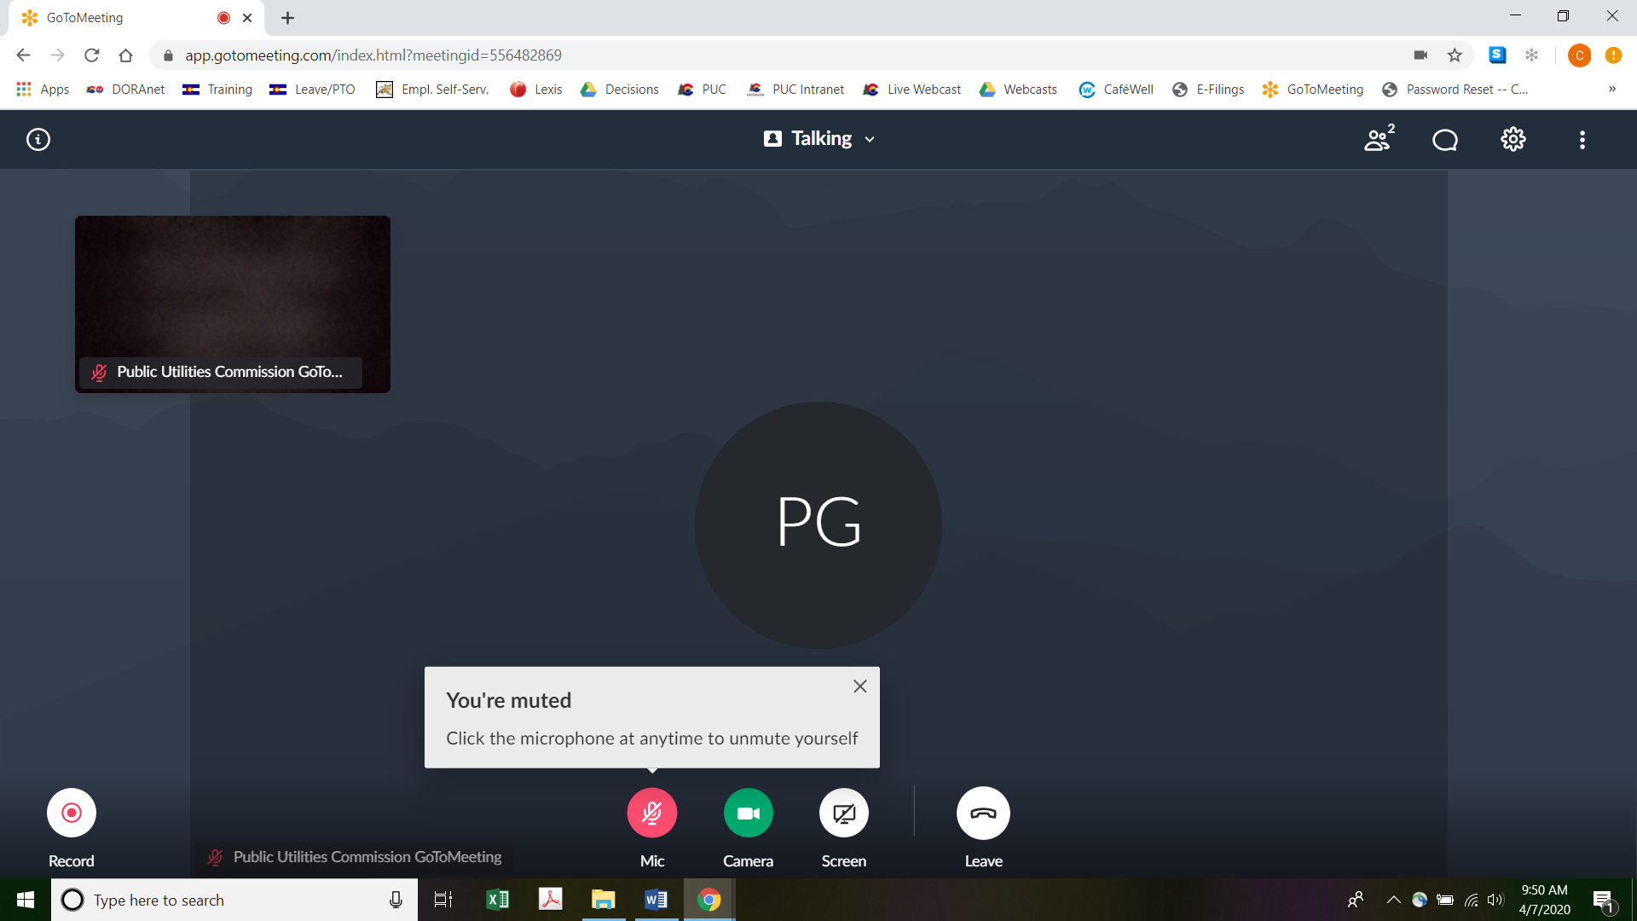
- All participants in the hearing should mute (turn off) their microphones during the hearing until called upon by the ALJ. When prompted by the ALJ, please click on the microphone icon to turn on your microphone and then commence speaking. The red circle around the microphone icon will turn green indicating that your microphone is turned on. While you are speaking, please listen for any direction you are given by the ALJ.
- To terminate your participation in the hearing, please click on the telephone handset icon with the word “Leave” underneath it and then click the “Yes” button in the pop-up box, or the “Not now” button if you would like to stay in the meeting, as shown in the screenshots below.
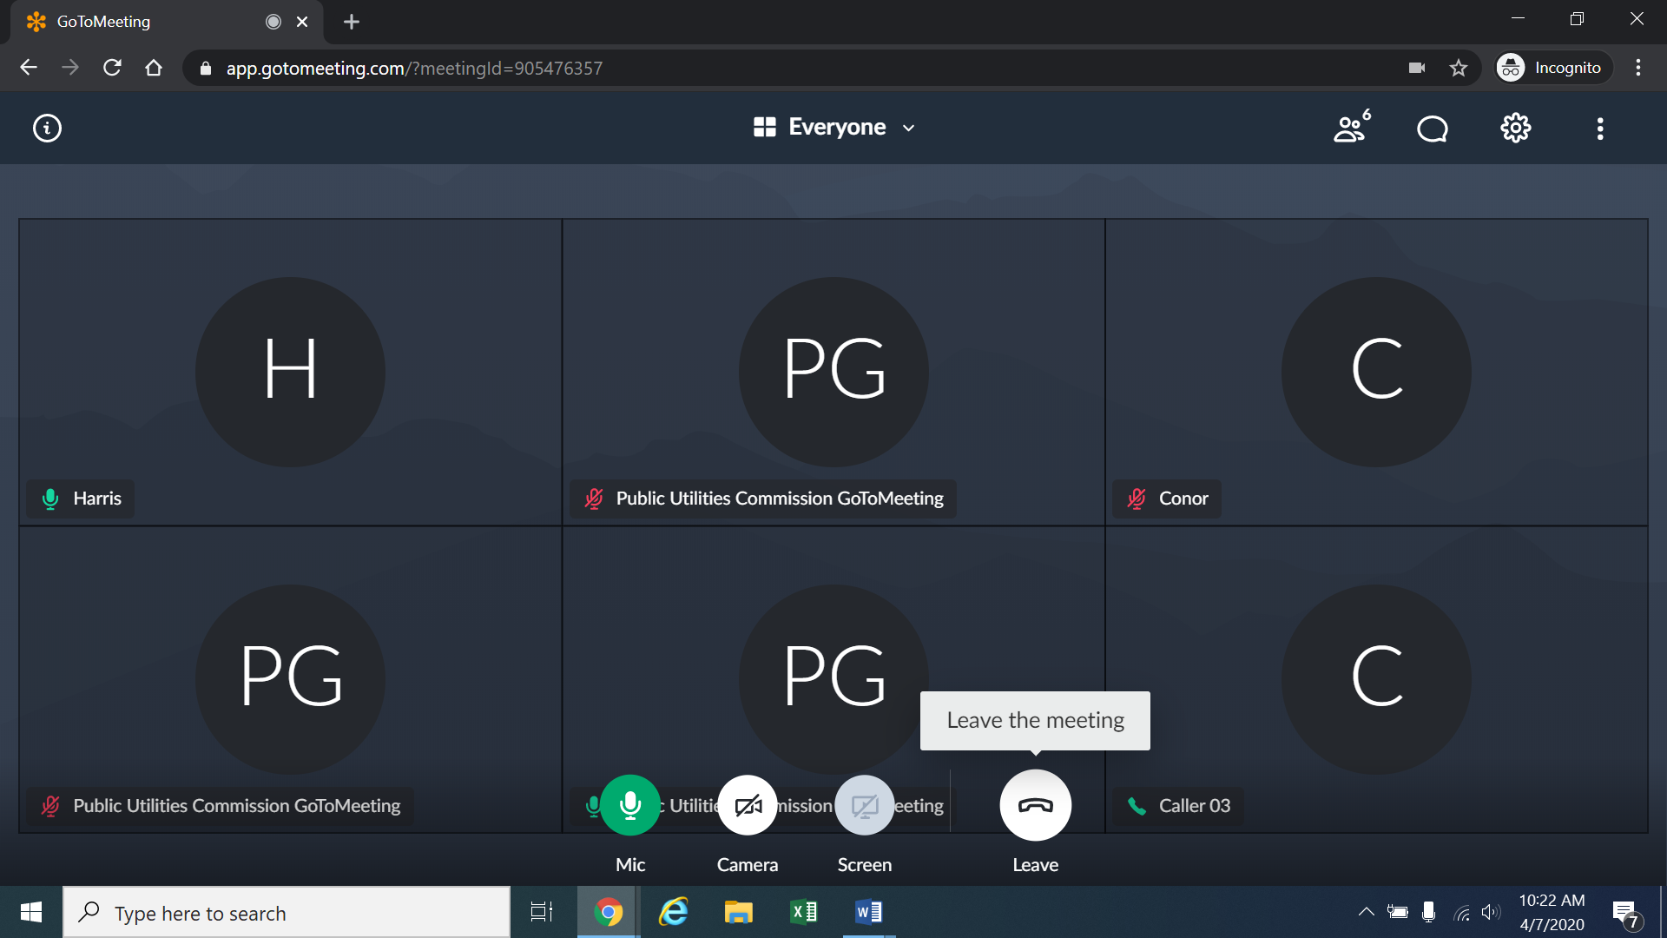
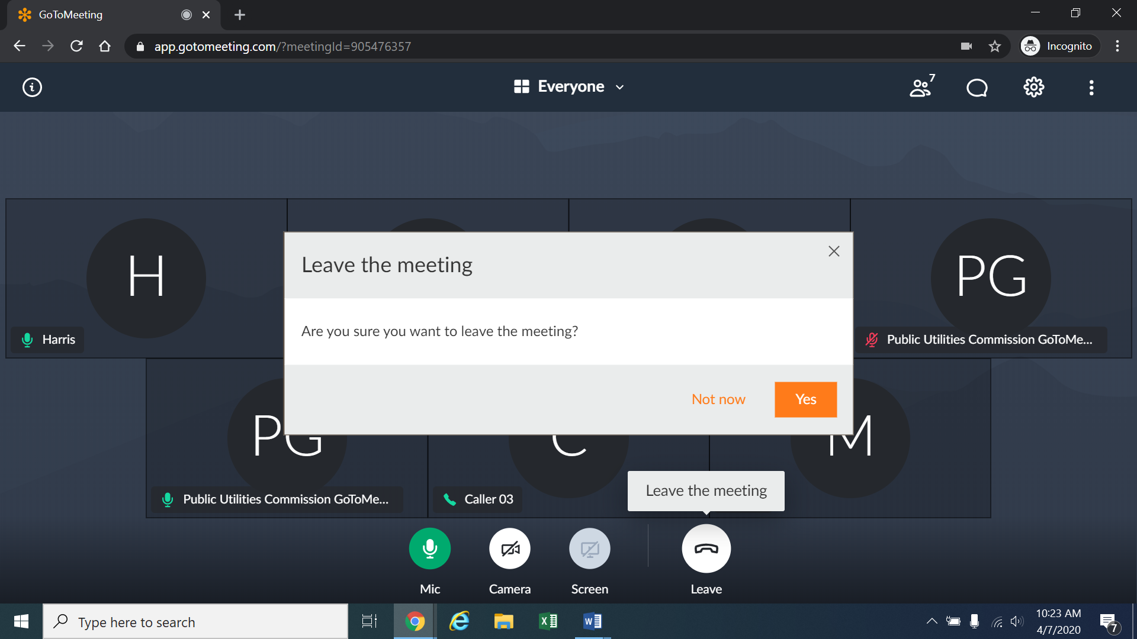

Instructions for Observing the Remote Hearing
- If you will not participate in the hearing as a party or witness, but would like to listen to the remote hearing, please do not participate by telephone or computer as described above. Rather, please go to https://puc.colorado.gov/webcasts. The following webpage will appear.
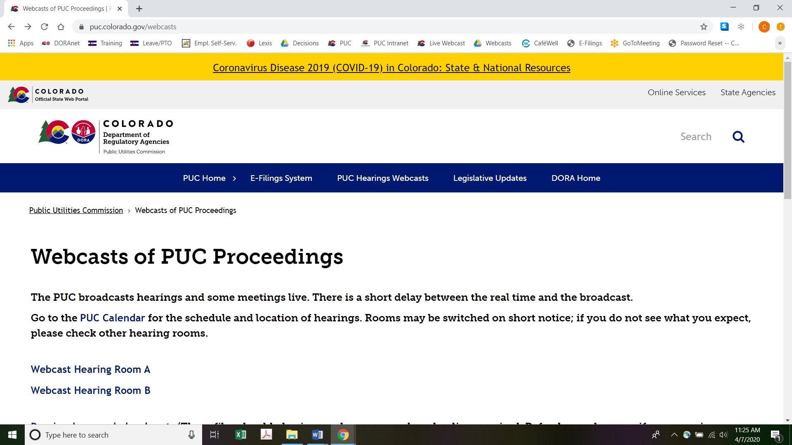
Please select the hearing room (“Webcast Hearing Room A” or “Webcast Hearing Room B”) listed for the remote hearing on the Commission’s public calendar, available at https://puc.colorado.gov/puccalendar. Once the hearing room is selected, please click one of the “audio only” links (e.g., “Hearing Room A Audio Only (IOS)” or “Hearing Room A Audio Only (Android/Other)”), or click the play button on the black screen, to stream audio of the hearing live (with a short delay between real time and the broadcast, as noted in the screenshot above).

Remote Prehearing Conference
- A remote prehearing conference is scheduled for June 12, 2020 at 10:30 a.m. The ALJ will send the call-in information (telephone number and the Meeting ID/Access code) and the URL by email to the parties and their counsel.

ORDER

It Is Ordered That:
- The hearing scheduled for June 16 through 19, 2020 shall be converted into a remote hearing. The parties and witnesses of the public must follow the instructions stated above and the information that will be provided by the Administrative Law Judge by email to the parties and their counsel. The parties, witnesses, and members of the public should not attend the remote hearing in-person.
- A remote prehearing conference is scheduled as follows:
DATE: June 12, 2020
TIME: 10:30 a.m.
FOR WEBCASTS: Hearing Room A
METHOD: Join by video conference at the link to be provided by the email from the Administrative Law Judge, OR

Join by telephone: Dial the telephone number provided in the email, and when prompted, enter the PIN (or Meeting ID) in the email.
- The parties, witnesses, and members of the public should not attend the remote prehearing conference in-person.
- This Decision is effective immediately.

(S E A L)    ATTEST: A TRUE COPY  Doug Dean,  Director | THE PUBLIC UTILITIES COMMISSION  OF THE STATE OF COLORADO  CONOR F. FARLEY  ________________________________  Administrative Law Judge

Decision No. C19-1015 was issued in this proceeding on December 18, 2019.
To minimize audio feedback, you are encouraged to listen using headphones connected to the audio/headset jack on your computer.

