BEFORE THE PUBLIC UTILITIES COMMISSION OF THE STATE OF COLORADO
PROCEEDING NO. 20A-0089CP
IN THE MATTER OF THE APPLICATION OF powderhorn pacific LLC FOR A CERTIFICATE OF PUBLIC CONVENIENCE AND NECESSITY TO OPERATE AS A COMMON CARRIER BY MOTOR VEHICLE FOR HIRE.
ATTACHMENT A
REQUIREMENTS AND INFORMATION
ON USING GOTOMEETING TO ATTEND HEARING
______________________________________________________________________________
- This Attachment is intended to direct the parties on certain aspects of their participation in the scheduled remote evidentiary hearing in this matter using GoToMeeting, and to provide information which will aid parties in doing so. This is not intended to provide full and complete instructions on how to use GoToMeeting to participate in a hearing. Parties are responsible for ensuring they have familiarized themselves with GoToMeeting and are able to use it for the hearing.
- Participants in a GoToMeeting hearing by video-conference should use a computer connected to the internet with an operational microphone and a speaker. To participate by computer, at the date and time of the hearing, participants must enter the link provided to them for the GoToMeeting hearing in their internet browser.
- Participants will then be taken to the screen where they may join the hearing. Parties should select the computer option, as shown in the below image.
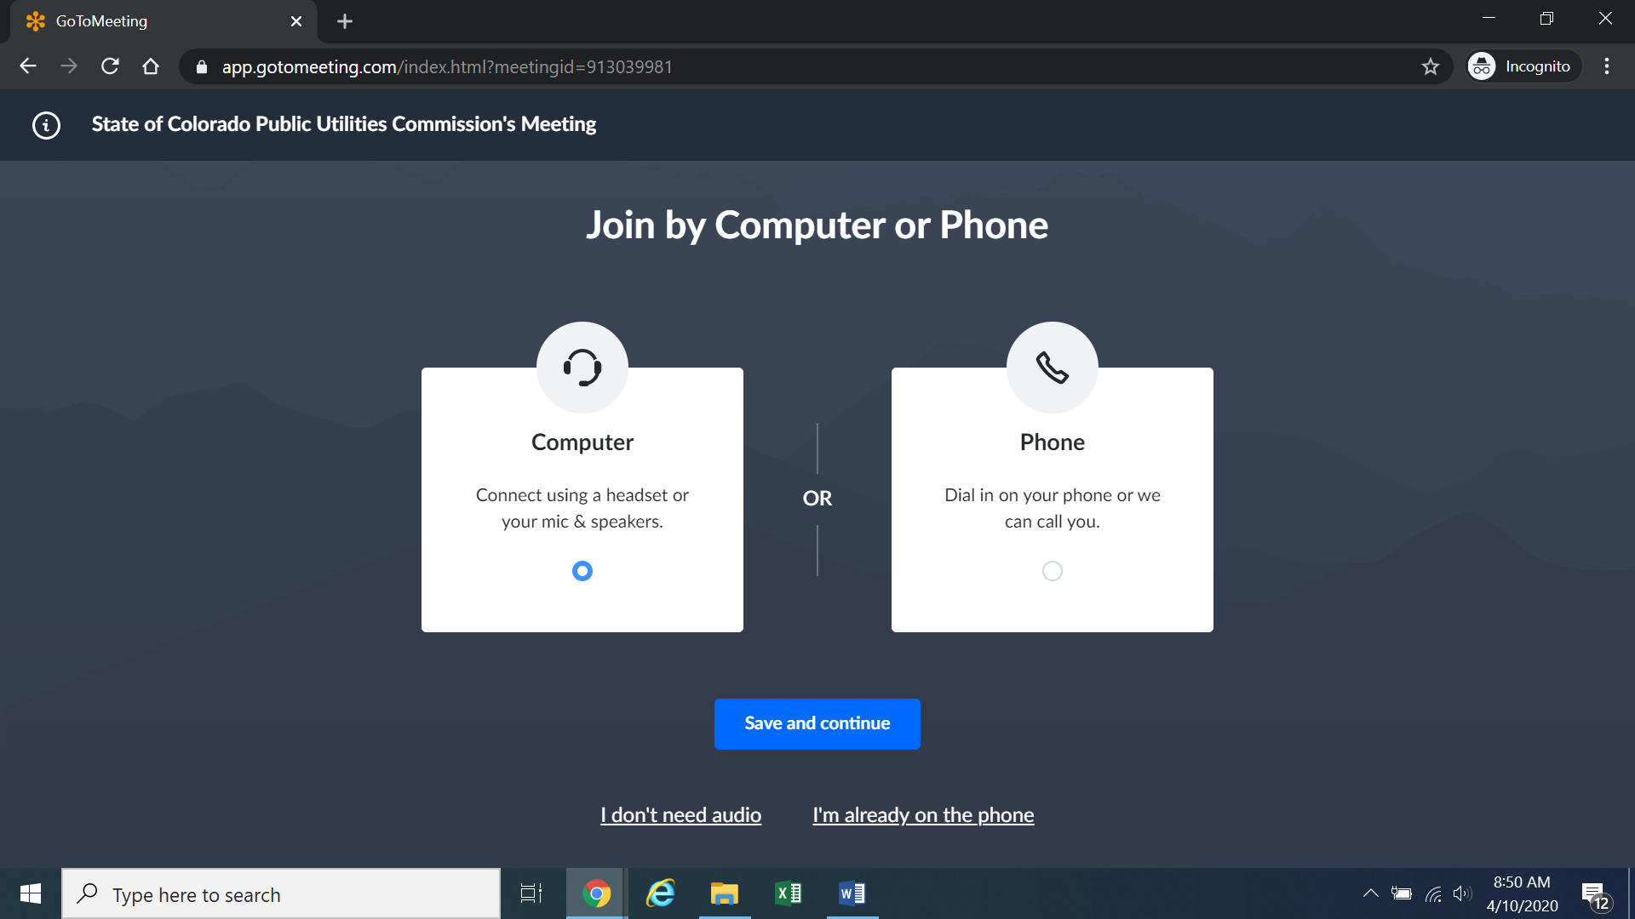
- Participants will then be required to confirm their audio settings; once done, participants should select the “Save and continue” icon. If participants are prompted to allow the session to access their computers’ microphone and camera, they should allow access. As explained later, participants will be able to modify their settings should they wish to turn off their cameras.

- Participants will be prompted to enter their name for identification during the session, as shown in the image below.
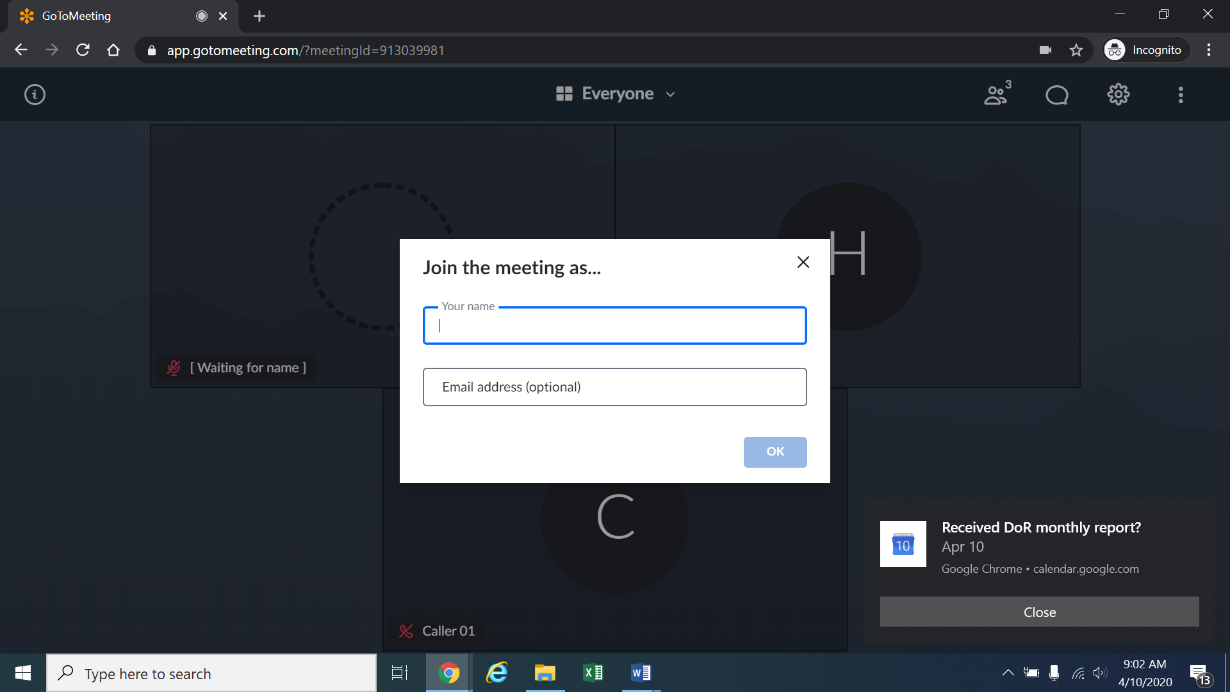
- All participants must enter their full first and last name. Among other reasons, this is required because the Administrative Law Judge (ALJ) will lock down the meeting once all parties have joined to minimize the potential that the meeting may be disrupted by
non-participants. The ALJ will unlock the hearing when witnesses are called to testify so that they may call or join GoToMeeting only when needed to testify.
- It is preferred that witnesses allow their image to be displayed while testifying. Participants who do not want their image displayed during the hearing may select the camera icon in the green circle at the bottom of the video screen at any point. A slash will appear over the camera icon, indicating that the camera has been turned off. Likewise, to mute or turn off the microphone, select the microphone icon and visually confirm that there is a slash over the microphone icon. Illustratively, the below image shows the microphone turned off and the camera turned on.
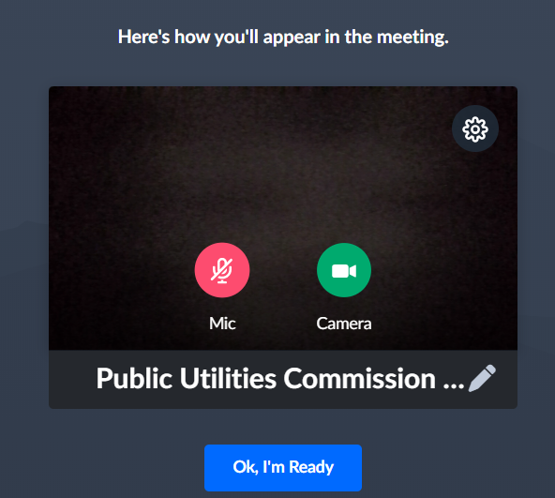
- Conversely, the below image shows the microphone and camera icons turned on and ready to transmit video and audio upon joining the hearing.
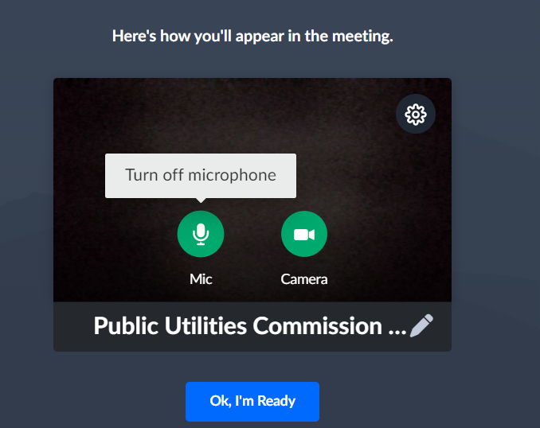
- Participants may control the audio volume using their computer’s audio controls. A court reporter will be participating in the evidentiary hearing to make a record of the hearing; to facilitate this, participants are required to take steps to minimize feedback and background noise. Whether participating by telephone or computer, all participants are required to mute their microphones during the hearing until called upon by the ALJ. When prompted by the ALJ, participants should unmute their microphone before beginning to speak. In addition, those participating by telephone may not use the speaker-phone function, as this creates feedback that makes it difficult to hear. All participants must ensure that they are in a location with minimal or no background noise while participating in the hearing. This will help minimize background noise when particpants are speaking.
- To terminate participation in the hearing, select the telephone handset icon with the word “Leave” underneath it and then select “Yes” in the pop-up box, as shown below. A party who inadvertently selects the handset icon may select “Not now” instead of “Yes” to stay in the meeting, as shown below.

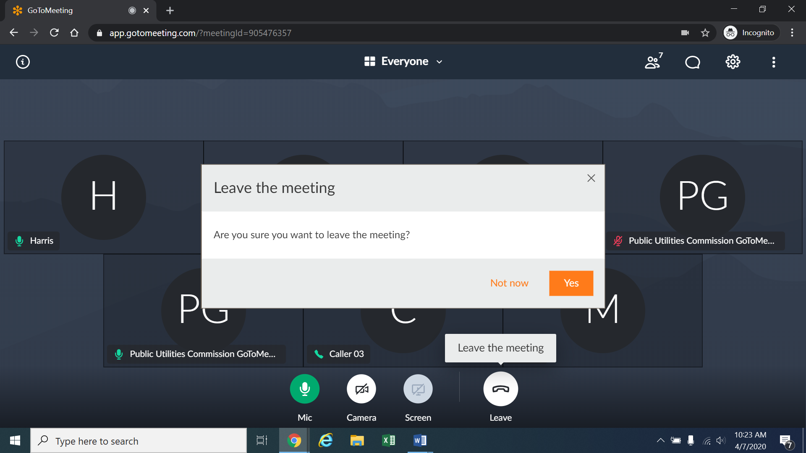
- Additional information and tutorials on using GoToMeeting are available at:
https://www.gotomeeting.com/meeting/resources/gotomeeting-quick-and-helpful-guide-for-attendees.

This link is provided for the parties’ convenience; the ALJ does not warrant that the information on the link is accurate or that it provides all the information participants may need to use GoToMeeting.
12. This Attachment does not include instructions on how to present exhibits using GoToMeeting. The parties are encouraged to review tutorials about presenting documents using GoToMeeting, and are responsible for ensuring they are able to do so.
13. The ALJ may reach out to the parties informally via email approximately one week before the hearing to perform a test run using GoToMeeting with the parties, including presenting exhibits. As such, the parties should be fully prepared to use GoToMeeting by that time.

These instructions are not directed at using a tablet or smartphone to participate in a GoToMeeting video-conference.
If there is any problem with the link provided in the Decision scheduling the hearing, participants should enter: https://app.gotomeeting.com/home.html in their browser, and input the nine-digit access or ID code in the Decision scheduling the hearing.
To minimize audio feedback, participants are encouraged to listen using headphones connected to their computers or telephones.

