Decision No. R20-0355-I
BEFORE THE PUBLIC UTILITIES COMMISSION OF THE STATE OF COLORADO
PROCEEDING NO. 19F-0620E
la plata electric association, inc.,
complainant,
v.
tri-state generation and transmission association, inc.,
respondent.
PROCEEDING NO. 19F-0621E
UNITED POWER, INC.,

COMPLAINANT,

V.

TRI-STATE GENERATION AND TRANSMISSION ASSOCIATION, INC.,
RESPONDENT.
interim DECISION of
administrative law judge
robert i. garvey
CONVERTING IN-PERSON HEARING
INTO REMOTE HEARING and
PROVIDING INSTRUCTIONS
FOR HOW TO PARTICIPATE REMOTELY
Mailed Date: May 8, 2020

TABLE OF CONTENTS
I. STATEMENT 2
A. Background 2
B. Impact of Subsequent Developments on Hearings 3
C. Instructions for Participating in Remote Hearing 4
1. Instructions for Participating by Telephone 5
2. Instructions for Participating by Computer 5
3. Instructions for Observing the Remote Hearing 11
II. ORDER 12
A. It Is Ordered That: 12

STATEMENT

Background
- La Plata Electric Association, Inc. and United Power, Inc. (United Power) (collectively, Complainants) filed these formal complaints against Tri-State Generation and Transmission Association, Inc. on November 5 and 6, 2019, respectively, requesting that this Commission determine a just, reasonable, and non-discriminatory exit charge for Complainants. On November 25, 2019, by Decision No. C19-0955-I, the Commission consolidated the complaints in Proceeding Nos. 19F-0620E and 19F-0621E and designated Commissioner Frances Koncilja as the Hearing Commissioner.
- The procedural history of this proceeding is set out in previous Decisions and is repeated here as necessary to put this Decision in context.
- Commissioner Koncilja’s term expired in January 2020. She was asked and agreed to continue to serve until a new commissioner was appointed and confirmed in her stead. A new Commissioner was sworn in on March 13, 2020.
- On March 13, 2020, by Decision No. R20-0175-I, the evidentiary hearing in this proceeding, scheduled for March 23 to March 27, 2020, was suspended and the proceeding returned to the Commission en banc.
- On March 23, 2020, United Power filed its Notice of After-Decided Authority and Request for Video or Telephonic Status Conference.
- On March 25, 2020, by Decision No. C20-0201-I, the Commission referred the matter to an Administrative Law Judge.
- On April 3, 2020, by Decision No. R20-0218-I, a status conference was scheduled for April 14, 2020.
- At the status conference, dates for an evidentiary hearing and post hearing statements of position were agreed to by the parties.

Impact of Subsequent Developments on Hearings
- On March 10, 2020, Colorado Governor Jared Polis declared a state of emergency over the novel coronavirus pandemic (COVID-19). Since then, Colorado State government and the Commission have been working diligently to address how to safely and effectively manage the challenges presented by COVID-19. These efforts have focused on limiting the disruption to the services delivered by the Commission (and other State agencies), while attempting to mitigate the risks to State employees and the public. For example, the Commission has been conducting its Weekly Meetings remotely, and the Commission has asked members of the public not to attend meetings in person, but to view them by webcast. More recently, public access to
- the building containing the Commission’s offices and hearing rooms has been restricted and it is unclear when the restriction will be lifted.
- Under these circumstances, the hearing scheduled for the week of May 18, 2020 shall be converted into a remote hearing in which the participants will appear from remote locations, as provided below. The ALJ finds that holding a remote hearing is consistent with current public health advisories to prevent the spread of COVID-19. The ALJ concludes that it is in the parties’ and the public interest to hold the hearing in this proceeding as a remote hearing.

Instructions for Participating in Remote Hearing
- The Commission uses the web-hosted video conferencing service, GoToMeeting, to hold video conferences, and in this case, a remote hearing. Parties and witnesses may participate in the remote hearing by computer, or telephone. Attending the hearing by computer allows for video-conference participation in the hearing. Participating by video-conference allows parties wishing to present evidence to display exhibits on the video-conference screen and allows others participating by video-conference to view the displayed exhibits as they are presented in a manner most similar to that which occurs during in-person hearings.
- The ALJ strongly encourages all parties and witnesses to participate in the hearing using a computer, especially any party wishing to present documents for consideration during the hearing. Parties joining the hearing by telephone may view exhibits by accessing the exhibits within the administrative record for this proceeding through the Commission’s free E-Filing
- System. Parties may register for the Commission’s E-Filing System at no charge at the following website: https://www.dora.state.co.us/pls/efi/EFI.homepage.
- The following are general instructions for how to participate by telephone or by computer. Additional information and tutorials for using GoToMeeting are available at:
https://www.gotomeeting.com/meeting/resources/gotomeeting-quick-and-helpful-guide-for-attendees.

These links are only provided for convenience and are not intended to guarantee that the information on the link is accurate or that it provides all the information the parties may need in order to use GoToMeeting. Those parties and individuals who plan to participate in the remote hearing by computer are strongly advised to familiarize themselves with GoToMeeting before the hearing.

Instructions for Participating by Telephone
- The parties will be provided a telephone number via email by the ALJ during the week prior to the hearing. Those who intend on participating by telephone during the remote hearing must call the phone number when the hearing takes place. When prompted, input the Meeting ID/Access Code which will also be provided, to join the hearing. The parties are on notice that they are not to share this information with the public, the media, or anyone who will not be participating in the hearing. Instructions for non-participants to listen to the hearing are contained in paragraph 21.

Instructions for Participating by Computer
- Any party who wishes to participate in the remote hearing by computer must use a computer that is connected to the internet and has a microphone and a speaker. At the time of the
- hearing, please go to a link that will be provided to the parties during the week before the hearing. The parties are on notice that they are not to share this link with the public, the media, or anyone who will not be participating in the hearing. Instructions for non-participants to listen to the hearing are contained in paragraph 21.
- The webpage below will appear:
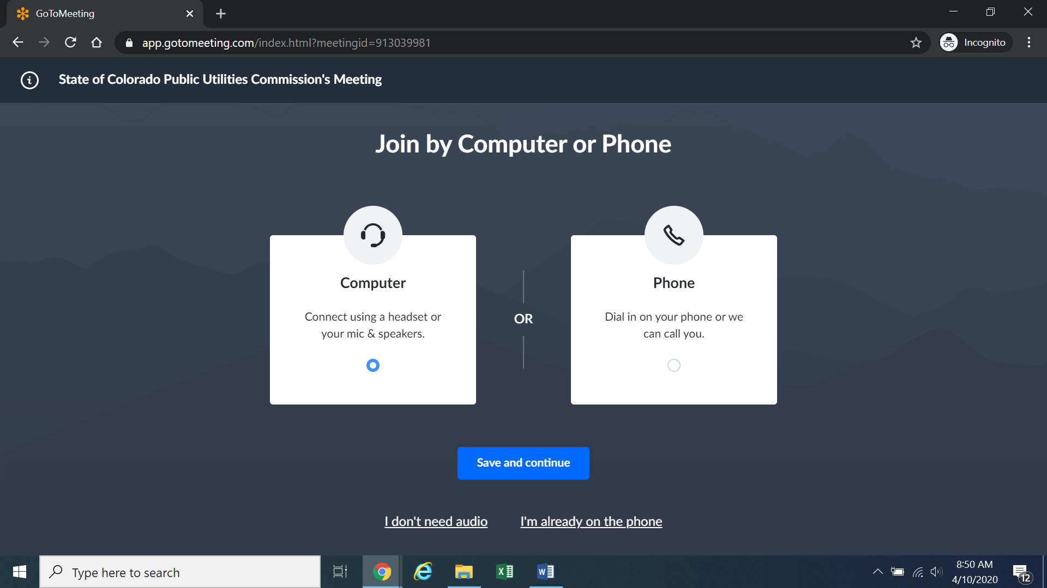
Confirm your audio settings and click “Save and continue.” Note: You may be prompted to allow the session to access your microphone and/or camera. Finally, you will be prompted to enter your name for identification during the session:
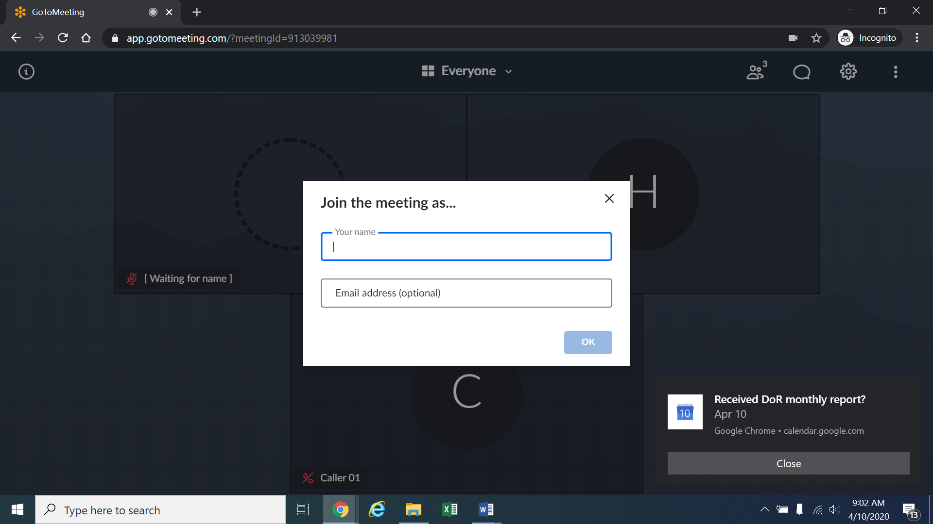
Alternatively, if there is any problem with the link provided above, please go to https://app.gotomeeting.com/home.html and enter the nine-digit Meeting ID/Access Code identified in the email which will be sent the week before the hearing to join the meeting.
- If you do not want others participating in the hearing to see you, please click on the camera icon contained in the green circle at the bottom of the video screen. The icon will turn white and a slash will be placed over the camera icon indicating that your camera has been turned off. Likewise, if you do not want others participating in the hearing to hear you, confirm that there is a slash over the microphone icon contained in the red circle indicating that your
- microphone has been turned off. In the screenshot of the webpage below, the microphone is turned off while the camera is turned on:
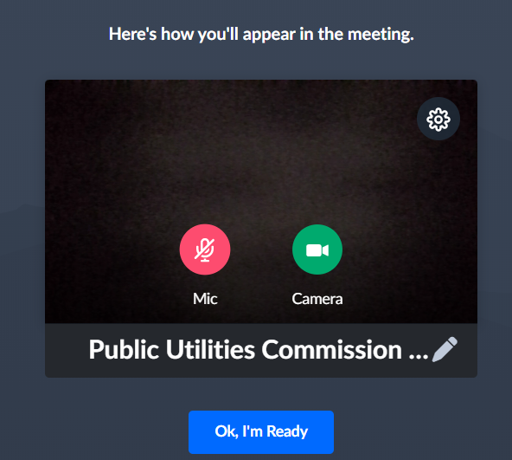
Conversely, the screenshot of the webpage below shows the microphone and video icons turned on and are ready to transmit video and audio when you join the hearing:
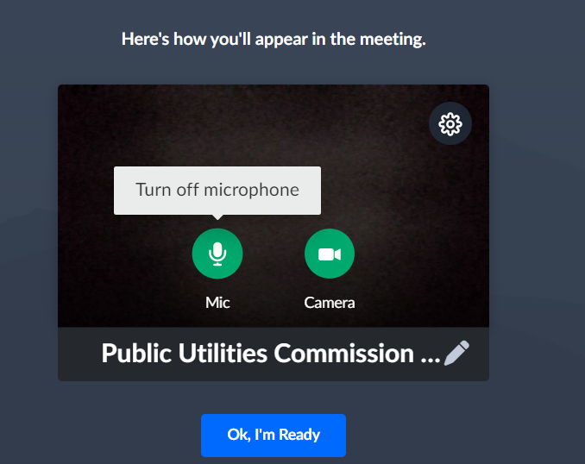
- You can control the volume of the audio through the volume controls on your computer. The screenshot below shows the screen after joining the hearing with the camera turned on and the microphone turned off:
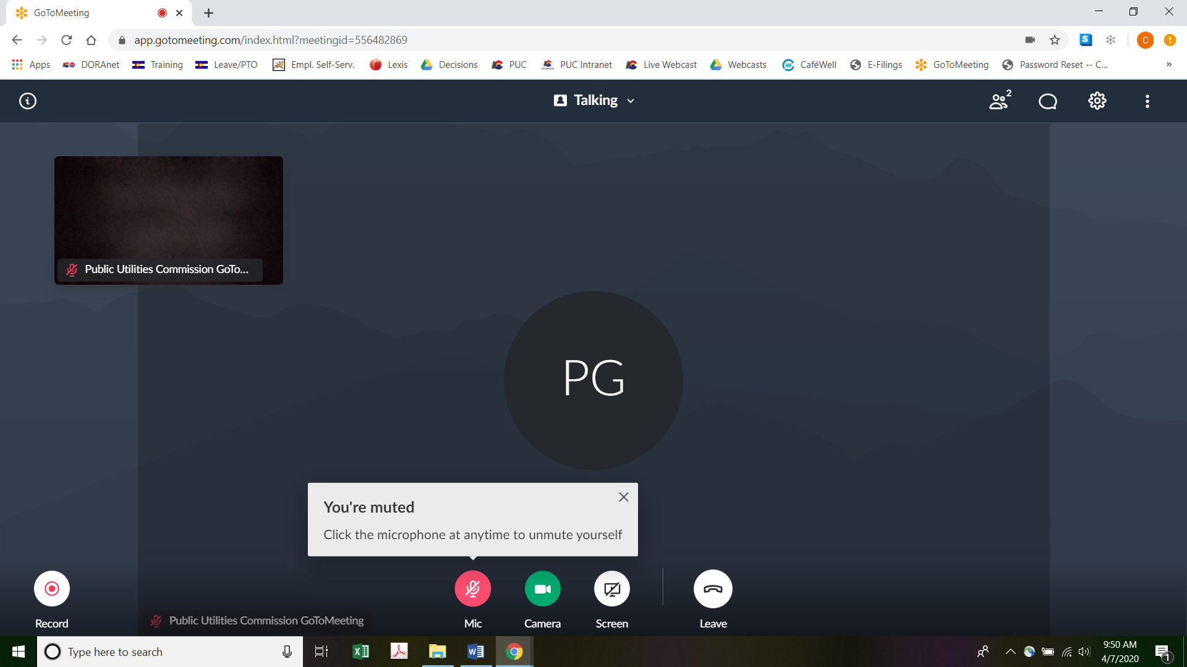
- All participants in the hearing should mute (turn off) their microphones during the hearing until called upon by the ALJ. When prompted by the ALJ, please click on the microphone icon to turn on your microphone and then commence speaking. The red circle around the microphone icon will turn green indicating that your microphone is turned on. While you are speaking, please listen for any direction you are given by the ALJ.
- To terminate your participation in the hearing, please click on the telephone handset icon with the word “Leave” underneath it and then click the “Yes” button in the pop-up box, or the “Not now” button if you would like to stay in the meeting, as shown in the screenshots below:
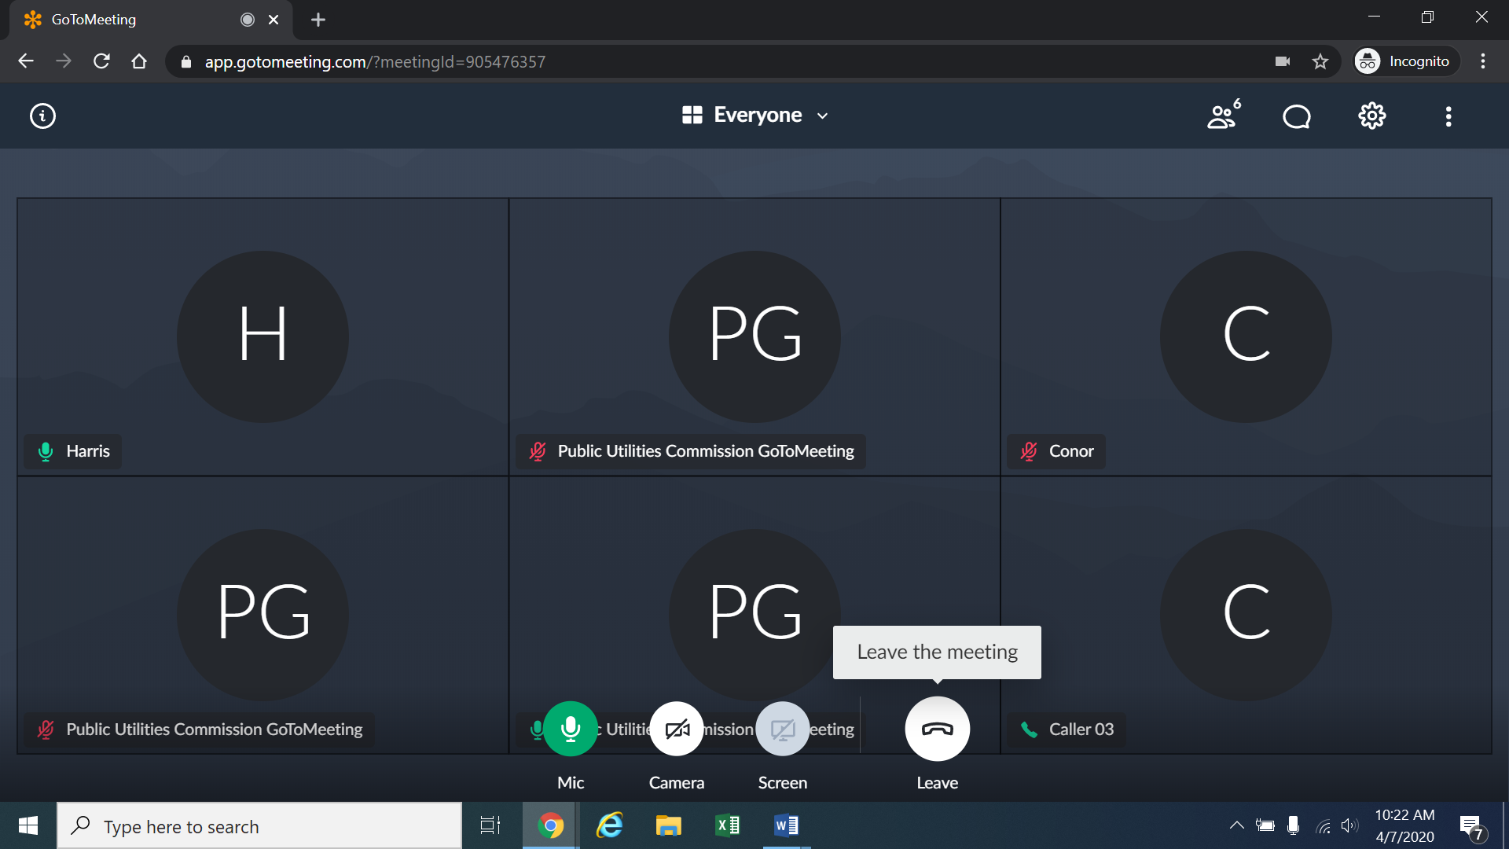
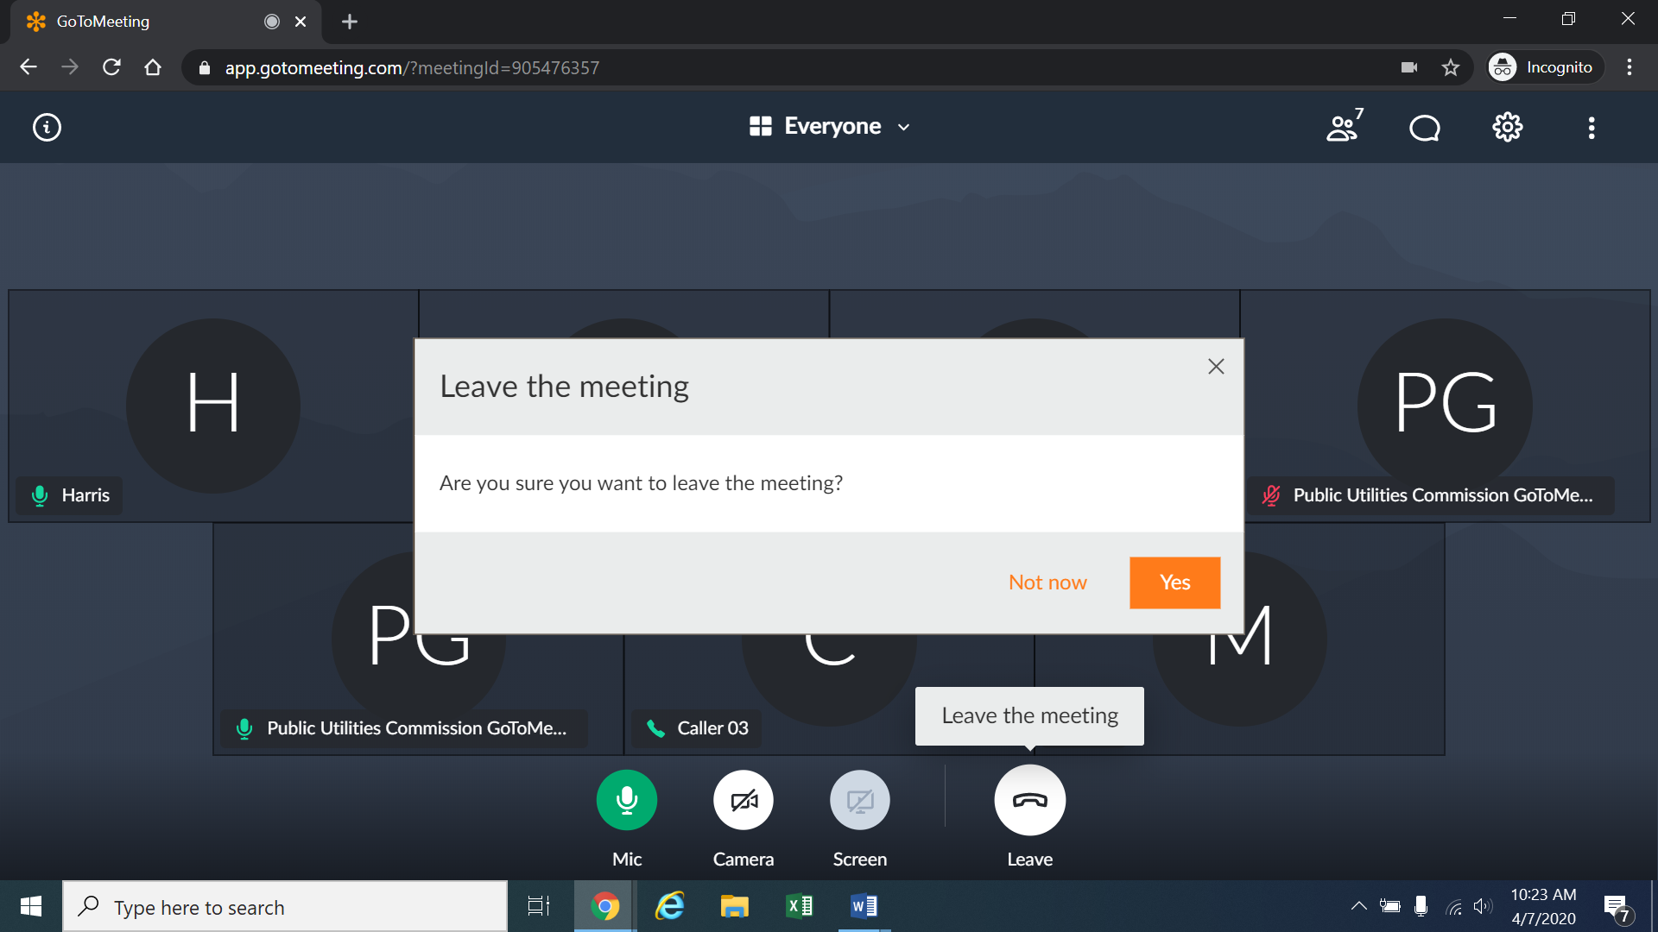

Instructions for Observing the Remote Hearing
- If you will not participate in the hearing as a party or witness, but would like to listen to the remote hearing, please do not participate by telephone or computer as described above. Rather, please go to https://puc.colorado.gov/webcasts. The following webpage will appear:
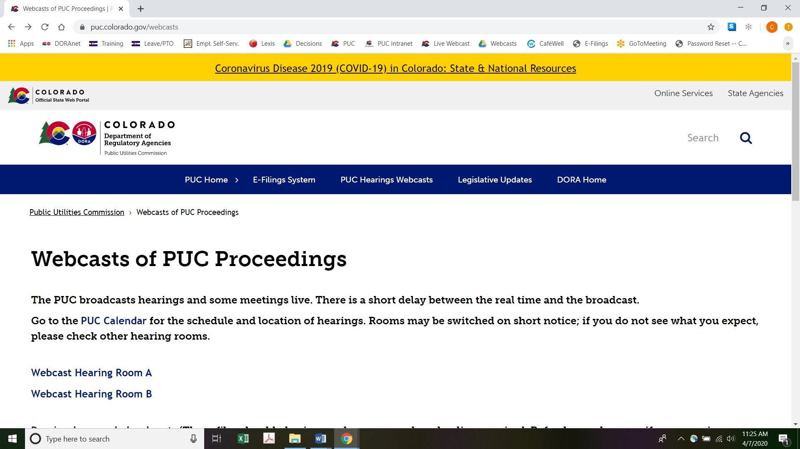
Please select the hearing room (“Webcast Hearing Room A” or “Webcast Hearing Room B”) listed for the remote hearing on the Commission’s public calendar, available at https://puc.colorado.gov/puccalendar. Once the hearing room is selected, please click one of the “audio only” links (e.g., “Hearing Room A Audio Only (IOS)” or “Hearing Room A Audio Only (Android/Other)”), or click the play button on the black screen, to stream audio of the hearing live (with a short delay between real time and the broadcast, as noted in the screenshot above).

ORDER

It Is Ordered That:
- The hearing scheduled for the week of May 18, 2020 at 9:00 a.m. shall be converted into a remote hearing. The parties, witnesses, and members of the public must follow the instructions stated above. The parties, witnesses, and members of the public should not attend the remote hearing in-person.
- This Decision is effective immediately.

(S E A L)    ATTEST: A TRUE COPY  Doug Dean,  Director | THE PUBLIC UTILITIES COMMISSION  OF THE STATE OF COLORADO  ROBERT I. GARVEY  ________________________________  Administrative Law Judge

The ALJ has engaged in informal communication with the parties via email concerning holding the hearing as scheduled but converting it into a remote hearing or continuing the hearing. During those informal communications, the ALJ instructed the parties that an interim decision converting the hearing to a remote hearing would issue on April 27, 2020 unless the parties filed a motion requesting to continue the hearing. As no such motion has been filed by one or all of the parties, the ALJ is issuing this Decision at this time.
To minimize audio feedback, you are encouraged to listen using headphones connected to the audio/headset jack on your computer.

