USING GOTOMEETING
TO ATTEND HEARING BY VIDEO CONFERENCE
______________________________________________________________________________
- This Attachment is intended to provide information to aid parties in joining a remote hearing by video conference using GoToMeeting, but is not intended to provide full and complete instructions on how to do so. Additional information and tutorials are available at:
https://www.gotomeeting.com/meeting/resources/gotomeeting-quick-and-helpful-guide-for-attendees.

This link is provided for the parties’ convenience and does not warrant that the information on the link is accurate or that it provides all the information the parties may need in order to use GoToMeeting.
2. Parties planning to participate in a GoToMeeting hearing by video conference should use a computer connected to the internet with an operational microphone and a speaker. To participate by computer, at the date and time of the hearing, parties must enter the link provided
in the Decision scheduling the hearing in their internet browser.
3. Parties will then be taken to the screen where they may join the hearing, as shown in the below image:
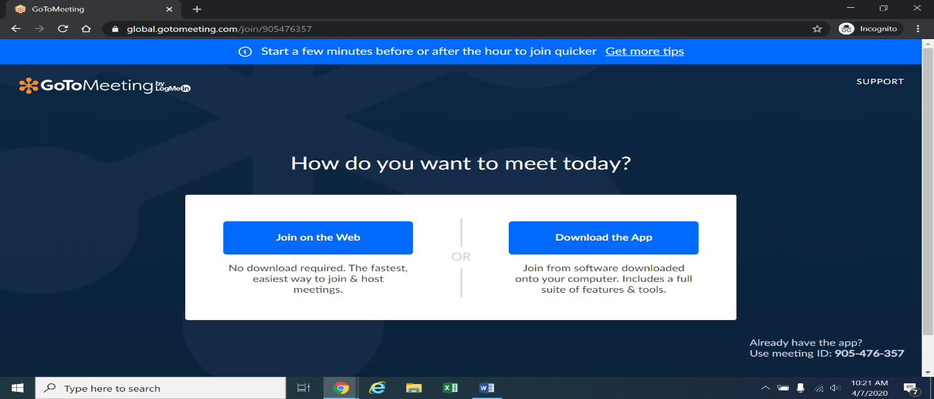
4. Once parties are at the above page, they must select “Join on the Web” in the blue box on the left. The webpage below will appear.
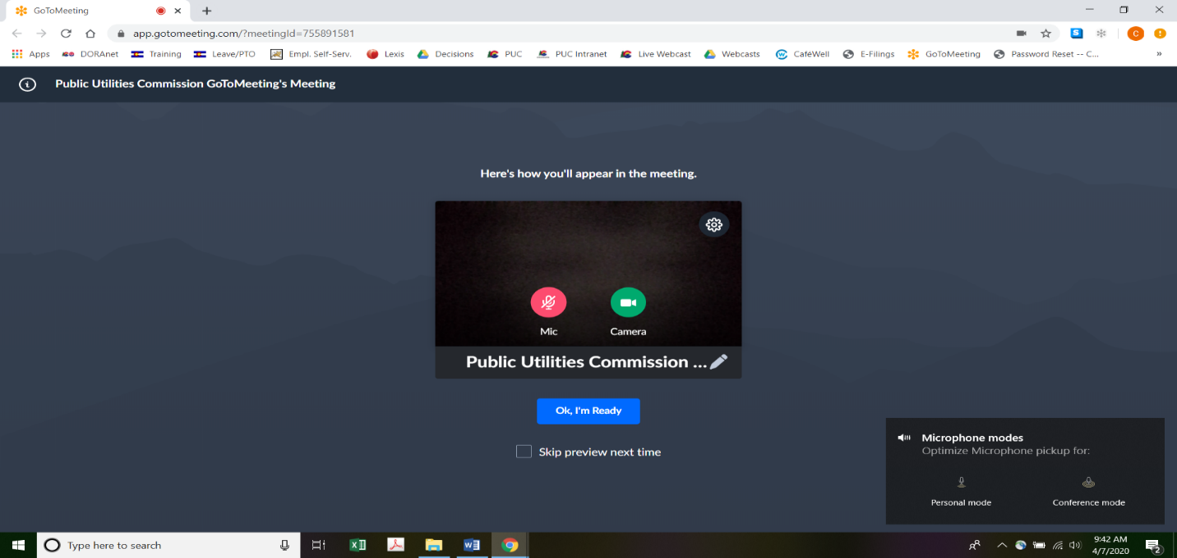
5. Parties experiencing difficulties with the link provided above, should instead go to https://app.gotomeeting.com/home.html and enter the meeting access code or ID number in the Decision scheduling the hearing to join the hearing. Parties may be directed to download a plug-in in order to join the meeting. If so, parties should download the plug-in; this should take only a few moments.
6. Parties who do not wish their image to be displayed during the hearing may turn off their computer’s video camera icon by clicking on the video camera icon image contained in the green circle at the bottom of the video screen. A slash will appear over the video camera icon to indicate that the video camera is off. Parties may turn off their microphones in a similar way by clicking on the microphone icon at the bottom of the video screen. Demonstratively, the image above shows the microphone turned off and the video camera turned on; the image below shows the microphone and video camera turned on.
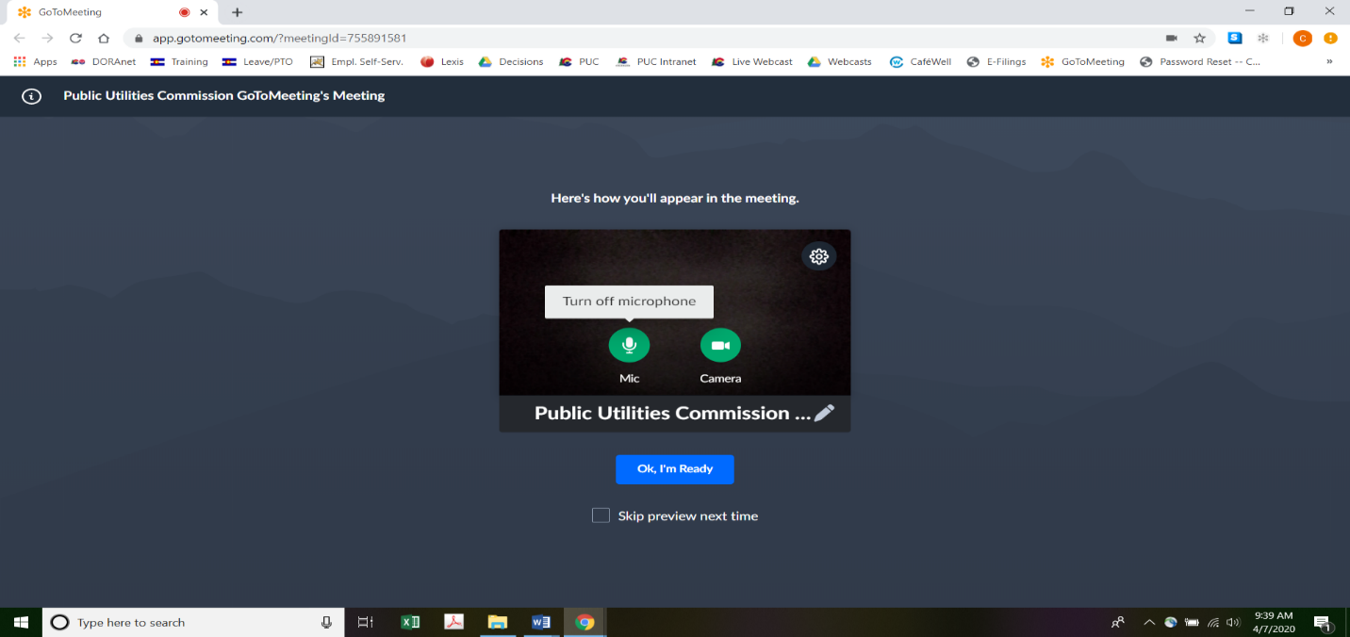
7. When parties have set their video camera and microphone preferences, parties must next select the “Ok, I’m Ready” icon shown above in the blue box to join the meeting.
8. To minimize background noise, parties should turn off (or mute) their microphones during the hearing when not speaking. Parties may manage their audio volume using volume controls on their computers.
9. To terminate participation in the hearing, parties should click on the telephone handset icon with the word “Leave” underneath it and then click the “Yes” button in the pop-up box (as shown below). A party who inadvertently clicks on the handset icon may select
“Not now” instead of “Yes” to stay in the meeting, as shown below.
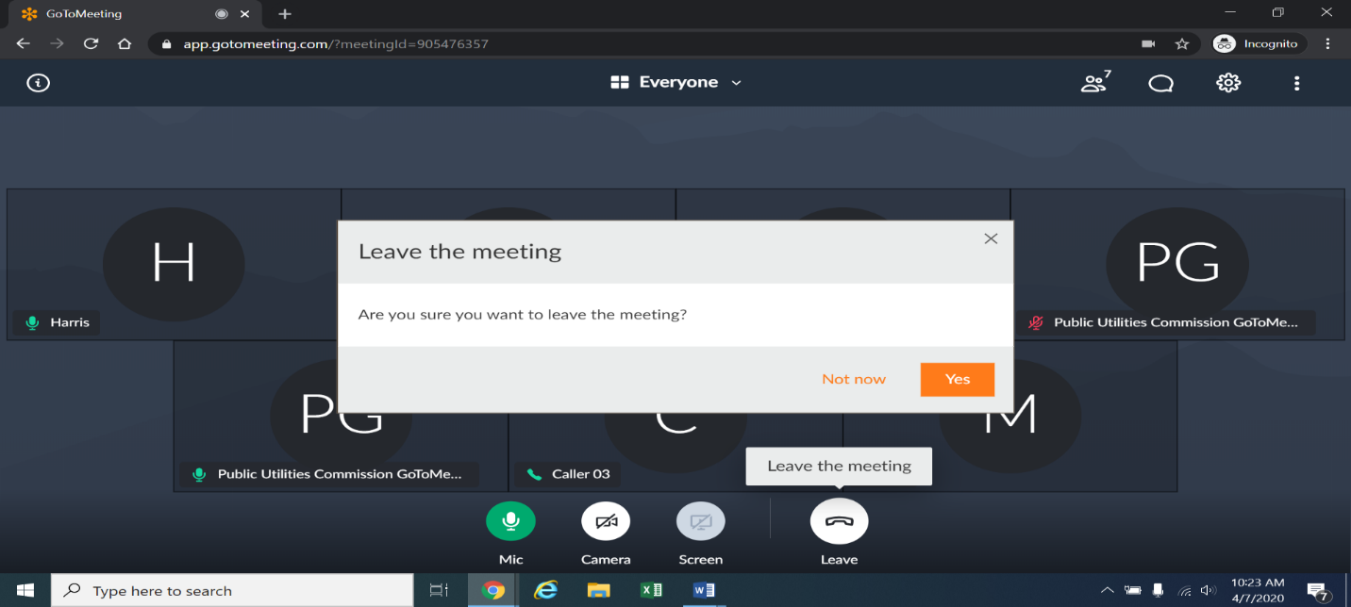

These instructions are not directed at using a tablet or smartphone to participate in a GoToMeeting video conference.
To minimize audio feedback, parties are encouraged to listen using headphones connected to the audio/headset jack on their computers.

