Decision No. R20-0318-I
BEFORE THE PUBLIC UTILITIES COMMISSION OF THE STATE OF COLORADO
PROCEEDING NO. 19R-0485TR
IN THE MATTER OF THE PROPOSED RULES REGULATING VEHICLE BOOTING COMPANIES, 4 CODE OF COLORADO REGULATIONS 723-6.
INTERIM decision of
administrative law judge
conor f. farley
ADDRESSING PUBLIC COMMENT
HEARING AND MOTION TO CONTINUE HEARING
Mailed Date: April 29, 2020

TABLE OF CONTENTS
I. STATEMENT 2
A. Background 2
B. Instructions for Participating in Remote Public Comment Hearing 5
1. Instructions for Participating by Telephone 6
2. Instructions for Participating by Computer 6
3. Instructions for Observing the Public Comment Hearing 12
4. Written Comments 13
II. ORDER 13
A. It Is Ordered That: 13

STATEMENT

Background
- On September 12, 2019, the Public Utilities Commission (Commission) issued the Notice of Proposed Rulemaking (NOPR) that commenced this proceeding. In the NOPR, the Commission proposed to adopt rules that permanently implement the requirement in Senate Bill 19-236 for the Commission to regulate Vehicle Booting Companies. The purpose of Rules 6806 through 6819 of the Commission’s Rules Regulating Transportation by Motor Vehicle, 4 Code of Colorado Regulations 723-6, is to preserve the health, safety, welfare, and property of the public. As stated in the NOPR, the Commission made the proposed rules provided with the NOPR in legislative (i.e., strikeout/ underline) format and in final format, available to the public through the Commission's Electronic Filings system. Finally, the Commission established October 11, 2019 as the deadline for written comments filed by members of the public, scheduled a hearing for October 28, 2019, and referred this proceeding to an administrative law judge (ALJ). The proceeding was subsequently assigned to the undersigned ALJ.
- The following members of the public filed comments before the October 11, 2019 deadline established in the NOPR: Owner-Operator Independent Drivers Association, Inc., Wyatt’s Towing, Towing Done Right, LLC (Towing Done Right), Colorado Booting LLC (Colorado Booting), Colorado Security Services, doing business as Colorado Parking Services, and Dark Sky LLC (Dark Sky).
- The ALJ held the public comment hearing on October 28, 2018 starting at 9:00 a.m. On that day, state government offices in the Denver Metro Area, including the Commission, delayed their opening until 10:00 a.m. due to inclement weather. As a result, the ALJ convened the hearing at 9:00 a.m., but then took a recess until 10:00 a.m. At that time, representatives of Towing Done Right, Colorado Booting, Dark Sky, and Wyatt’s Towing attended the hearing. No other person or entity presented written or oral comments at the hearing.
- On December 3, 2019, the ALJ issued Recommended Decision No. R19-0961 and attached the rules in redline legislative format and in final format.
- Colorado Booting and Towing Done Right filed exceptions to Recommended Decision No. R19-0961 on December 23, 2019. Towing Done Right attached seven exhibits to its exceptions. According to the Commission, “[b]oth the exceptions and attachments offer some information that is new to this proceeding.”
- On February 7, 2020, the Commission issued Decision No. C19-0083 that granted the exceptions and remanded the proceeding “so that the ALJ can consider the information and arguments presented in the exceptions.” Citing the inclement weather on the day of the public comment hearing held on October 28, 2019, Decision No. C19-0083 “direct[ed] the ALJ to hold an additional public comment hearing to discuss the issues and information presented in these exceptions.”
- On February 13, 2020, in Decision No. R20-0098-I, the ALJ: (a) established a deadline of March 16, 2020 for additional written comments on the proposed rules; and
- (b) scheduled an additional hearing to take public comments regarding the proposed rules for April 2, 2020 at 9:00 a.m. Notice of the April 2, 2020 public comment hearing was published in the February 25, 2020 issue of The Colorado Register pursuant to the Administrative Procedure Act.
- On March 13, 2020, Parking Done Right LLC and Towing Done Right LLC (Parking Done Right) filed a Motion to Continue the Hearing (Motion) because counsel for both companies is scheduled to appear at a hearing in Adams County District Court on April 2, 2020 “on a case that cannot in all likelihood be continued.” Counsel for Parking Done Right further states that no other counsel for Parking Done Right is available to appear at the April 2, 2020 hearing in this proceeding. As a result, counsel for Parking Done Right requests in the Motion that the April 2, 2020 public comment hearing be continued to a future date.
- By minute entry during the Commission’s weekly meeting held on March 18, 2020, the Commission referred the Motion to the ALJ.
- On March 24, 2020, the ALJ issued Decision No. R20-0188-I stating that, in light of the COVID-19 pandemic and the resulting state of emergency issued by Governor Polis on March 19, 2020: (a) the April 2, 2020 public comment hearing would be convened for the sole purpose of continuing the hearing to a later date; (b) interested persons who desire to provide comments at a public comment hearing should not attend the April 2, 2020 public comment hearing; (c) those interested persons would be given the opportunity to provide comments at the
- future continued public comment hearing that will be scheduled as noted above; and (d) the Motion to Continue Hearing filed by Parking Done Right would be addressed by a separate decision on or after April 2, 2020.
- On April 2, 2020, the ALJ convened the public comment hearing that was webcast via https://puc.colorado.gov/webcasts. The ALJ noted the state of emergency, and the directives regarding social distancing from federal, state, and local authorities. The ALJ then continued the hearing until May 14, 2020 and requested that any additional written comments be filed by May 7, 2020. Finally, the ALJ denied as moot the Motion to Continue Hearing filed by Parking Done Right in light of the actions taken by the ALJ at the April 2, 2020 public comment hearing.

Instructions for Participating in Remote Public Comment Hearing
- The Commission prefers written comments over oral comments. As a result, the Commission urges individuals to provide their comments in written form via the methods described in more detail below on page 11-12.
- For those individuals who want to provide oral comments, the Commission uses the web-hosted video conferencing service, GoToMeeting, to hold video conferences, and in this case, a remote public comment hearing. Individuals who wish to provide public comments during the public comment hearing can participate and provide their comments either by telephone or computer. The following are general instructions for how to participate by telephone or by computer.
- Additional information and tutorials for using GoToMeeting are available at:
https://www.gotomeeting.com/meeting/resources/gotomeeting-quick-and-helpful-guide-for-attendees.

This link is only provided for the convenience of the individuals who plan to participate in the remote public comment hearing, and is not intended to guarantee that the information on the link is accurate or that it provides all the information the parties may need in order to use GoToMeeting. Those individuals who plan to participate in the remote public comment hearing by computer are strongly advised to familiarize themselves with GoToMeeting before the hearing.

Instructions for Participating by Telephone
- Any member of the public or party who wishes to provide comments by telephone during the remote public comment hearing must call 646-749-3122 when the hearing takes place. When prompted, input 512267317#. You will then be placed into the public comment hearing. Please note that your session and participation will be controlled by the ALJ/Commission Staff.

Instructions for Participating by Computer
- Any member of the public or party who wishes to participate in the
public comment hearing by computer must use a computer that is connected to the
- internet and has a microphone and a speaker. At the time of the hearing, please go to https://global.gotomeeting.com/join/512267317. The webpage below will appear.
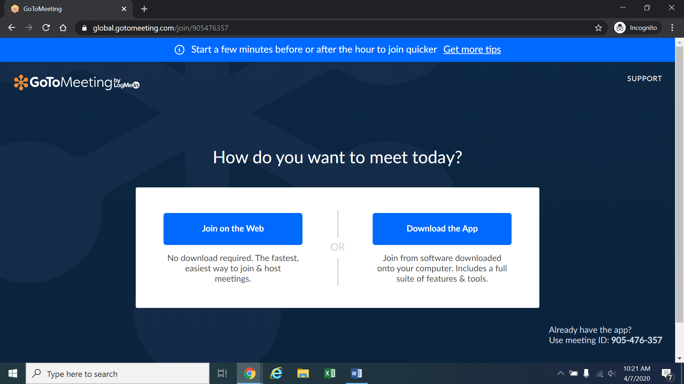
Next, please click “Join on the Web” in the blue box on the left. The webpage below will appear.
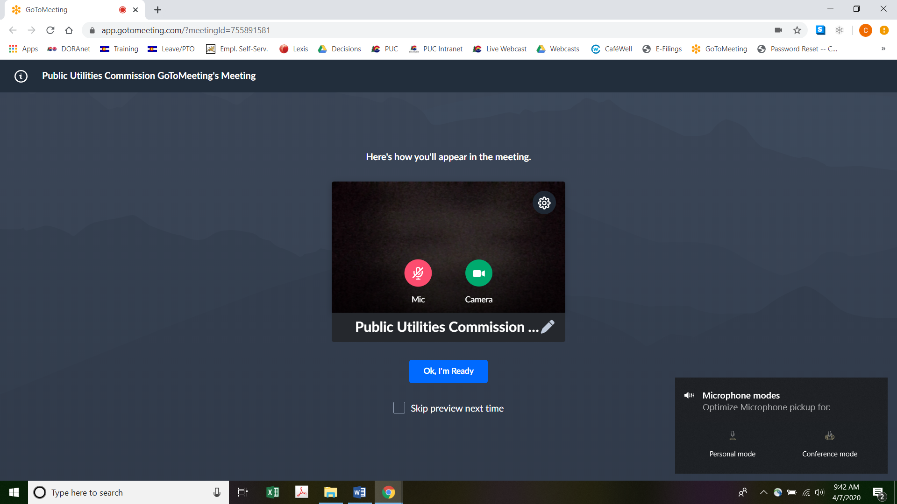
Alternatively, if there is any problem with the link provided above, please go to https://app.gotomeeting.com/home.html and enter 512-267-317, which is the Meeting ID/Access Code, to join the meeting.
- If you do not want others participating in the hearing to see you, please click on the camera icon contained in the green circle at the bottom of the video screen. The icon will turn white and a slash will be placed over the camera icon indicating that your camera has been turned off. Likewise, if you do not want others participating in the hearing to hear you, confirm that there is a slash over the microphone icon contained in the red circle indicating that your microphone has been turned off. In the screenshot of the webpage above, the microphone is turned off while the camera is turned on. Conversely, the screenshot of the webpage below shows the microphone and video icons turned on and are ready to transmit video and audio when you join the hearing.
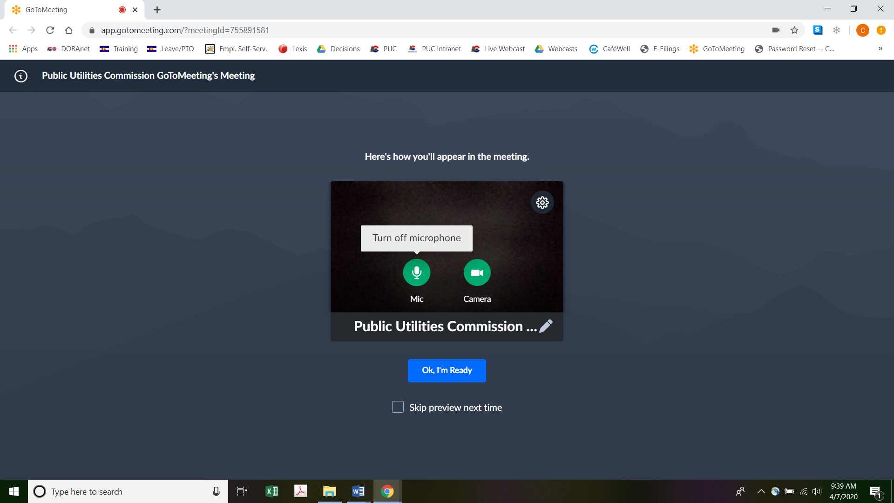
- When you have the video and microphone settings the way you want them, please click “Ok, I’m Ready” in the blue box (shown in the screenshots above) to join the meeting.
- You can control the volume of the audio through the volume controls on your computer. The screenshot below shows the screen after joining the hearing with the camera turned on and the microphone turned off.
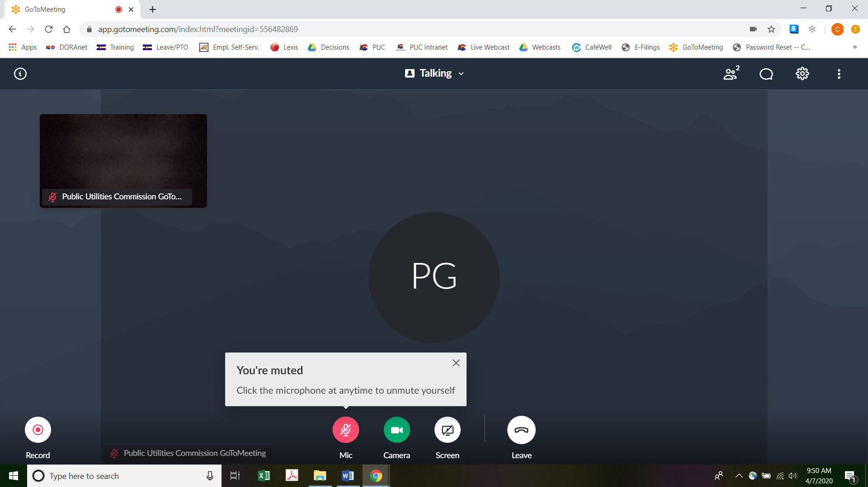
- All participants in the hearing should mute (turn off) their microphones during the hearing until called upon by the ALJ to provide comments. When prompted by the ALJ to provide comments, please click on the microphone icon to turn on your microphone and then commence speaking. The red circle around the microphone icon will turn green indicating that your microphone is turned on. While you are speaking, please listen for any direction you are given by the ALJ.
- To terminate your participation in the hearing, please click on the telephone handset icon with the word “Leave” underneath it and then click the “Yes” button in the pop-up box, or the “Not now” button if you would like to stay in the meeting, as shown in the screenshots below.
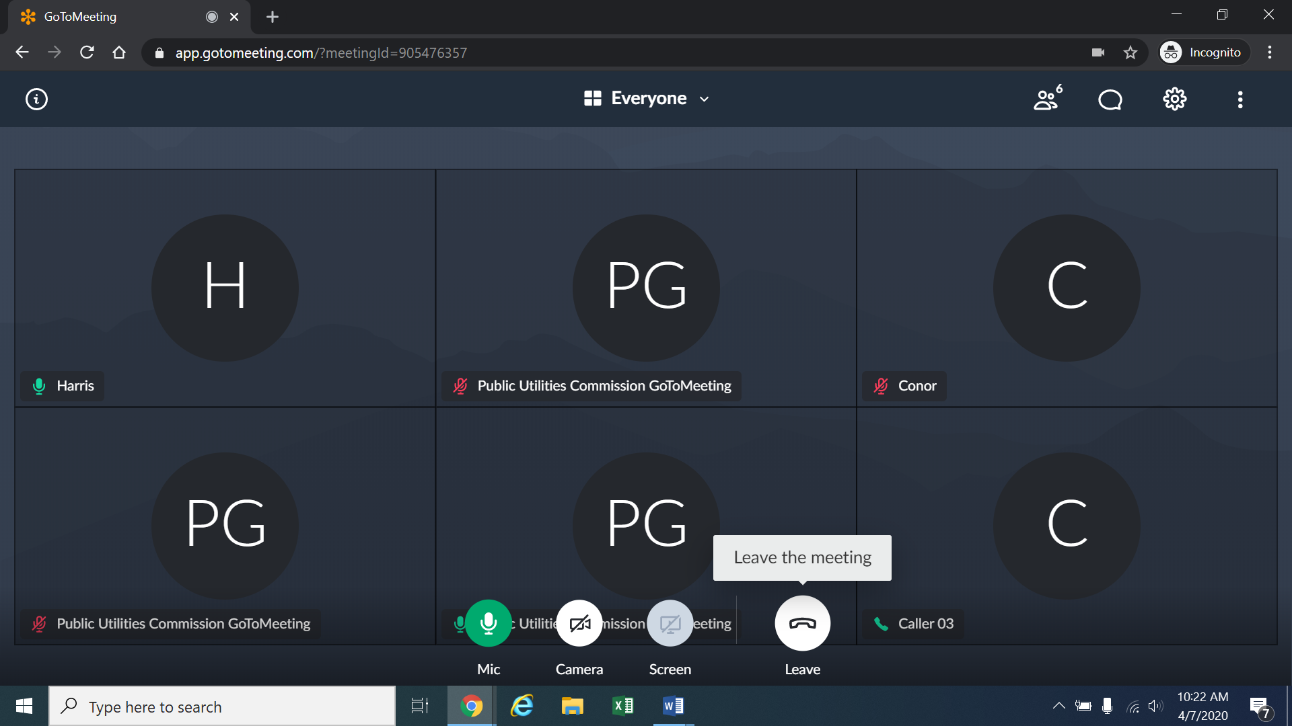
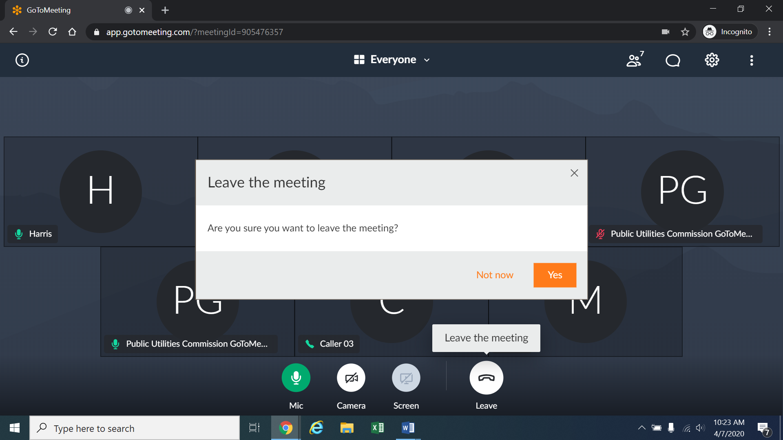

Instructions for Observing the Public Comment Hearing
- If you do not wish to speak but would like to listen to the public comment hearing, please do not participate by telephone or computer as described above. Rather, please go to https://puc.colorado.gov/webcasts. The following webpage will appear.
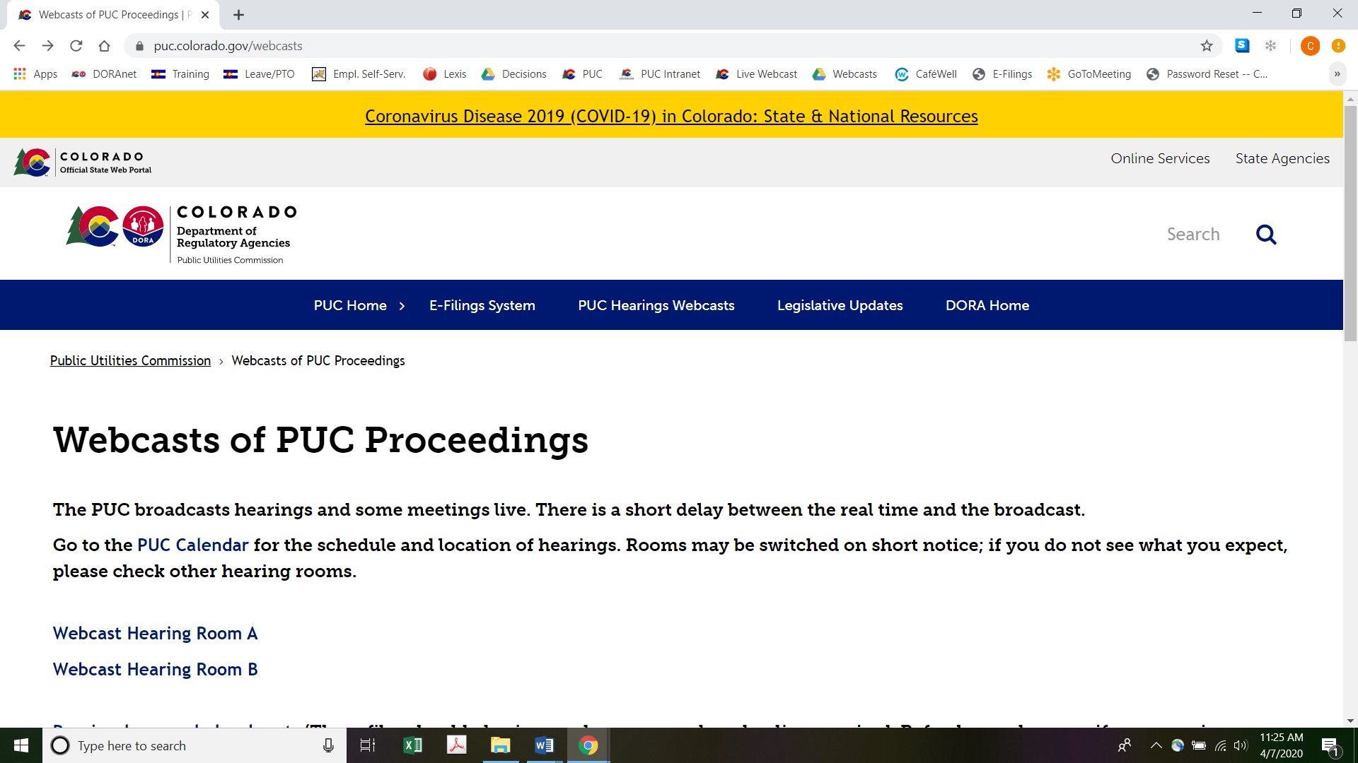
Please select the hearing room (“Webcast Hearing Room A” or “Webcast Hearing Room B”) listed for the public comment hearing on the Commission’s public calendar, available at https://puc.colorado.gov/puccalendar. Once the hearing room is selected, please click one of the “audio only” links if using a mobile device (e.g., “Hearing Room A Audio Only (IOS)” or “Hearing Room A Audio Only (Android/Other)”), or click the play button on the black screen, to stream audio of the hearing live (with a short delay between real time and the broadcast, as noted in the screenshot above).

Written Comments
- The Commission prefers written comments over oral comments. As a result, interested persons are encouraged to submit written comments through either: (a) the Commission’s Electronic Filing System at https://www.dora.state.co.us/pls/efi/EFI.homepage in this proceeding; or (b) the Commission’s website at https://puc.colorado.gov/ by clicking on the “FILE A COMMENT OR COMPLAINT” link. Both oral and written comments will be given the same weight in this proceeding. Interested persons are urged to submit their written comments by May 7, 2020 to give the ALJ an opportunity to review them in advance of the remote public comment hearing.

ORDER

It Is Ordered That:
- Written comments from interested persons on the proposed rules are requested by May 7, 2020.
- A remote public comment hearing is scheduled for May 14, 2020. It shall take place from 9:00 a.m. until it is concluded. Members of the public who wish to participate in, and/or to provide public comments at, the remote public comment hearing, must follow the instructions stated above. Members of the public should not attend the public comment hearing in-person.
- The Motion to Continue the Hearing filed by Parking Done Right LLC and Towing Done Right LLC on March 13, 2020 is denied as moot.
- This Decision is effective immediately.

(S E A L)    ATTEST: A TRUE COPY  Doug Dean,  Director | THE PUBLIC UTILITIES COMMISSION  OF THE STATE OF COLORADO  CONOR F. FARLEY  ________________________________  Administrative Law Judge

See Decision No. C19-0748 issued in Proceeding No. 19R-0485TR on September 12, 2019.
Decision No. C20-0083 issued in Proceeding No. 19R-0485TR on February 7, 2020 at 2 (¶ 3).
Id. at 2 (¶ 5).
Id. at 2-3 (¶ 5).
§ 24-4-103, C.R.S.
Motion at 1 (¶ 2).
Id. at 1 (¶¶ 2-3).
To minimize audio feedback, you are encouraged to listen using headphones connected to the audio/headset jack on your computer.

