Decision No. R20-0308-I
BEFORE THE PUBLIC UTILITIES COMMISSION OF THE STATE OF COLORADO
PROCEEDING NO. 20A-0030CP
IN THE MATTER OF THE APPLICATION OF COLORADO DETOURS LLC FOR A CERTIFICATE OF PUBLIC CONVENIENCE AND NECESSITY TO OPERATE AS A COMMON CARRIER BY MOTOR VEHICLE FOR HIRE.
interim DECISION of
administrative law judge
Conor F. Farley
CONVERTING IN-PERSON HEARING INTO REMOTE HEARING, PROVIDING INSTRUCTIONS FOR HOW TO PARTICIPATE REMOTELY, AND SETTING new SCHEDULE for filing and serving witness and exhibit lists and pre-marked exhibits
Mailed Date: April 28, 2020

TABLE OF CONTENTS
I. STATEMENT 2
A. Background 2
B. Impact of Subsequent Developments on Hearings 2
C. Instructions for Participating in Remote Hearing 3
1. Instructions for Participating by Telephone 4
2. Instructions for Participating by Computer 4
3. Instructions for Observing the Remote Hearing 10
D. Witness and Exhibit Lists and Marked Exhibits 11
II. ORDER 12
A. It Is Ordered That: 12

STATEMENT

Background
- On January 16, 2020, Colorado Detours LLC (Colorado Detours) filed the application described in the caption above (Application).
- On January 21, 2020, the Commission issued a notice of the Application.
- On January 31, 2020, AEX, Inc. (AEX) and San Miguel Mountain Ventures, LLC (SMMV), filed a Joint Intervention.
- On February 26, 2020, the Commission deemed the Application complete and referred it to an Administrative Law Judge (ALJ) for disposition. The proceeding was subsequently assigned to the undersigned ALJ.
- On March 6, 2020, the ALJ issued Decision No. R20-0147-I that, among other things, scheduled an in-person hearing for May 7, 2020 starting at 9:00 a.m.

Impact of Subsequent Developments on Hearings
- On March 10, 2020, Colorado Governor Jared Polis declared a state of emergency over the novel coronavirus pandemic (COVID-19). Since then, Colorado State government and the Commission have been working diligently to address how to safely and effectively manage the challenges presented by COVID-19. These efforts have focused on limiting the disruption to the services delivered by the Commission (and other State agencies), while attempting to mitigate the risks to State employees and the public. For example, the Commission has been conducting its Weekly Meetings remotely, and the Commission has asked members of the public not to attend meetings in person, but to view them by webcast. More recently, public access to
- the building containing the Commission’s offices and hearing rooms has been restricted and it is unclear when the restriction will be lifted.
- Under these circumstances, the hearing scheduled for May 7, 2020 shall be converted into a remote hearing in which the participants will appear from remote locations, as provided below. The ALJ finds that holding a remote hearing is consistent with current public health advisories to prevent the spread of COVID-19. The ALJ concludes that it is in the parties’ and the public interest to hold the hearing in this proceeding as a remote hearing.

Instructions for Participating in Remote Hearing
- The Commission uses the web-hosted video conferencing service, GoToMeeting, to hold video conferences, and in this case, a remote hearing. Parties and witnesses may participate in the remote hearing by computer, or telephone. Attending the hearing by computer allows for video-conference participation in the hearing. Participating by video-conference allows parties wishing to present evidence to display exhibits on the video-conference screen and allows others participating by video-conference to view the displayed exhibits as they are presented in a manner most similar to that which occurs during in-person hearings.
- The ALJ strongly encourages all parties and witnesses to participate in the hearing using a computer, especially any party wishing to present documents for consideration during the hearing. Parties joining the hearing by telephone may view exhibits by either providing an email
- address where the exhibits may be sent at the time of the hearing, or by accessing the exhibits within the administrative record for this proceeding through the Commission’s free E-Filing System. Parties may register for the Commission’s E-Filing System at no charge at the following website: https://www.dora.state.co.us/pls/efi/EFI.homepage.
- The following are general instructions for how to participate by telephone or by computer. Additional information and tutorials for using GoToMeeting are available at:
https://www.gotomeeting.com/meeting/resources/gotomeeting-quick-and-helpful-guide-for-attendees.

These links are only provided for convenience and are not intended to guarantee that the information on the link is accurate or that it provides all the information the parties may need in order to use GoToMeeting. Those parties and individuals who plan to participate in the remote hearing by computer are strongly advised to familiarize themselves with GoToMeeting before the hearing.

Instructions for Participating by Telephone
- The parties and witnesses who will participate by telephone during the remote hearing must call 312-757-3121 when the hearing takes place. When prompted, input 808680205#, which is the Meeting ID/Access Code, to join the hearing.

Instructions for Participating by Computer
- Any member of the public or party who wishes to participate in the
remote hearing by computer must use a computer that is connected to the
- internet and has a microphone and a speaker. At the time of the hearing, please go to https://global.gotomeeting.com/join/808680205. The webpage below will appear.
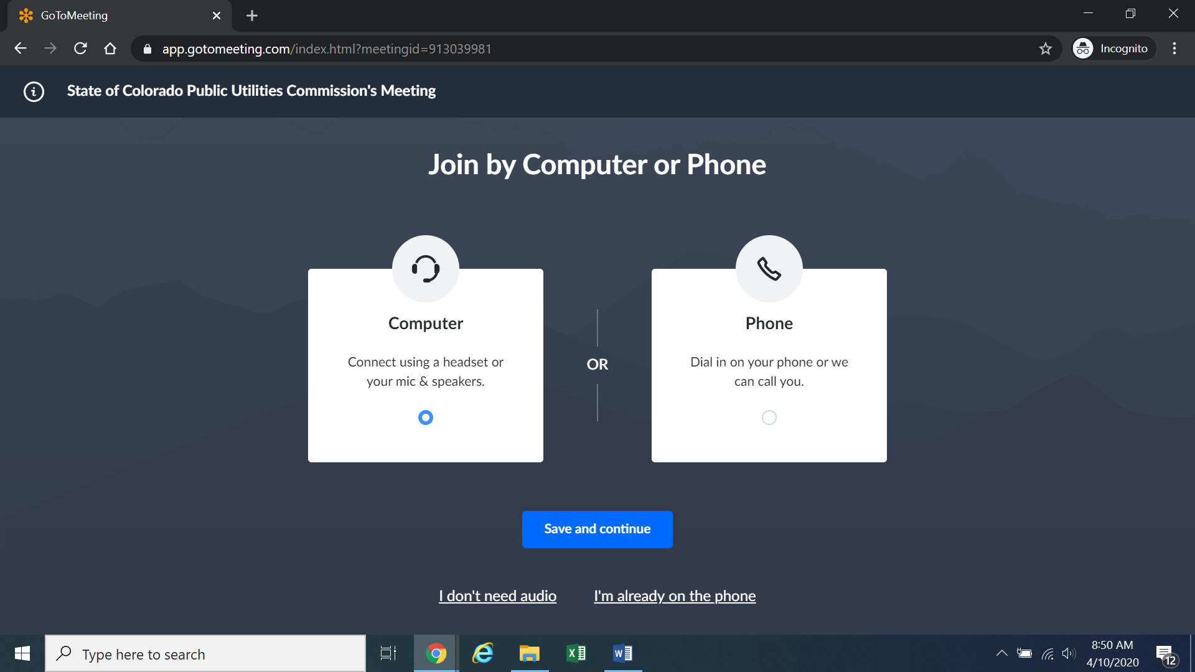
Confirm your audio settings and click “Save and continue.” Note: You may be prompted to allow the session to access your microphone and/or camera. Finally, you will be prompted to enter your name for identification during the session:
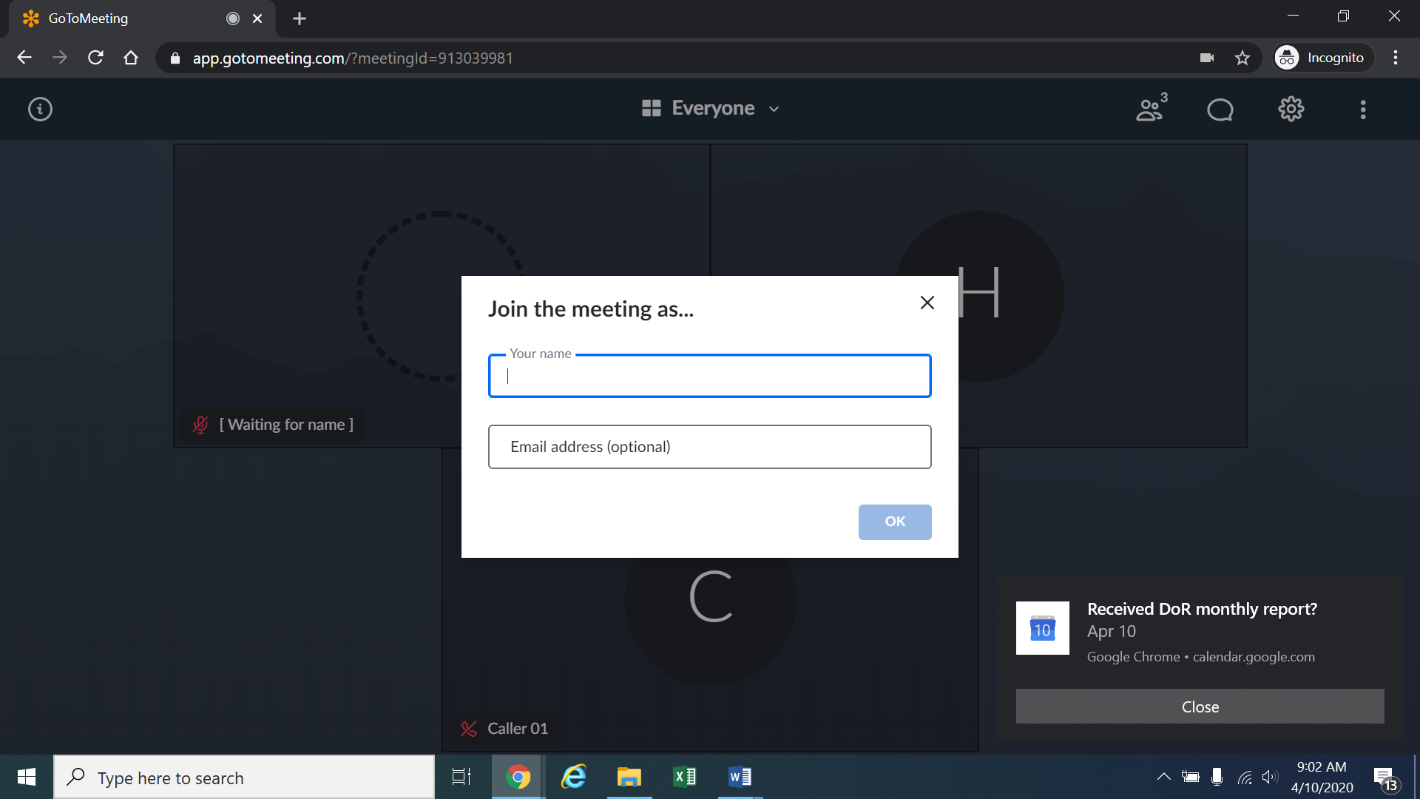
Alternatively, if there is any problem with the link provided above, please go to https://app.gotomeeting.com/home.html and enter the 9 digit Meeting ID/Access Code identified in the section above entitled “Instructions for Participating by Telephone” to join the meeting.
- If you do not want others participating in the hearing to see you, please click on the camera icon contained in the green circle at the bottom of the video screen. The icon will turn white and a slash will be placed over the camera icon indicating that your camera has been turned off. Likewise, if you do not want others participating in the hearing to hear you, confirm that there is a slash over the microphone icon contained in the red circle indicating that your
- microphone has been turned off. In the screenshot of the webpage below, the microphone is turned off while the camera is turned on:
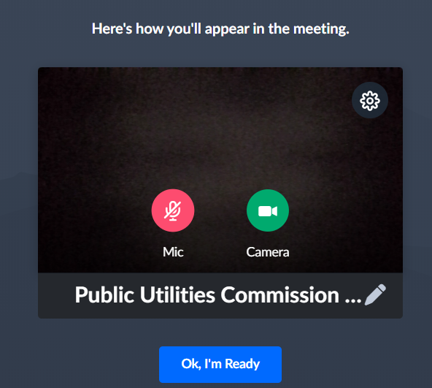
Conversely, the screenshot of the webpage below shows the microphone and video icons turned on and are ready to transmit video and audio when you join the hearing.
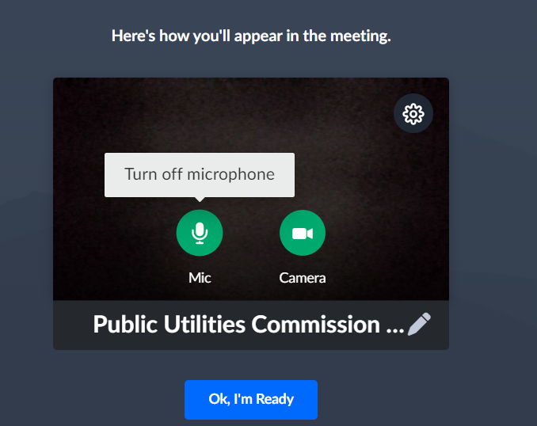
- You can control the volume of the audio through the volume controls on your computer. The screenshot below shows the screen after joining the hearing with the camera turned on and the microphone turned off.
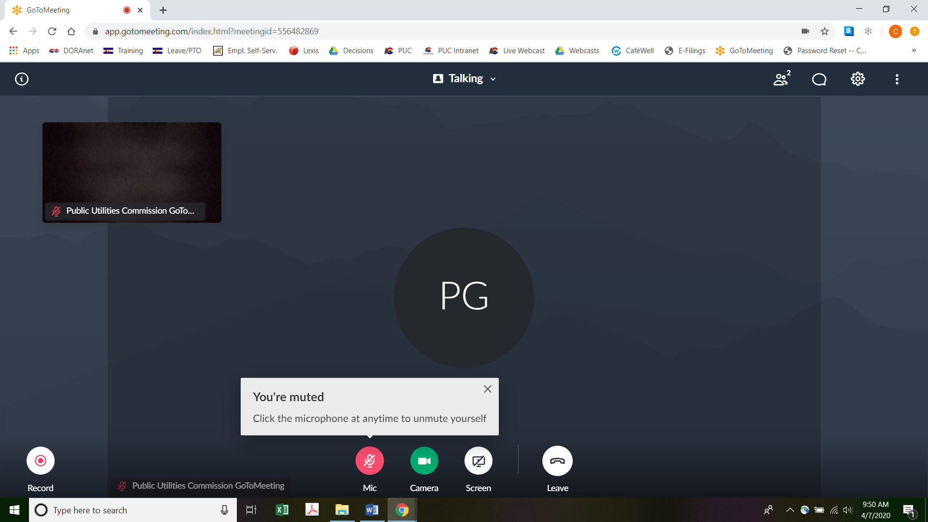
- All participants in the hearing should mute (turn off) their microphones during the hearing until called upon by the ALJ. When prompted by the ALJ, please click on the microphone icon to turn on your microphone and then commence speaking. The red circle around the microphone icon will turn green indicating that your microphone is turned on. While you are speaking, please listen for any direction you are given by the ALJ.
- To terminate your participation in the hearing, please click on the telephone handset icon with the word “Leave” underneath it and then click the “Yes” button in the pop-up box, or the “Not now” button if you would like to stay in the meeting, as shown in the screenshots below.
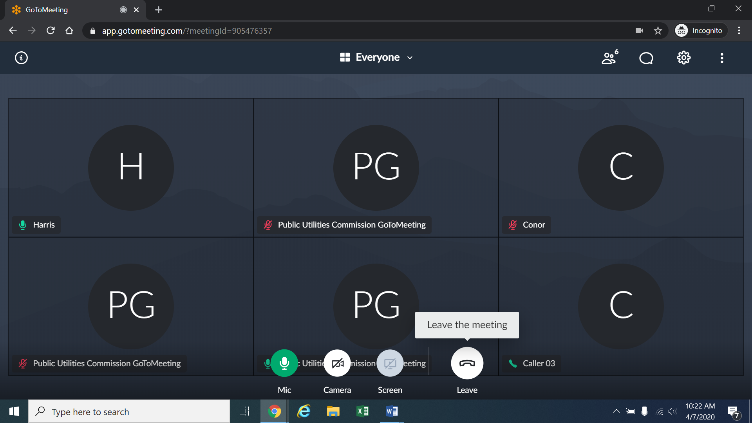
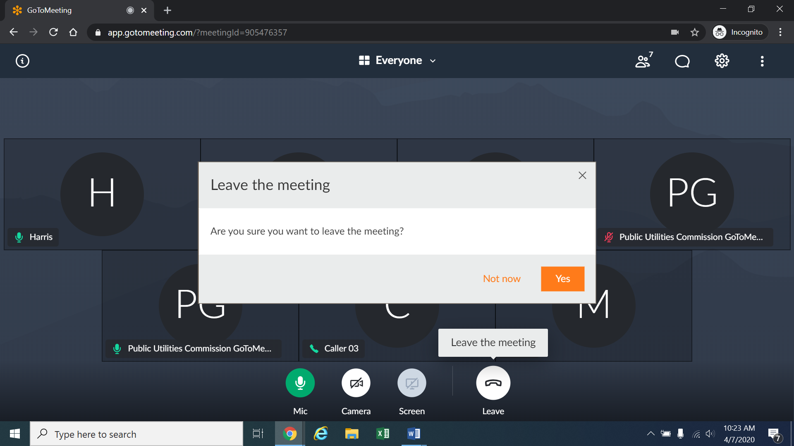

Instructions for Observing the Remote Hearing
- If you will not participate in the hearing as a party or witness, but would like to listen to the remote hearing, please do not participate by telephone or computer as described above. Rather, please go to https://puc.colorado.gov/webcasts. The following webpage will appear.
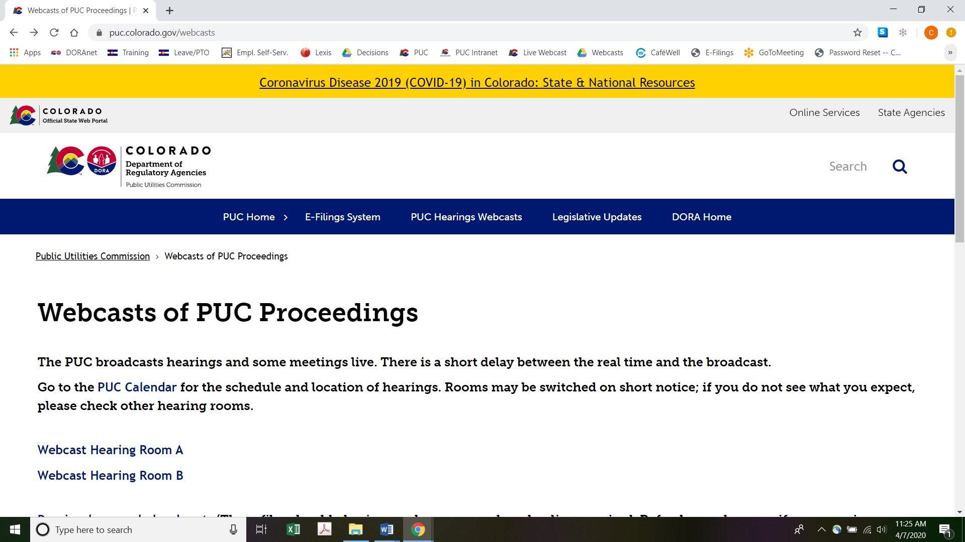
Please select the hearing room (“Webcast Hearing Room A” or “Webcast Hearing Room B”) listed for the remote hearing on the Commission’s public calendar, available at https://puc.colorado.gov/puccalendar. Once the hearing room is selected, please click one of the “audio only” links (e.g., “Hearing Room A Audio Only (IOS)” or “Hearing Room A Audio Only (Android/Other)”), or click the play button on the black screen, to stream audio of the hearing live (with a short delay between real time and the broadcast, as noted in the screenshot above).

Witness and Exhibit Lists and Marked Exhibits
- Decision No. R20-0147-I established deadlines of March 30, 2020 and April 13, 2020 for the filing of witness and exhibit lists and exhibits for Colorado Detours and AEX and SMMV, respectively. Neither party appears to have complied with the deadlines. Under our unique circumstances, the ALJ shall establish new deadlines for the filing of these documents. Specifically, on or before May 4, 2020, Colorado Detours will be ordered to file and serve on AEX and SMMV: (a) a list that identifies the witnesses Colorado Detours intends to call at the hearing, the last known address and telephone number of each witness, and a summary of the anticipated testimony of each witness; and (b) copies of the pre-marked exhibits Colorado Detours will present at the hearing. Colorado Detours shall pre-mark exhibits starting with exhibit number 1.
- On or before May 5, 2020, AEX and SMMV will be ordered to file and serve on Colorado Detours: (a) a list that identifies each of the witnesses AEX and SMMV intend to call at the hearing, the last known address and telephone number of each witness, and a summary of the anticipated testimony of each witness; and (b) copies of the pre-marked exhibits AEX and SMMV will present at the hearing. AEX and SMMV shall pre-mark exhibits starting with the next exhibit number following the last exhibit number used by Colorado Detours.
- If Colorado Detours and/or AEX and SMMV send their witness and exhibit lists and marked exhibits via U.S. Mail to the Commission for filing, they must email their witness and exhibit lists and marked exhibits to the ALJ and the other parties by 5:00 p.m. on the dates stated above.

ORDER

It Is Ordered That:
- The hearing scheduled for May 7, 2020 at 9:00 a.m. shall be converted into a remote hearing. The parties, witnesses, and members of the public must follow the instructions stated above. The parties, witnesses, and members of the public should not attend the remote hearing in-person.
- On or before May 4, 2020, Colorado Detours, LLC (Colorado Detours) shall file and serve on AEX, Inc. (AEX) and San Miguel Mountain Ventures, LLC (SMMV): (a) a list that identifies the witnesses Colorado Detours intends to call at the hearing, the last known address and telephone number of each witness, and a summary of the anticipated testimony of each witness; and (b) copies of the pre-marked exhibits Colorado Detours will present at the hearing.
- On or before May 5, 2020, AEX and SMMV shall each file and serve on Colorado Detours: (a) a list that identifies the witnesses AEX and SMMV intend to call at the hearing, the last known address and telephone number of each witness, and a summary of the anticipated testimony of each witness; and (b) copies of the pre-marked exhibits AEX and SMMV will present at the hearing.
- If Colorado Detours and/or AEX and SMMV send their witness and exhibit lists and marked exhibits via U.S. Mail to the Commission for filing, they must email their witness and exhibit lists and marked exhibits to the Administrative Law Judge and the other parties by 5:00 p.m. on the dates stated above.
- This Decision is effective immediately.

(S E A L)    ATTEST: A TRUE COPY  Doug Dean,  Director | THE PUBLIC UTILITIES COMMISSION  OF THE STATE OF COLORADO  CONOR F. FARLEY  ________________________________  Administrative Law Judge

The ALJ has engaged in informal communication with the parties via email concerning holding the hearing as scheduled but converting it into a remote hearing or continuing the hearing. During those informal communications, the ALJ instructed the parties that an interim decision converting the hearing to a remote hearing would issue on April 27 unless the parties filed a motion requesting to continue the hearing. As no such motion has been filed by one or all of the parties, the ALJ is issuing this decision at this time.
To minimize audio feedback, you are encouraged to listen using headphones connected to the audio/headset jack on your computer.

