Decision No. R20-0413-I
BEFORE THE PUBLIC UTILITIES COMMISSION OF THE STATE OF COLORADO
PROCEEDING NO. 20A-0059E
IN THE MATTER OF THE VERIFIED APPLICATION OF TRI-STATE GENERATION AND TRANSMISSION ASSOCIATION, INC. FOR APPROVAL OF THE RETIREMENT OF THE NUCLA STATION, AND REQUEST FOR WAIVER OF RULE 3103(D).
interim decision OF
ADMINISTRATIVE LAW JUDGE
CONOR F. FARLEY
CONVERTING IN-PERSON PREHEARING
CONFERENCE INTO REMOTE PREHEARING CONFERENCE AND PROVIDING INSTRUCTIONS
FOR HOW TO PARTICIPATE REMOTELY
Mailed Date: June 1, 2020

TABLE OF CONTENTS
I. BY THE COMMISSION 2
A. Background 2
B. Impact of COVID-19 on Prehearing Conference 3
C. Instructions for Participating in, and Observing, the Remote Prehearing Conference 4
1. Instructions for Participating by Telephone 5
2. Instructions for Participating by Computer 5
3. Instructions for Observing 11
II. ORDER 12
A. It Is Ordered That: 12

BY THE COMMISSION

Background
- On February 14, 2020, Tri-State Generation and Transmission Association, Inc. (Tri-State) filed a Verified Application and Request for Waiver of Rule 3103(d) in which it requests that the Commission: (a) approve the retirement of the Nucla Station and the abandonment or discontinuation of such facilities without equivalent replacement; and (b) waive the notice requirements of Commission Rule 3103(d) of the Rules Regulating Electric Utilities, 4 Code of Colorado Regulations 723-3 (Application). The Nucla Station ceased operations on September 9, 2019, which Tri-State officially announced on September 19, 2019. Tri-State had entered into an agreement with the Colorado Department of Public Health and Environment, the U.S. Environmental Protection Agency, WildEarth Guardians, and the National Parks Conservation Association in September 2016 to retire the Nucla Station by December 31, 2022. Tri-State moved up the retirement date due to the “dwindling” use of the Nucla Station caused by the inability of the Nucla Station to produce electricity at a competitive cost compared to natural gas and renewable-generated electricity.
- Later on February 14, 2020, the Commission issued notice of the Application.
- On March 13, 2020, the Office of Consumer Counsel (OCC) filed a notice of intervention and entry of appearance.
- On March 16, 2020, Western Resource Advocates (WRA) filed a Motion for Leave to Participate as Amicus Curiae and Response to Tri-State’s Request to Waive Commission Rules Amicus Motion (WRA’s Motion).
- On March 17, 2020, Trial Staff of the Commission (Staff) filed a notice of intervention by right and entry of appearance.
- On March 23, 2020, Tri-State filed an Unopposed Motion Regarding Request for Waiver, Additional Notice, and Limited Extended Intervention Period (Unopposed Motion).
Tri-State states that Staff, the OCC, and WRA do not oppose the Unopposed Motion.
- On March 24, 2020, Tri-State filed a Response to WRA’s Motion in which it stated that it did not oppose WRA’s participation as an amicus curiae in this proceeding.
- On April 23, 2020, the Commission deemed the Application complete and referred this proceeding to an Administrative Law Judge (ALJ) for disposition. The proceeding was subsequently assigned to the undersigned ALJ.
- On May 1, 2020, the ALJ issued Decision No. R20-0329-I that, among other things, granted-in-part and denied-in-part the Unopposed Motion, granted WRA’s Motion, ordered supplemental direct testimony on questions identified in the decision, and scheduled an in-person prehearing conference for June 11, 2020.

Impact of COVID-19 on Prehearing Conference
- On March 10, 2020, Colorado Governor Jared Polis declared a state of emergency over the novel coronavirus pandemic (COVID-19). Since then, Colorado State government and the Commission have been working diligently to address how to safely and effectively manage the challenges presented by COVID-19. These efforts have focused on limiting the disruption to the services delivered by the Commission (and other State agencies), while attempting to mitigate the risks to State employees and the public. For example, the Commission has been
- conducting its Weekly Meetings remotely, and the Commission has asked members of the public not to attend meetings in person, but to view them by webcast. Finally, public access to the building containing the Commission’s offices and hearing rooms has been restricted and it is unclear when the restriction will be lifted.
- Under these circumstances, the prehearing conference scheduled for June 11, 2020 shall be converted into a remote prehearing conference at which the participants will appear from remote locations, as provided below. The ALJ finds that holding a remote prehearing conference is consistent with current public health advisories to prevent the spread of
COVID-19. The ALJ concludes that it is in the parties’ and the public interest to hold the prehearing conference in this proceeding as a remote prehearing conference.

Instructions for Participating in, and Observing, the Remote Prehearing Conference
- The Commission uses the web-hosted video conferencing service GoToMeeting, to hold video conferences, and in this case, a remote hearing. Parties and witnesses may participate in the remote prehearing conference by computer, or telephone. Attending the remote prehearing conference by computer allows for video-conference participation in the hearing. Participating by video-conference allows parties wishing to present evidence to display exhibits on the video-conference screen and allows others participating by video-conference to view the displayed exhibits as they are presented in a manner most similar to that which occurs during
in-person hearings.
- The ALJ strongly encourages all parties and entities seeking party status to participate in the remote prehearing conference using a computer, especially any party or entity wishing to present documents for consideration during the prehearing conference. Parties or entities joining the remote prehearing conference by telephone may view exhibits by either providing an email address where the exhibits may be sent at the time of the prehearing conference, or by accessing the documents within the administrative record for this proceeding through the Commission’s free E-Filing System. Parties may register for the Commission’s
E-Filing System at no charge at the following website:
https://www.dora.state.co.us/pls/efi/EFI.homepage.
- The following are general instructions for how to participate by telephone or by computer. Additional information and tutorials for using GoToMeeting are available at:
https://www.gotomeeting.com/meeting/resources/gotomeeting-quick-and-helpful-guide-for-attendees.
These links are only provided for convenience and are not intended to guarantee that the information on the link is accurate or that it provides all the information the parties may need to use GoToMeeting. Those parties and individuals who plan to participate in the remote prehearing conference by computer are strongly advised to familiarize themselves with GoToMeeting before the hearing.

Instructions for Participating by Telephone
- The ALJ will send an email to the parties and their counsel containing the call-in information (telephone number and the Meeting ID/Access code). The parties, entities seeking party status, and their counsel who will participate by telephone during the remote prehearing conference must call the phone number included in the email when the remote prehearing conference takes place. When prompted, the parties, their counsel, and witnesses must input the Meeting ID/Access Code to join the remote prehearing conference.

Instructions for Participating by Computer
- The email noted above sent by the ALJ will also contain the URL necessary to participate in the remote prehearing conference by computer. Any party, counsel, or witnesses who wish to participate in the remote prehearing conference by computer must use a computer that is connected to the internet and has a microphone and a speaker. At the time of the hearing, please input the URL included in the email sent by the ALJ and the webpage below will appear.
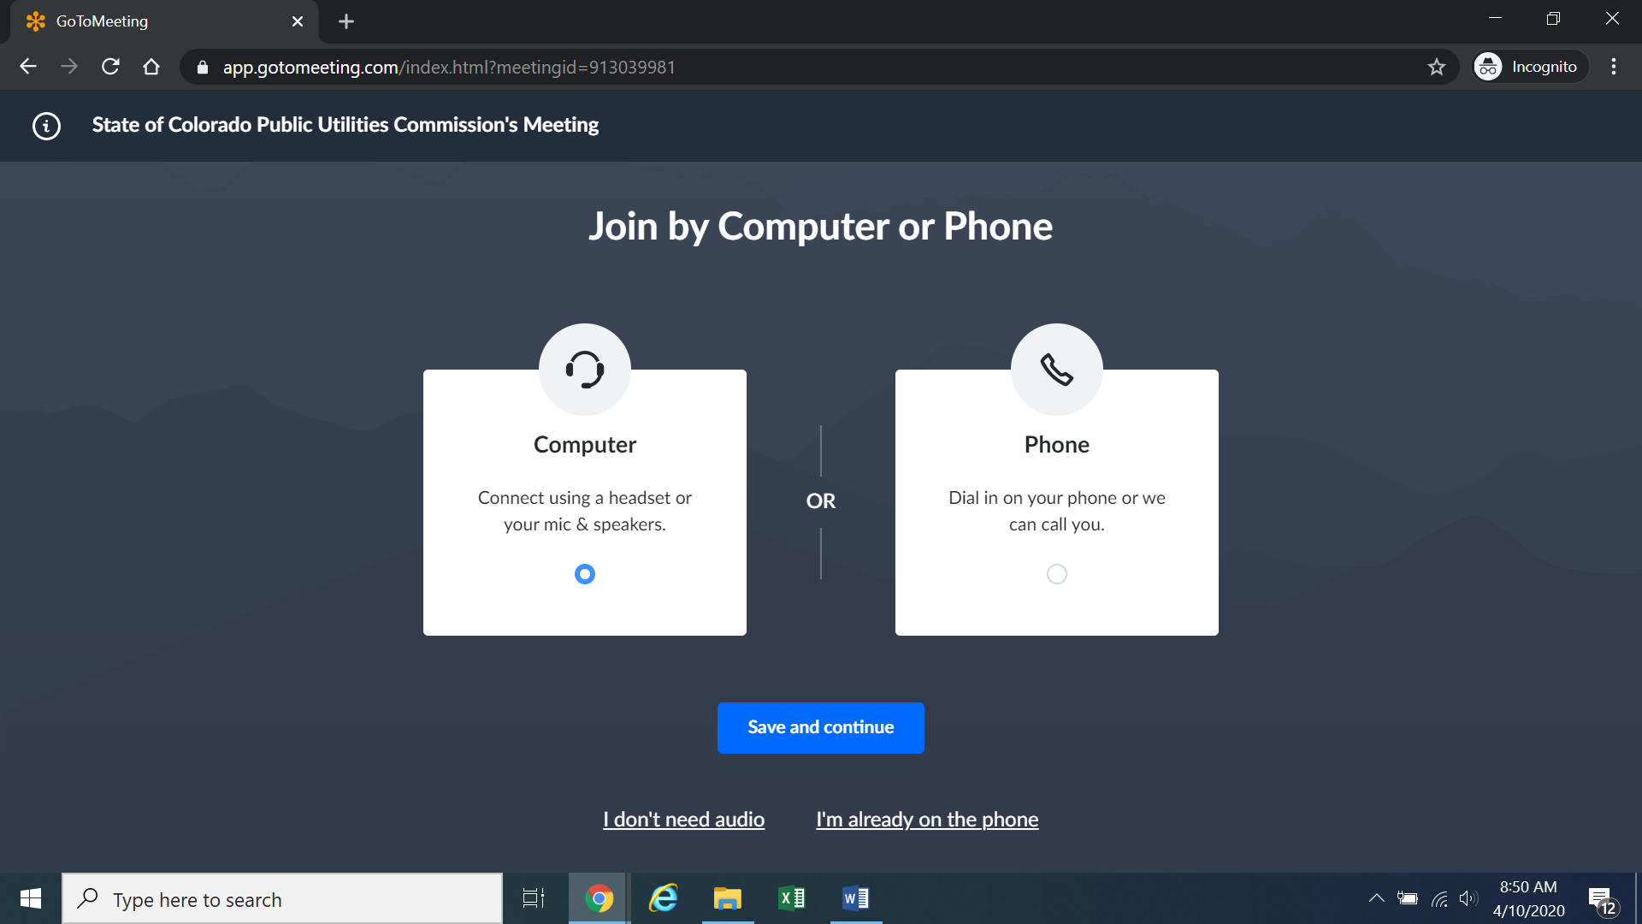
Confirm your audio settings and click “Save and continue.” Note: You may be prompted to allow the session to access your microphone and/or camera. Finally, you will be prompted to enter your name for identification during the session:
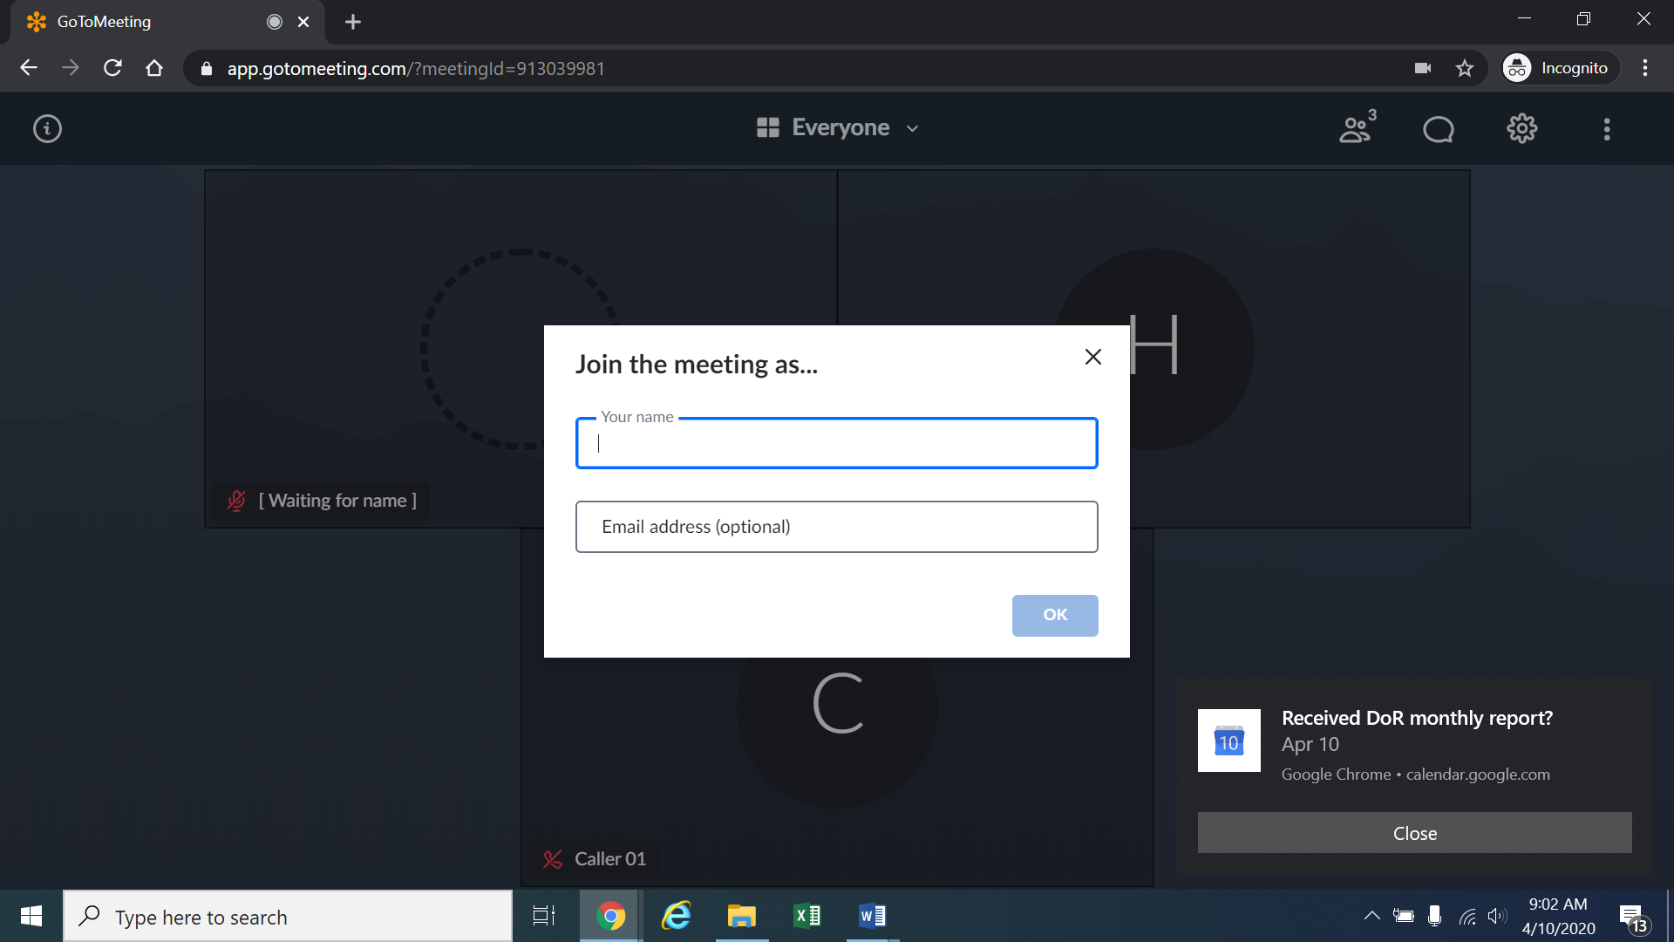
Alternatively, if there is any problem with the link provided included in the email provided by the ALJ, please go to https://app.gotomeeting.com/home.html and enter the nine-digit Meeting ID/Access Code included in the email.
- If you do not want others participating in the remote prehearing conference to see you, please click on the camera icon contained in the green circle at the bottom of the video screen. The icon will turn white and a slash will be placed over the camera icon indicating that your camera has been turned off. Likewise, if you do not want others participating in the remote prehearing conference to hear you, confirm that there is a slash over the microphone icon
- contained in the red circle indicating that your microphone has been turned off. In the screenshot of the webpage below, the microphone is turned off while the camera is turned on:
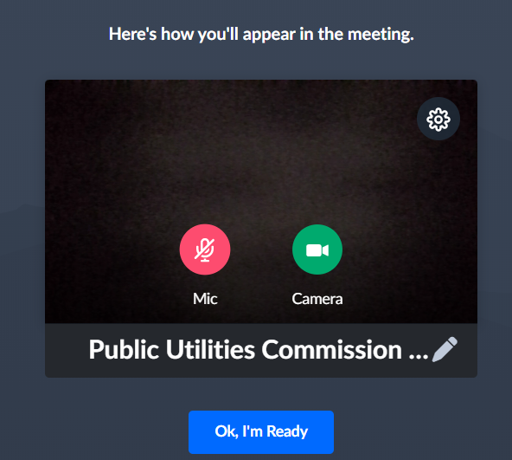
Conversely, the screenshot of the webpage below shows the microphone and video icons turned on and are ready to transmit video and audio when you join the hearing.
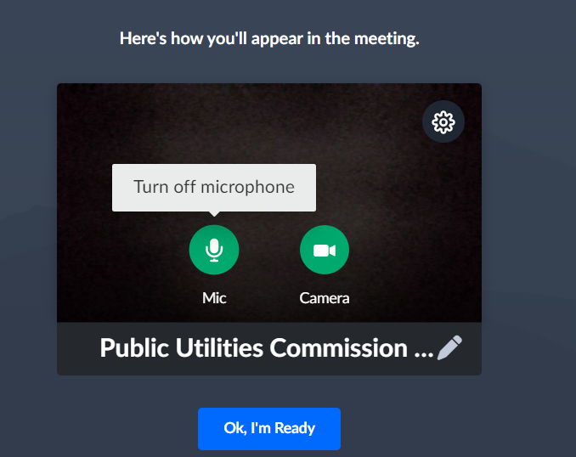
- You can control the volume of the audio through the volume controls on your computer. The screenshot below shows the screen after joining the remote prehearing conference with the camera turned on and the microphone turned off.
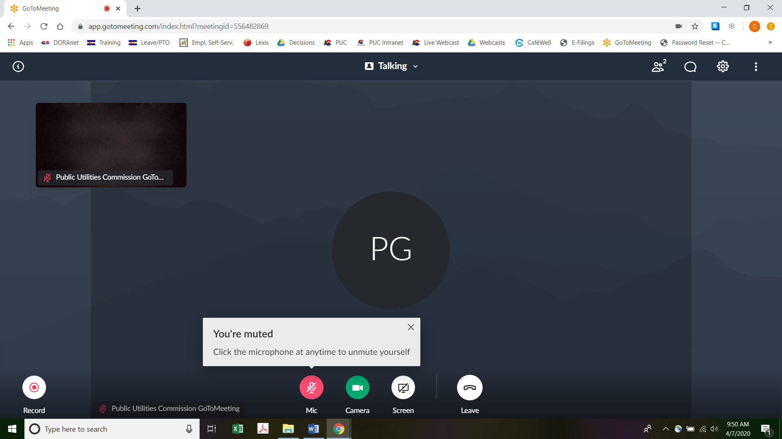
- All participants in the remote prehearing conference should mute (turn off) their microphones during the remote prehearing conference until called upon by the ALJ. When prompted by the ALJ, please click on the microphone icon to turn on your microphone and then commence speaking. The red circle around the microphone icon will turn green indicating that your microphone is turned on. While you are speaking, please listen for any direction you are given by the ALJ.
- To terminate your participation in the hearing, please click on the telephone handset icon with the word “Leave” underneath it and then click the “Yes” button in the pop-up box, or the “Not now” button if you would like to stay in the meeting, as shown in the screenshots below.
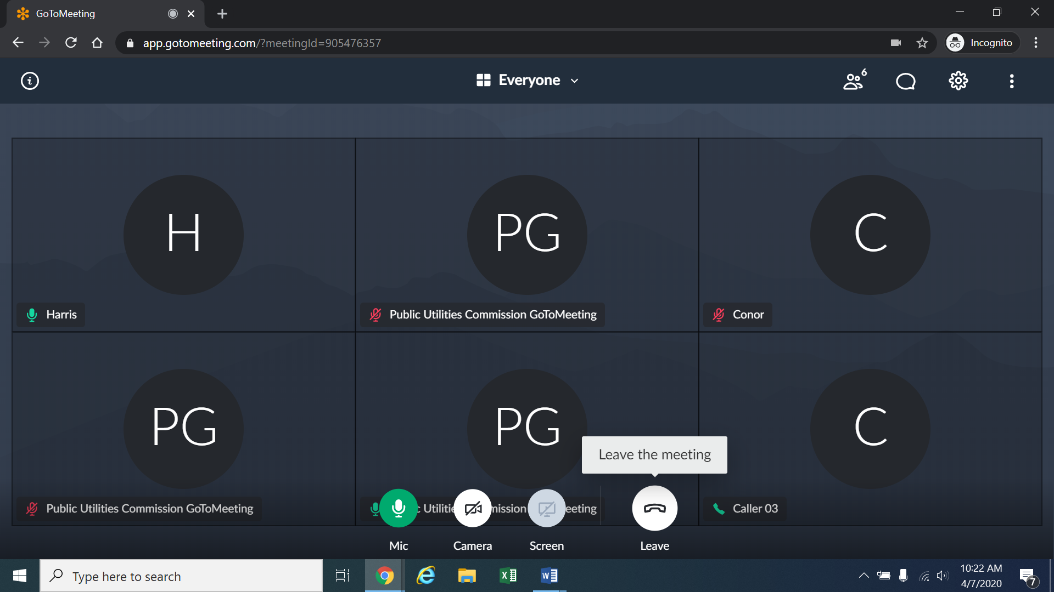
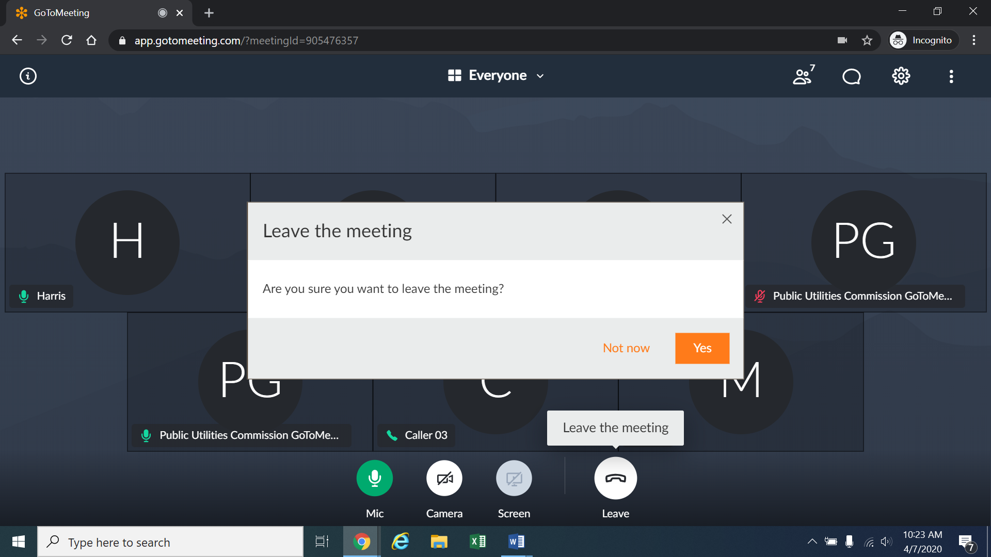

Instructions for Observing
- If you will not participate in the remote prehearing conference as a party, but would like to listen to the remote prehearing conference, please do not participate by telephone or computer as described above. Rather, please go to https://puc.colorado.gov/webcasts. The following webpage will appear.
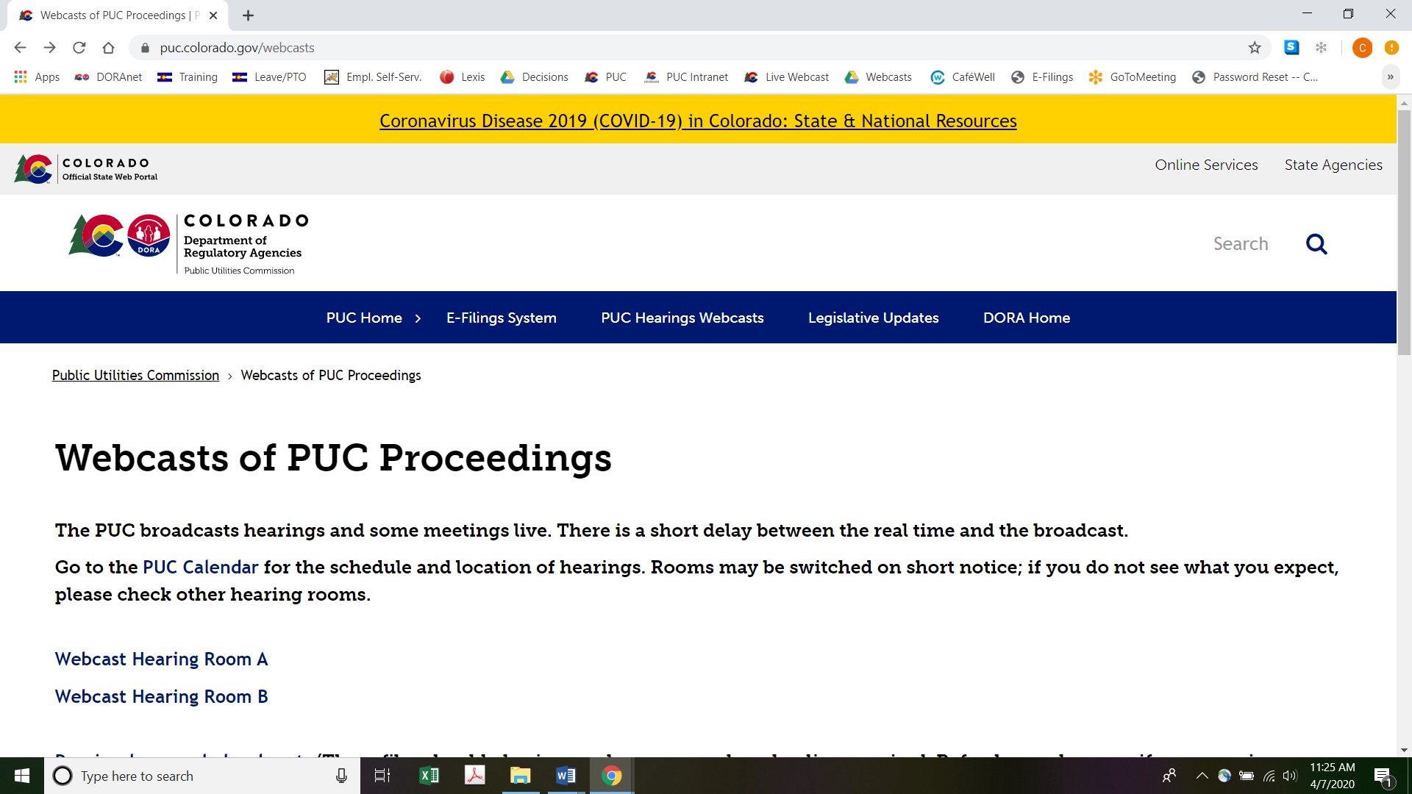
Please select the hearing room (“Webcast Hearing Room A” or “Webcast Hearing Room B”) listed for the remote prehearing conference on the Commission’s public calendar, available at https://puc.colorado.gov/puccalendar. Once the hearing room is selected, please click one of the “audio only” links (e.g., “Hearing Room A Audio Only (IOS)” or “Hearing Room A Audio Only (Android/Other)”), or click the play button on the black screen, to stream audio of the hearing live (with a short delay between real time and the broadcast, as noted in the screenshot above).

ORDER

It Is Ordered That:
- The prehearing conference scheduled for June 11, 2020 shall be converted into a remote prehearing conference. The parties and entities seeking party status must follow the instructions stated above and the information provided by the Administrative Law Judge by email. Members of the public should follow the instructions above for observing the remote prehearing conference. The parties, entities seeking party status, and members of the public should not attend the remote prehearing conference in-person.
- This Decision is effective immediately.

(S E A L)    ATTEST: A TRUE COPY  Doug Dean,  Director | THE PUBLIC UTILITIES COMMISSION  OF THE STATE OF COLORADO  CONOR F. FARLEY  ________________________________  Administrative Law Judge

Application at 2.
Direct Testimony of Barr W. Ingold at 7:8-14; Direct Testimony of Robert W. Wolaver at 3:12-23 (both filed with Application).
Decision No. C20-0282-I.
To minimize audio feedback, you are encouraged to listen using headphones connected to the audio/headset jack on your computer.

