Decision No. C23-0801-I
BEFORE THE PUBLIC UTILITIES COMMISSION OF THE STATE OF COLORADO
PROCEEDING NO. 23A-0392EG
IN THE MATTER OF THE APPLICATION OF PUBLIC SERVICE COMPANY OF COLORADO FOR APPROVAL OF ITS 2024-2028 CLEAN HEAT PLAN.
ERRATA NOTICE FOR
INTERIM COMMISSION DECISION
ESTABLISHING A PROCEDURAL SCHEDULE AND DISCOVERY PROVISIONS, SCHEDULING AN EVIDENTIARY HEARING, SCHEDULING A PUBLIC COMMENT HEARING, AND ESTABLISHING A DEADLINE FOR RESPONSIVE COMMENTS REGARDING HEARING VENUE
Errata mailed December 20, 2023
Original Decision No. C23-0801-I mailed December 4, 2023

- Ordering Paragraph 3 indicates the incorrect hearing date of January 10, 2024 at 4:00 p.m. until 6:00 p.m.
Ordering Paragraph 3 is amended to reflect the correct hearing date of January 8, 2024 at 4:00 p.m. until 6:00 p.m.

(S E A L)    ATTEST: A TRUE COPY  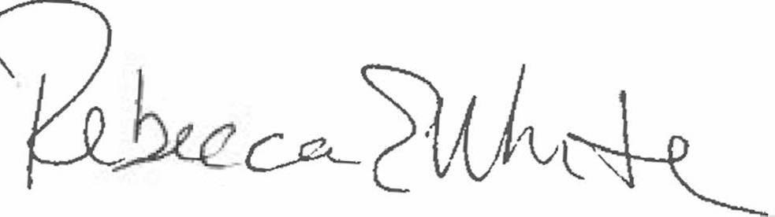  Rebecca E. White,  Director | THE PUBLIC UTILITIES COMMISSION  OF THE STATE OF COLORADO  REBECCA E. WHITE  ________________________________  Director

