Decision No. C23-0741-I-E
BEFORE THE PUBLIC UTILITIES COMMISSION OF THE STATE OF COLORADO
PROCEEDING NO. 23A-0533G
IN THE MATTER OF THE APPLICATION OF PUBLIC SERVICE COMPANY OF COLORADO FOR APPROVAL OF ITS 2024 GAS PRICE RISK MANAGEMENT PLAN AND TO APPROVE REVISED TARIFFS.
errata for
Interim commission decision ESTABLISHING
shortened notice AND INTERVENTION period
Errata mailed November 2, 2023
Original Decision No. C23-0741-I mailed November 1, 2023

- Ordering Paragraph No. 3 states:
The notice and intervention period shall expire at 5:00 p.m. on August 9, 2023.
Ordering Paragraph No. 3 is amended to read as follows:
The notice and intervention period shall expire at 5:00 p.m. on November 15, 2023.
(S E A L)    ATTEST: A TRUE COPY  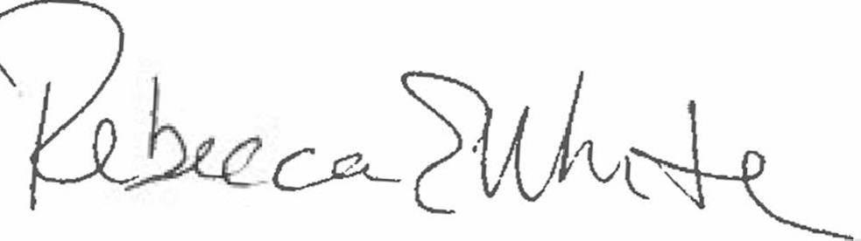  Rebecca E. White,  Director | THE PUBLIC UTILITIES COMMISSION  OF THE STATE OF COLORADO  REBECCA E. WHITE  ________________________________  Director

