Decision No. C23-0681-I
BEFORE THE PUBLIC UTILITIES COMMISSION OF THE STATE OF COLORADO
PROCEEDING NO. 21R-0538R
IN THE MATTER OF THE PROPOSED AMENDMENTS TO THE RULES REGULATING RAILROADS, RAIL FIXED GUIDEWAYS, TRANSPORTATION BY RAIL, AND RAIL CROSSINGS, 4 CODE OF COLORADO REGULATIONS 723-7.
Interim commission DECISION GRANTING MOTION FOR 14-DAY EXTENSION OF TIME TO FILE EXCEPTIONS TO RECOMMENDED
DECISION NO. R23-0618
Mailed Date: October 11, 2023
Adopted Date: October 11, 2023

BY THE COMMISSION

Statement, Findings, and Conclusions
- By this Decision, the Commission grants the Amended Motion for Extension of Time to File Exceptions (Motion), initially filed by Union Pacific Railroad Company (Union Pacific) on October 4, 2023, and then amended on October 6, 2023.
- Through the Motion, Union Pacific requests an extension of time to file exceptions to Recommended Decision No. R23-0618, issued September 22, 2023, by Administrative Law Judge Melody Mirbaba (Recommended Decision). The Recommended Decision adopts amendments to the Commission’s Rules Regulating Railroads, Rail Fixed Guideways, Transportation by Rail, and Rail Crossings, 4 Code of Colorado Regulations 723-7. Pursuant to § 40-6-109(2), C.R.S., the statutory deadline to file exceptions is October 12, 2023. As grounds for the Motion, Union Pacific states that it has experienced delay in obtaining the transcripts for this Proceeding from the assigned court reporter. Union Pacific requests a 14-day extension of time to file exceptions.
- On October 5, 2023, BNSF Railway Company (BNSF) filed a joinder in Union Pacific’s request for an extension of time to file exceptions. As grounds for its request for extension, BNSF also cited delay in obtaining the transcripts from the court reporter.
- Given the stated reasons for delay set forth by Union Pacific and BNSF, we find good cause to extend the deadline to file exceptions by the requested 14-day period. This extension applies to Union Pacific, BNSF, and any other rulemaking participant intending to file exceptions to the Recommended Decision.
- We also find it appropriate to waive the remaining response time to the Motion.

ORDER

It Is Ordered That:
- The Amended Motion for Extension of Time to File Exceptions (Motion), initially filed by Union Pacific Railroad Company on October 4, 2023, and amended on October 6, 2023, and joined by BNSF Railway Company on October 5, 2023, is granted.
- The deadline for rulemaking participants to file exceptions to Recommended Decision No. R23-0618 is extended to October 26, 2023.
- Response time to the Motion is waived.
- This Decision is effective upon its Mailed Date.

ADOPTED IN COMMISSIONERS’ WEEKLY MEETING
October 11, 2023.
(S E A L)    ATTEST: A TRUE COPY  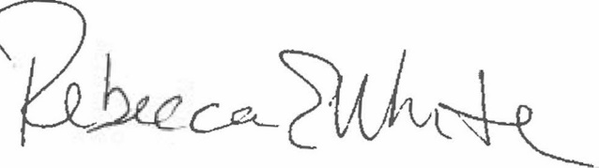  Rebecca E. White,  Director | THE PUBLIC UTILITIES COMMISSION  OF THE STATE OF COLORADO  ERIC BLANK  ________________________________  MEGAN M. GILMAN  ________________________________  TOM PLANT  ________________________________  Commissioners

