Decision No. C23-0518-I
BEFORE THE PUBLIC UTILITIES COMMISSION OF THE STATE OF COLORADO
PROCEEDING NO. 22AL-0483E
IN THE MATTER OF ADVICE LETTER NO. 834 FILED BY BLACK HILLS COLORADO ELECTRIC, LLC DOING BUSINESS AS BLACK HILLS ENERGY TO INCREASE THE TRANSMISSION COST ADJUSTMENT RIDER, TO BECOME EFFECTIVE JANUARY 1, 2023.
INTERIM Commission decision
STAYING RECOMMENDED DECISION
Mailed Date: August 4, 2023
Adopted Date: August 2, 2023

BY THE COMMISSION

Statement, Findings, and Conclusions
- By this Decision, the Commission stays Decision No. R23-0464, mailed
July 18, 2023, by Administrative Law Judge Aviv Segev (Recommended Decision). The Recommended Decision permanently suspends the tariff sheet filed by Black Hills Colorado Electric LLC, doing business as Black Hills Energy (Black Hills) pursuant to Advice Letter No. 834-Electric, and orders Black Hills to make an advice letter compliance filing to modify the tariff sheet consistent with the findings and conclusions in the Recommended Decision.
- Pursuant to § 40-6-109(2), C.R.S., Decision No. R23-0464 will become the decision of the Commission if no exceptions are filed within 20 days after service of the order, or within such extended period of time as the Commission may order. However, § 40-6-109(2), C.R.S., permits the Commission to stay a recommended decision upon its own motion.
- The Commission will stay Decision No. R23-0464 on its own motion to allow for a Commission review of the recommendation of the ALJ. We do not disturb any other deadlines in this Proceeding. At a future Commissioners’ Weekly Meeting, we will review the ALJ’s recommendations along with any exceptions filed within 20 days after Decision No. R23-0464 was mailed.

ORDER

The Commission Orders That:
- In accordance with § 40-6-109(2), C.R.S., Decision No. R23-0464, mailed
July 18, 2023, is stayed.
- The deadline for the filing of exceptions, August 7, 2023, and for responses to any exceptions, August 14, 2023, remain unchanged.
- This Decision is effective upon its Mailed Date.

ADOPTED IN COMMISSIONERS’ WEEKLY MEETING
August 2, 2023.
(S E A L)    ATTEST: A TRUE COPY  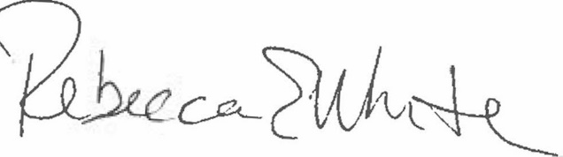  Rebecca E. White,  Director | THE PUBLIC UTILITIES COMMISSION  OF THE STATE OF COLORADO  ERIC BLANK  ________________________________  MEGAN M. GILMAN  ________________________________  TOM PLANT  ________________________________  Commissioners

