Decision No. C23-0486
BEFORE THE PUBLIC UTILITIES COMMISSION OF THE STATE OF COLORADO
PROCEEDING NO. 23A-0103R
IN THE MATTER OF THE CITY OF LONGMONT FOR AUTHORITY TO INSTALL CROSSING IMPROVEMENTS FOR THE PURPOSES OF IMPLEMENTING A QUIET ZONE AT THE 3RD AVENUE AND BNSF RAILWAY CROSSING (US DOT NO. 244848N) IN CITY OF LONGMONT, BOULDER COUNTY, STATE OF COLORADO.
commission decision granting motion
for extension of time
Mailed Date: July 27, 2023
Adopted Date: July 19, 2023

by the commission

Statement
- This matter comes before the Commission for consideration of a Request for Extension of Time (Motion) filed by the City of Longmont (Longmont) on June 26, 2023 requesting an extension of time to file the fully signed Construction and Maintenance Agreement and to file the Notice of Completion of Work to the Commission.
- As grounds for this Motion, Longmont states that the Construction and Maintenance Agreement has been signed by both Longmont and BNSF. However, execution of Exhibit B-1 – Revocable License Agreement, is pending from BNSF as of June 26, 2023. Longmont is requesting an extension of time to November 30, 2023 to file the fully signed Construction and Maintenance Agreement with signed exhibits.
- Because of the extension of time to file the fully signed Construction and Maintenance Agreement, Longmont also asks for an extension of time to September 30, 2024 to submit the notice of construction completion and updated National Inventory Form.
- There were no responses filed to this Motion.
- Now being fully advised in the matter, we grant the Motion.

ORDER

The Commission Orders That:
- The Request for Extension of Time (Motion) filed by the City of Longmont (Longmont) on June 26, 2023 requesting an extension of time to file the fully signed Construction and Maintenance Agreement and to file the Notice of Completion of Work to the Commission is granted.
- Longmont shall file the fully signed Construction and Maintenance Agreement by November 30, 2023, and the Notice of Completion of Work in this matter by
September 30, 2024. However, we understand this notice may be provided earlier than this date depending on changes to the construction schedule.
- The Commission retains jurisdiction to enter further decisions, as necessary.
- This Decision is effective on its Mailed Date.

ADOPTED IN COMMISSIONERS’ WEEKLY MEETING
July 19, 2023.
(S E A L)    ATTEST: A TRUE COPY  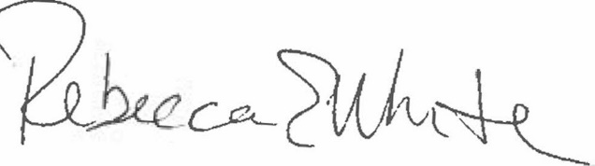  Rebecca E. White,  Director | THE PUBLIC UTILITIES COMMISSION  OF THE STATE OF COLORADO  ERIC BLANK  ________________________________  MEGAN M. GILMAN  ________________________________  TOM PLANT  ________________________________  Commissioners

