Decision No. C23-0296
BEFORE THE PUBLIC UTILITIES COMMISSION OF THE STATE OF COLORADO
PROCEEDING NO. 23A-0102R
IN THE MATTER OF THE APPLICATION OF THE COLORADO DEPARTMENT OF TRANSPORTATION, ON BEHALF OF THE TOWN OF WINDSOR, FOR AUTHORITY TO INSTALL 4-QUADRANT FLASHING LIGHT SIGNALS WITH GATES, BELLS, CONSTANT WARNING TIME CIRCUITRY, OVERHEAD CANTILEVER FLASHERS, NEW SIGNAL CABINET AND NEW CONCRETE CROSSING MATERIAL AT TRACKS OWNED BY GREAT WESTERN RAILWAY CROSSING COUNTY ROAD 17 (CR 17), USDOT NO. 849-379N, IN WELD COUNTY, STATE OF COLORADO.
commission decision
granting application
Mailed Date: May 9, 2023
Adopted Date: May 3, 2023

BY THE COMMISSION

Statement
- This matter comes before the Commission for consideration of an application (Application) filed by the Colorado Department of Transportation (CDOT) on behalf of the Town of Windsor (Windsor) on February 28, 2023, requesting authority to install active warning equipment consisting of four-quadrant flashing lights signals with gates and bells, overhead cantilever flashers, a new signal cabinet, constant warning time circuitry, and new concrete crossing materials using Federal Section 130 Funds and Town of Windsor funds, at the crossing of Weld County Road (WCR 17) with the tracks of the Great Western Railway of Colorado (GWR) at railroad mile post 26.36 of the Longmont Subdivision, National Inventory No. 8493789N, in Windsor, County of Weld, State of Colorado.
- The Commission gave notice of this Application (Notice) to all interested parties, including adjacent property owners pursuant to § 40-6-108(2), C.R.S. The Notice was mailed on March 13, 2023.
- There were no interventions in this matter.
- The Commission Application is this matter was automatically deemed complete within the meaning of § 40-6-109.5, C.R.S. by operation of rule on April 27, 2023.
- The Commission has jurisdiction in this matter under §§ 40-4-106(2)(a) and (3)(a), C.R.S.
- Now being fully advised in the matter, we grant the Application.

Findings of Fact
- The Commission gave notice to all interested parties, including the adjacent property owners. No intervention was received opposing the Application.
- CDOT requests authority to install active warning equipment consisting of four-quadrant flashing lights with gates and bells, new signal cabinet, constant warning time circuitry, and new concrete crossing material at the crossing of WCR 17 with the GWR.
- There has been one accident at the crossing involving property damage only that occurred in 2004.
- CDOT states the current traffic volume using the crossing is approximately 4,200 vehicles per day (VPD) at a posted speed limit of 55 miles per hour (MPH) with approximately 4 percent heavy vehicles using the crossing. School buses do use the crossing. Traffic is projected to grow to approximately 4.400 VPD by 2026 and 4,800 VPD by 2041. There are currently approximately two through train movements per day using the crossing at speeds of up to 10 MPH with no current projections of future train traffic growth.
- The estimated cost for the work at the crossing is $1,092,046.70 for the total project with the Town of Windsor paying for $75,000 of the project and the Federal Section 130 Funds paying $1,017,046.70 for the project.
- CDOT estimates that construction will begin on June 1, 2023, and be completed by December 31, 2024. CDOT will be required to file a copy of the signed Construction and Maintenance Agreement for this crossing prior to starting work at the crossing. We will expect this signed agreement to be filed no later than May 31, 2023, prior to the start of construction. We will also require CDOT to inform the Commission in writing that the crossing work is complete and operational within ten days of completion. The Commission will expect this letter by December 31, 2024. However, the Commission does understand this letter may be provided earlier or later than this date depending on changes or delays to the construction schedule.
- We will require CDOT and GWR to update their respective parts of the crossing inventory form for this crossing and file a copy of the updated crossing inventory form in this proceeding. The Commission will expect this information to be filed with the completion of the crossing work by December 31, 2024.

Conclusions
- The Commission has jurisdiction in this matter under §§ 40-4-106(2)(a) and (3)(a), C.R.S.
- No intervenor that filed a petition to intervene or other pleading contests or opposes the Application.
- Because the Application is unopposed, the Commission will determine this matter upon the record, without a formal hearing under § 40-6-109(5), C.R.S., and Rule 1403, Commission Rules of Practice and Procedure, 4 Code of Colorado Regulations 723-1.
- Based on the Findings of Fact, we find good cause exists and that the requirements of public safety are met by granting the Application consistent with the above discussion.

ORDER

The Commission Orders That:
- The application (Application) filed by the Colorado Department of Transportation (CDOT) on behalf of the Town of Windsor (Windsor) on February 28, 2023, requesting authority to install active warning equipment consisting of four-quadrant flashing lights signals with gates and bells, overhead cantilever flashers, a new signal cabinet, constant warning time circuitry, and new concrete crossing materials using Federal Section 130 Funds and Town of Windsor funds, at the crossing of Weld County Road (WCR) 17 with the tracks of the Great Western Railway of Colorado (GWR) at railroad mile post 26.36 of the Longmont Subdivision, National Inventory No. 8493789N, in Windsor, County of Weld, State of Colorado was automatically deemed complete within the meaning of § 40-6-109.5, C.R.S. by operation of rule on April 27, 2023.
- The Application is granted.
- CDOT is authorized and ordered to proceed with installation of active warning equipment consisting of four-quadrant flashing lights with gates and bells, new signal cabinet, constant warning time circuitry, and new concrete crossing material at the crossing of WCR 17 with GWR in Windsor, Colorado.
- CDOT shall file a copy of the signed Construction and Maintenance Agreement for this project by May 31, 2023, prior to starting work at the crossing.
- CDOT shall inform the Commission in writing that the crossing changes are complete and operational within ten days of completion. We shall expect this letter by December 31, 2024. However, we understand this letter may be provided earlier or later than this date depending on changes or delays to the construction schedule.
- CDOT and GWR shall be required to update the National Inventory Form for this crossing and file a copy of the updated crossing inventory form in this proceeding by December 31, 2024.
- The 20-day period provided for in § 40-6-114, C.R.S., within which to file applications for rehearing, reargument, or reconsideration, begins on the first day following the effective date of this Decision.

- This Decision is effective on its Mailed Date.

ADOPTED IN COMMISSIONERS’ WEEKLY MEETING
May 3, 2023.
(S E A L)    ATTEST: A TRUE COPY  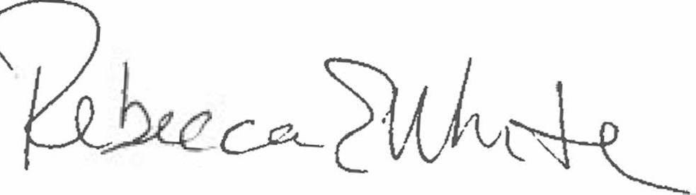  Rebecca E. White,  Director | THE PUBLIC UTILITIES COMMISSION  OF THE STATE OF COLORADO  ERIC BLANK  ________________________________  MEGAN M. GILMAN  ________________________________  TOM PLANT  ________________________________  Commissioners

