Decision No. C23-0139-E
BEFORE THE PUBLIC UTILITIES COMMISSION OF THE STATE OF COLORADO
PROCEEDING NO. 23L-0080E
IN THE MATTER OF the application of public service company of colorado for an order authorizing it to revise its ELECTRIC COMMODITY adjustment to be effective mARCH 1, 2023, on less than statutory notice.
ERRATA NOTICE FOR
COMMISSION DECISION APPROVING DOWNWARD ADJUSTMENT AND GRANTING MOTIONS
Errata mailed February 27, 2023
Original Decision No. C23-0139 mailed February 24, 2023

- The Original Ordering Paragraph 4 was omitted: Order Paragraph 4 shall be inserted to read as follows:
Public Service shall file a new advice letter and tariff on not less than one business days’ notice to put into effect the tariff attached to the Application. The advice letter and tariff shall be filed as a new advice letter proceeding and shall comply with all applicable rules. In calculating the proposed effective date, the date the filing is received at the Commission is not included in the notice period and the entire notice period must expire prior to the effective date. The advice letter and tariff must comply in all substantive respects to this Decision in order to be filed as a compliance filing on shortened notice. These tariffs shall be effective for actual electricity sales on or after their effective date of March 1, 2023.Black Hills Colorado Electric, LLC.

- Ordering Paragraph 4 through 12 becomes Ordering Paragraph 5 through 13.
(S E A L)    ATTEST: A TRUE COPY  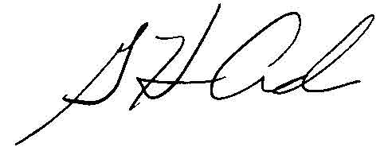  G. Harris Adams,  Interim Director | THE PUBLIC UTILITIES COMMISSION  OF THE STATE OF COLORADO  G. HARRIS ADAMS  ________________________________  Interim Director

