Decision No. C23-0092
BEFORE THE PUBLIC UTILITIES COMMISSION OF THE STATE OF COLORADO
PROCEEDING NO. 22A-0059CP
IN THE MATTER OF THE APPLICATION OF PALISADE TROLLEY LLC FOR A
CERTIFICATE OF PUBLIC CONVENIENCE AND NECESSITY TO OPERATE AS A
COMMON CARRIER BY MOTOR VEHICLE FOR HIRE.
COMMISSION DECISION
DECLINING TO ACCEPT PETITION FOR DECLARATORY ORDER
Mailed Date: February 9, 2023
Adopted Date: February 8, 2023

BY THE COMMISSION

Statement
- On January 26, 2023, Palisade Trolley filed a Petition for Declaratory Order asking this Commission to issue a written decision addressing the exceptions filed in this proceeding and to provide the company with a timeline by which it may expect its letters of authority to be issued.
- Rule 1304(f) provides that the Commission may issue a declaratory order to remove an uncertainly affecting a petitioner with respect to any Commission order and may dismiss or otherwise not accept any petition requesting such an order.
- In this case, the Commission issued the written decision that was the subject of Palisade Trolley’s petition on February 1, 2023. And, today, it has modified Decision No. C23-0070 to include a list of compliance items highlighted from our rules. If Palisade Trolley makes the necessary filings and payments, the Commission will be able to issue any Letters of Authority in short order.
- This resolves the questions Palisade Trolley raised in its Petition and therefore we see no remaining uncertainty which could be resolved by accepting the Petition.

ORDER

It Is Ordered That:
- The Commission declines to accept the Petition for Declaratory Order filed on January 26, 2023, by Palisade Trolley.
- The 20-day period provided for in § 40-6-114, C.R.S., within which to file applications for rehearing, reargument, or reconsideration, begins on the first day following the effective date of this Decision.

- This Decision is effective upon its Mailed Date.

ADOPTED IN COMMISSIONERS’ WEEKLY MEETING
February 8, 2023.
(S E A L)    ATTEST: A TRUE COPY  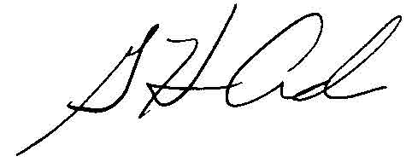  G. Harris Adams,  Interim Director | THE PUBLIC UTILITIES COMMISSION  OF THE STATE OF COLORADO  ERIC BLANK  ________________________________  MEGAN M. GILMAN  ________________________________  TOM PLANT  ________________________________  Commissioners

