Decision No. C22-0712
BEFORE THE PUBLIC UTILITIES COMMISSION OF THE STATE OF COLORADO
PROCEEDING NO. 21A-0319R
IN THE MATTER OF THE APPLICATION OF THE TOWN OF CASTLE ROCK, COLORADO, 80109 FOR AUTHORITY TO MODIFY THE CROSSING PROTECTION EQUIPMENT AT THE EXISTING AT-GRADE CROSSINGS OF THE UNION PACIFIC RAILROAD TRACKS AT 2ND, 3RD, AND 5TH STREETS IN CASTLE ROCK, COLORADO.
commission DECISION granting waiver and denying application for rehearing, reargument, and reconsideration as moot
Mailed Date: November 10, 2022
Adopted Date: November 9, 2022

by the commission

Statement
- This matter comes before the Commission for consideration of a Joint Motion for Variance (Joint Motion) Pursuant to 4 CCR 723-1-1003 and a Joint Application for Rehearing, Reargument, or Reconsideration (RRR) pursuant to §40-6-114, C.R.S. and 4 CCR 723-1-1506 filed by Union Pacific Railroad Company (UPRR) and the Town of Castle Rock (Castle Rock or Town) on October 11, 2022.
- Now being fully advised in the matter, we grant the Motion for Variance of Commission Rule 4 Code of Colorado Regulations (CCR) 723-7-7301(a) of the Commissions Rules Regulating Railroads, Rail Fixed Guideways, Transportation by Rail, and Rail Crossings a deny the Application for RRR as moot consistent with the discussion below.

Finding of Fact
- On July 1, 2021, Castle Rock filed an unopposed application in this proceeding to authorize modifications of the railroad crossing protection equipment at the 2nd, 3rd, and 5th Street crossings with the tracks of the Union Pacific Railroad Company (UPRR), which establish quiet zones and was granted through Decision No. C21-0527 issued August 27, 2021 (Initial Approval Decision). The Initial Approval Decision clarified that Rule 7301(a) requires railroads to maintain all passive and active crossing warning devices at the railroads’ cost for the life of the crossing, and specifically denied cost allocations assigned only to Castle Rock in the Application. Through subsequent decisions, the Commission permitted extensions of time for construction and maintenance (C&M) agreements to be filed given ongoing negotiations between Castle Rock and UPRR. However, no RRR or request to modify the cost-allocation determinations in the Initial Approval Decision were filed.
- On August 30, 2022, Castle Rock filed an Unopposed Motion to Accept Late Filing of Signed C&M Agreements. The attached C&M agreements contained cost-allocations that were specifically denied by the Commission in the Initial Approval Decision without support or explanation. Through its September Decision, the Commission therefore denied the unopposed motion to accept late filing of signed C&M agreements without a showing of good cause to waive Rule 7301(a) or modify the Initial Approved Decision. The Commission instructed the Town of Castle Rock to file C&M agreements that conformed with the Initial Approval Decision or other appropriate pleadings by November 30, 2022.
- On October 11, 2022, UPRR and Castle Rock filed a request for RRR concurrent with the Joint Motion seeking a variance from Rule 7301(a).
- In the Joint Motion for variance, the parties argue that the Town is making changes to seek and establish a quiet zone through Castle Rock, which UPRR argues eliminates one of the operational safety protocols that complies with FRA requirement and which UPRR claims that it derives no ascertainable benefit from a quiet zone, only Castle Rock. Because of these UPRR opinions, and because the parties state that for the sake of fairness and equity, the parties concur that UPRR should not pay for maintenance on this project.
- Through the concurrently filed RRR, the parties ask that the Commission reconsider its September Decision that instructed the parties to provide C&M agreements in conformation with the Initial Approval Decision or provide appropriate pleadings explaining good cause waiver of the Rule 7301(a). In RRR the parties ask that the Commission simply accept the previously filed pleadings from August 30, 2022.

Discussion and Conclusions
- There are a number of statements made in the Joint Motion that are opinion based, exclude statutory policy requirements regarding highway-rail grade crossing safety, and ignore the Commissions policy reasons for establishing Commission Rule 4 CCR 723-7-7301(a), which requires railroads to maintain all passive and active crossing warning devices at the railroads’ cost for the life of the crossing.
- First, UPRR argues that quiet zones eliminate train horns, which the railroad argues are one of UPRRs operational safety protocols that comply with Federal Railroad Administration (FRA) requirements. However, it is through FRA rules regarding the use of train horns by railroads that quiet zone requirements were developed by FRA. For crossings designated as quiet zones, in lieu of train horns, supplemental safety measures were developed by FRA as appropriate safety substitutions. UPRR’s statements miss the point that other safety measures are necessarily in place under FRA guidelines.
- Additionally, while UPRR states its opinion that it derives no ascertainable benefit from a quiet zone, the increased level of safety at the crossing using the supplemental safety measures developed by FRA equates to increased benefits to both railroads and road authorities and not, as UPRR opines, only an increase in benefits to Castle Rock.
- We disagree with UPRR that the railroad receives no benefit in the crossing updates, which further underlies the policy supporting Rule 7301(a) that requires some costs obligations be placed on the railroad. However, in this case, and based on the updated filings in this case, we agree that good cause exists to waive the rule and allow the project to move forward as unanimously agreed in the interest of the needs of the Castle Rock community.
- Because we grant the Joint Motion, the request for RRR seeking reconsideration of the September Decision filed concurrently with the Joint Motion that aimed to comply with the direction in the September Decision, is moot and therefore denied, consistent with the discussion above.

ORDER

The Commission Orders That:
- The Joint Motion for Variance pursuant to 4 CCR 723-1-1003 requesting a variance from 4 Code of Colorado Regulations (CCR) 723-7-7301(a) of the Commission’s Rules Regulating Railroads, Rail Fixed Guideways, Transportation by Rail, and Rail Crossings is granted.
- The Joint Application for Rehearing, Reargument, or Reconsideration pursuant to §40-6-114, C.R.S. and 4 CCR 723-1-1506 filed by Union Pacific Railroad Company (UPRR) and the Town of Castle Rock (Castle Rock) is denied as moot.
- This Decision is effective on its Mailed Date.

ADOPTED IN COMMISSIONERS’ WEEKLY MEETING
November 9, 2022.

(S E A L)    ATTEST: A TRUE COPY  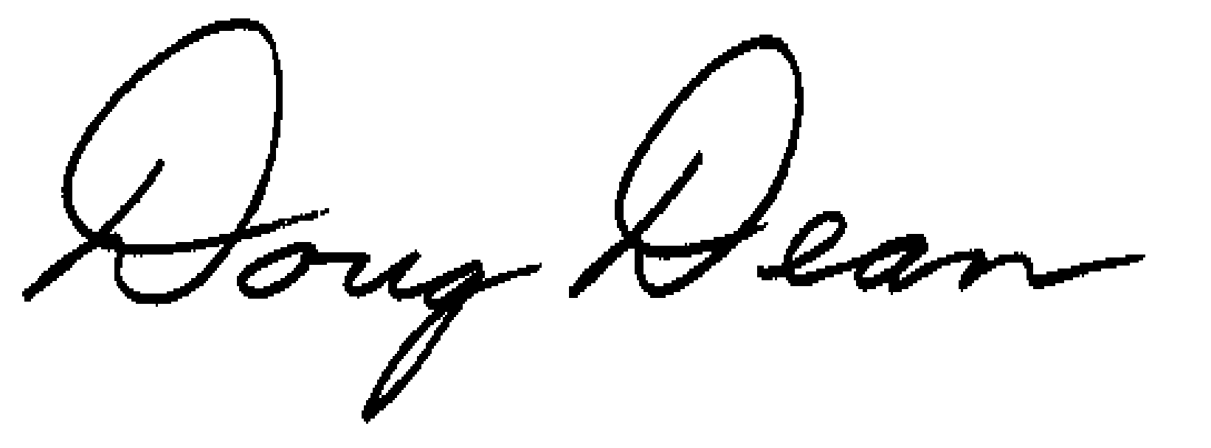  Doug Dean,  Director | - THE PUBLIC UTILITIES COMMISSION  OF THE STATE OF COLORADO  ERIC BLANK  ________________________________  JOHN C. GAVAN  ________________________________  MEGAN GILMAN  ________________________________  Commissioners

UPRR was granted intervention in this proceeding but does not oppose the Application nor any subsequent filing.
See Decision No. C21-0527, issued August 27, 2021, at ¶ 12 and Ordering ¶ 4.
Decision No. C22-0565, issued September 21, 2022.

