Decision No. C21-0051-I
BEFORE THE PUBLIC UTILITIES COMMISSION OF THE STATE OF COLORADO
PROCEEDING NO. 20A-0345E
IN THE MATTER OF THE VERIFIED APPLICATION OF PUBLIC SERVICE COMPANY OF COLORADO FOR APPROVAL OF AN ECONOMIC DEVELOPMENT RATE (EDR) PROPOSAL PURSUANT TO COLORADO HB 18-1271.
INTERIM COMMISSION DECISION Granting, with modifications, the unopposed motion to Amend the procedural deadlines and waiver of response time
Mailed Date: January 28, 2021
Adopted Date: January 27, 2021

BY THE COMMISSION

Statement
- This Decision grants with modifications the Unopposed Motion to Amend the Procedural Deadlines (Unopposed Motion) and Waiver of Response Time filed by Trial Staff of the Commission (Trial Staff) on January 22, 2021.

Discussion
- On August 21, 2020, Public Service Company of Colorado (Public Service or the Company) filed an application to implement an Economic Development Rate (EDR) pursuant to House Bill 18-1271. The proposed EDR is designed to recruit incremental or expanded loads from large customers through a rate discount via contracts up to ten years. By Decision No. C20-0702-I, issued October 6, 2020, the Commission deemed the application complete and set the matter for hearing en banc.
- The parties to this proceeding are Trial Staff, the Office of Consumer Counsel, and the Colorado Energy Consumers (collectively “Parties”) as established by Decision No. C20-0726-I, issued October 9, 2020. Black Hills Colorado Electric, LLC is also participating in this proceeding as amicus curiae, and as a non-litigating party was not consulted for purposes of this Unopposed Motion.
- On January 14, 2021, through Decision No. C21-0032-I, the Commission directed the Company to respond to five prompts for additional information by submitting Second Supplemental Direct Testimony on or before January 25, 2021.
- On January 22, 2021, Trial Staff filed the Unopposed Motion, explaining it is designed to provide the Parties sufficient time to conduct discovery and prepare Answer Testimony on Public Service’s Second Supplemental Direct Testimony.
- The Unopposed Motion modifies the date at which Answer Testimony is due from February 8, 2021, to February 16, 2021; the date for Rebuttal and Cross-Answer Testimony from March 12, 2021, to March 15, 2021; and the date which Stipulations and/or Settlement Agreements are due from March 22, 2021, to March 26, 2021. The procedural schedule is as follows:
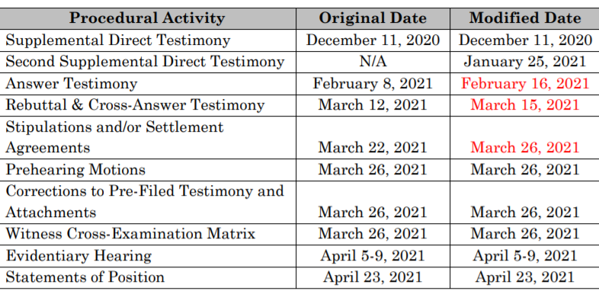
- The Motion also requests that the Commission waive response time to the Motion since it is unopposed.

Conclusions and Findings
- The Commission finds the proposed schedule changes per the Unopposed Motion are conducive to producing a viable record in this proceeding with one modification. In order to minimize confusion and overlap of activities, we adjust the date of submission of the Witness Cross-Examination Matrix from March 26, 2021 to March 30, 2021.

ORDER

The Commission Orders That:
- Subject to the modification discussed above, we grant the Unopposed Motion to Amend Procedural Deadlines and for Waiver of Response Time.
- The waiver of response time is granted.
- This Decision is effective upon its Mailed Date.

ADOPTED IN COMMISSIONERS’ WEEKLY MEETING
January 27, 2021.

(S E A L)    ATTEST: A TRUE COPY  Doug Dean,  Director | THE PUBLIC UTILITIES COMMISSION  OF THE STATE OF COLORADO  ERIC BLANK  ________________________________  JOHN GAVAN  ________________________________  MEGAN M. GILMAN  ________________________________  Commissioners

