Decision No. R23-0559-I-E
BEFORE THE PUBLIC UTILITIES COMMISSION OF THE STATE OF COLORADO
PROCEEDING NO. 23R-0085TO
IN THE MATTER OF THE PROPOSED AMENDMENTS TO THE COMMISSION’S RULES REGULATING TOWING CARRIERS, 4 CODE OF COLORADO REGULATIONS 723-6, TO IMPLEMENT HB 22-1314.
ERRATA NOTICE FOR
interim decision OF
ADMINISTRATIVE LAW JUDGE
ALENKA HAN
issuing hearing exhibit 4
Errata Mailed August 24, 2023
Original Decision No. R23-0559-I mailed on August 22, 2023

- Ordering Paragraph 1 indicated public comment hearing will take place on
July 25, 2023.
This date should be amended to August 31, 2023.
(S E A L)    ATTEST: A TRUE COPY  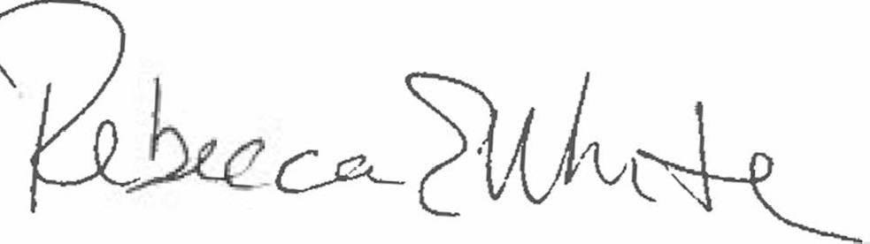  Rebecca E. White,  Director | THE PUBLIC UTILITIES COMMISSION  OF THE STATE OF COLORADO  REBECCA E. WHITE  ________________________________  Director

