Decision No. R23-0447-I
BEFORE THE PUBLIC UTILITIES COMMISSION OF THE STATE OF COLORADO
PROCEEDING NO. 23G-0153TO
COLORADO PUBLIC UTILITIES COMMISSION,
COMPLAINANT,
V.
SLADE DICK, DOING BUSINESS AS S&R AFFORDABLE TOWING LLC
RESPONDENT.
PROCEEDING NO. 23G-0154TO
COLORADO PUBLIC UTILITIES COMMISSION,
COMPLAINANT,
V.
SLADE DICK, DOING BUSINESS AS S&R AFFORDABLE TOWING LLC
RESPONDENT.
INTERIM DECISION OF
ADMINISTRATIVE LAW JUDGE
conor f. farley
SCHEDULING REMOTE HEARING, ADDRESSING EXHIBITS, SETTING DEADLINE FOR MOTION TO RESCHEDULE remote HEARING AND
PROVIDING OTHER ADVISEMENTS
Mailed Date: July 10, 2023

STATEMENT

Procedural history
- On March 31, 2023, the Colorado Public Utilities Commission (Commission) filed Civil Penalty Assessment or Notice of Complaint to Appear (CPAN) No. 135021 and 135131 (CPANs), which each allege that Slade Dick, doing business as S&R Affordable Towing LLC (S&R Affordable Towing) violated §§ 40-10.1-107(1), 401(1)(a) on February 28, 2023 and February 24, 2023, respectively. The CPANs each state that the civil penalty assessed for the alleged violations is $13,915, but that if Skyline Towing pays the civil penalty within ten calendar days of its receipt of the CPAN, the civil penalty will be reduced to $6,957.50. Finally, the CPANs each state that, if the Commission does not receive payment within ten days, the CPAN will convert into a Notice of Complaint to Appear, and a hearing will be scheduled at which the Commission Staff will seek the “Total Amount” of $13,915. The CPAN also states that the Commission may order Skyline Towing to cease and desist from violating statutes and Commission rules.
- The CPAN states that the Commission personally served the CPANs on
March 30, 2023.
- S&R Affordable Towing has not paid any amount, much less the reduced civil penalty amount or the total civil penalty amount, of the CPAN.
- On April 20, 2023, Trial Staff of the Commission (Staff) filed a Notice of Intervention and Entry of Appearance.
- On April 26, 2023, the Commission referred this proceeding to an Administrative Law Judge (ALJ) for disposition. The proceeding was subsequently assigned to the undersigned ALJ.
- On May 23, 2023, the ALJ issued Decision No. R23-0341-I that consolidated Proceeding Nos. 23G-0153TO and 23G-0154TO and provided the opportunity for the parties to file a statement addressing the preference for a remote, hybrid, or in-person hearing.
- On May 30, 2023, Staff filed a Statement Regarding Hearing in which Staff stated that it prefers “either a remote or hybrid hearing to allow witnesses and counsel to appear virtually.” Staff also requested that the hearing not be scheduled during August 7-12, 2023 and August 14-18, 2023 due to the unavailability of witnesses or counsel.
- S&R Affordable Towing has not filed a statement expressing a preference for a type of hearing.

Hearing
- The hearing will be scheduled for August 29, 2023 at 9:00 a.m. as a remote hearing. At the remote hearing, the parties may call witnesses, present evidence, and make arguments in support of their position. Evidence includes documentary exhibits, testimony, and other tangible items that a party wishes the ALJ to consider in reaching a decision as to the allegations in this case.
- Attachment A to this Decision provides the information addressing how to use the Zoom platform for remotely participating in the remote hearing. Attachment B outlines procedures and requirements for marking and formatting exhibits to facilitate the efficient and smooth electronic evidence presentations at the remote hearing. It is extremely important that the parties carefully review and follow all requirements in this Decision and Attachments A and B.
- To minimize the potential that the video-conference part of the hearing may be disrupted by non-participants, the link, meeting ID code, and passcode to attend the hearing will be provided to the participants by email before the hearing, and the participants will be prohibited from distributing that information to anyone not participating in the hearing.
- If a party cannot attend the remote hearing on August 29, 2023, the party with the scheduling conflict must file a motion to reschedule the remote hearing by July 20, 2023. Before filing the motion to reschedule, the filing party must confer with the other party about whether the other party opposes the motion and the dates that both parties are available in
September 2023, except for September 8, 2023 and September 20-22, 2023. The motion to reschedule must then: (a) state whether it is opposed or unopposed; (b) identify the dates that both parties are available for a remote hearing in September 2023 (other than the dates noted above); and (c) identify the number of days that the parties anticipate the remote hearing will take.
- The parties are on notice that the ALJ will retain the discretion to change the method by which the hearing will be conducted (i.e., from remote to hybrid or in-person).

Exhibits
- Given that the hearing will be a remote hearing in which the parties, witnesses, attorneys, and the ALJ will accommodate remote participation by video-conference, exhibits must be presented electronically. The Public Utilities Commission utilizes Box.com to manage exhibits in a remote hearing. Attachment B to this Decision provides detailed instructions for the preparation and presentation of exhibits at the hearing through Box.com.
- Each party will receive an email containing an invitation to sign up for a free Box.com account. Once signed-up, each party will be invited to share a folder with (only) the staff in the Administrative Hearings Section, Commission advisors, and potentially Commissioners and Commission counsel. The party may share access to its Box.com account with others as they choose.

Additional Advisements
- The parties are advised and are on notice that this proceeding is governed by the Rules of Practice and Procedure found at 4 CCR 723-1. The ALJ expects the parties to be familiar with and to comply with these rules. The rules are available on the Commission’s website (https://puc.colorado.gov/pucrules) and in hard copy from the Commission.

ORDER

It Is Ordered That:
- A remote hearing is scheduled as follows:
DATE: August 29, 2023
TIME: 9:00 a.m. to 5:00 p.m.
PLACE: By video conference: using the Zoom web conferencing platform at a link be provided to the participants by email .
- The deadline to file a Motion to Reschedule the Remote Hearing is July 25, 2023.
- This Decision is effective immediately.
(S E A L)    ATTEST: A TRUE COPY  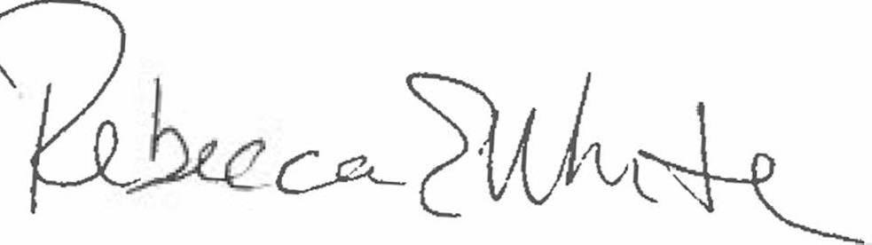  Rebecca E. White,  Director | THE PUBLIC UTILITIES COMMISSION  OF THE STATE OF COLORADO  CONOR F. FARLEY  ________________________________  Administrative Law Judge

CPAN Nos. 135021 and 135131 at 3.
Id.
Staff’s Statement Regarding Hearing at 1.
Id. at 2 (¶ 2).
Additional information about the Zoom platform and how to use the platform are available at: https://zoom.us/. All participants are strongly encouraged to participate in a test meeting prior to the scheduled hearing. See https://zoom.us/test.

