Decision No. R23-0292-E
BEFORE THE PUBLIC UTILITIES COMMISSION OF THE STATE OF COLORADO
PROCEEDING NO. 22F-0365E
SUNSHARE, LLC,
COMPLAINANT,
V.
PUBLIC SERVICE COMPANY OF COLORADO,
RESPONDENT.
ERRATA NOTICE FOR
RECOMMENDED DECISION of
administrative law judge
Conor F. Farley
DENYING CLAIMS IN COMPLAINT AND CLOSING PROCEEDING
Errata mailed May 15, 2023
Original Decision No. R23-0292 mailed May 3, 2023

- Paragraph 73 currently reads as follows:
Based on the foregoing, the ALJ concludes that Public Service has not carried its burden of proving that Public Service violated the Commission Decisions.
This is incorrect. Paragraph 73 shall be amended to state:
Based on the foregoing, the ALJ concludes that Sunshare has not carried its burden of proving that Public Service violated the Commission Decisions.

(S E A L)    ATTEST: A TRUE COPY  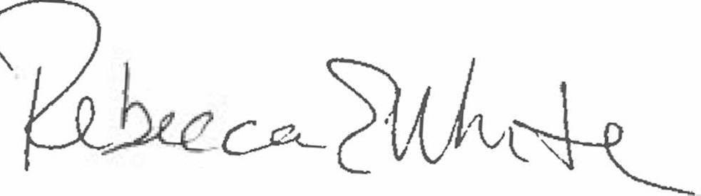  Rebecca E. White,  Director | THE PUBLIC UTILITIES COMMISSION  OF THE STATE OF COLORADO  CONOR F. FARLEY  ________________________________  Administrative Law Judge

