Decision No. R23-0212-I
BEFORE THE PUBLIC UTILITIES COMMISSION OF THE STATE OF COLORADO
PROCEEDING NO. 22F-0263EG
OLSON’S GREENHOUSES OF COLORADO, LLC,
COMPLAINANT,
V.
PUBLIC SERVICE COMPANY OF COLORADO,
RESPONDENT.
interim DECISION of
administrative law judge
Conor F. Farley
granting unopposed motion to RESPOND TO MOTION IN LIMINE
Mailed Date: March 31, 2023

STATEMENT

Relevant Background
- On March 17, 2023, Public Service Company of Colorado filed a Motion in Limine to exclude certain testimony of David E. Dismukes (Motion).
- On March 24, 2023, Olson’s Greenhouses of Colorado, LLC filed an Unopposed Motion for Extension of Time to respond to the Motion (Unopposed Motion).

Analysis
- Public Service does not oppose the relief sought in the Unopposed Motion. The Unopposed Motion states good cause for the requested relief. Accordingly, it will be granted.

ORDER

The Commission Orders That:
- The Unopposed Motion for Extension of Time to Respond to the Motion filed by Olson’s Greenhouses of Colorado, LLC on March 24, 2023, is granted.
- This Decision is effective immediately.

(S E A L)    ATTEST: A TRUE COPY  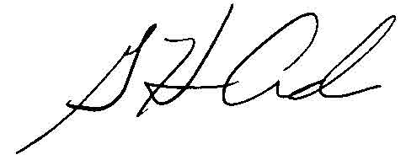  G. Harris Adams,  Interim Director | THE PUBLIC UTILITIES COMMISSION  OF THE STATE OF COLORADO  CONOR F. FARLEY  ________________________________  Administrative Law Judge

