Decision No. R23-0191-I
BEFORE THE PUBLIC UTILITIES COMMISSION OF THE STATE OF COLORADO
PROCEEDING NO. 22AL-0530E
IN THE MATTER OF ADVICE LETTER NO. 1906 - ELECTRIC FILED BY PUBLIC SERVICE COMPANY OF COLORADO TO REVISE ITS COLORADO P.U.C. NO. 8 - ELECTRIC TARIFF TO INCREASE BASE RATE REVENUES, IMPLEMENT NEW BASE RATES FOR ALL ELECTRIC RATE SCHEDULES, AND MAKE OTHER TARIFF CHANGES, TO BECOME EFFECTIVE DECEMBER 31, 2022.
PROCEEDING NO. 22AL-0478E
IN THE MATTER OF ADVICE LETTER NO. 1902 - ELECTRIC FILED BY PUBLIC SERVICE COMPANY OF COLORADO TO REVISE ITS COLORADO P.U.C. NO. 8 - ELECTRIC TARIFF TO INCREASE THE TRANSMISSION COST ADJUSTMENT RIDER, TO BECOME EFFECTIVE JANUARY 1, 2023.
Interim Decision OF HEARING COMMISSIONER ERIC BLANK SETTING VIRTUAL HEARING ON MOTION TO COMPEL
Mailed Date: March 17, 2023

By the Commission: Hearing Commissioner Eric Blank

statement
- Having been referred discovery disputes in this Proceeding, I hereby set a remote hearing on the Motion to Compel filed by the Office of the Utility Consumer Advocate on March 13, 2023.

ORDER

It Is Ordered That:
- A virtual hearing on this motion is scheduled as follows:
DATE: March 21, 2023
TIME: 6:30 a.m.
METHOD: Join by video conference using Zoom at the link to be provided in an email from Commission Staff.
- The parties attending the hearing should be prepared to discuss the merits of the Motion to Compel.
- This Order shall be effective immediately.
(S E A L)    ATTEST: A TRUE COPY  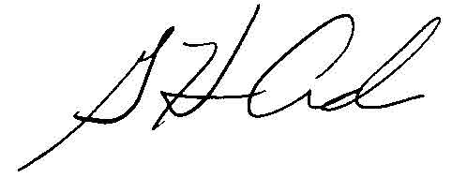  G. Harris Adams,  Interim Director | THE PUBLIC UTILITIES COMMISSION  OF THE STATE OF COLORADO  ERIC BLANK  ________________________________  Hearing Commissioner

