Decision No. R23-0089-E
BEFORE THE PUBLIC UTILITIES COMMISSION OF THE STATE OF COLORADO
PROCEEDING NO. 21N-0628GPS
IN THE MATTER OF THE NOTICE OF PROBABLE VIOLATION ISSUED TO YMCA OF THE ROCKIES ON DECEMBER 30, 2021.
ERRATA NOTICE FOR
recommended decision OF
ADMINISTRATIVE LAW JUDGE
ALENKA HAN
finding YMCA has completed the alternative enforcement requirements
and closing proceeding
Errata mailed February 21, 2023
Original Decision No. R23-0089 mailed February 9, 2023

Paragraph 14 has the following errors:
- In hisher Affidavit, PSP Chief Hensley represents that YMCA received either “satisfactory” or “not applicable” remarks for every line item on the PUC’s inspection report. YMCA received no “unsatisfactory” marks. Id. A copy of the Report is attached to Mr.Ms. Hensley’s Affidavit. PSP Chief Hensley concludes that in hisher “professional opinion . . . YMCA has remedied the violations contained in the December 30, 2021, NPV.” Id.

Paragraph 14 shall be amended to read as follows:
- In her Affidavit, PSP Chief Hensley represents that YMCA received either “satisfactory” or “not applicable” remarks for every line item on the PUC’s inspection report. YMCA received no “unsatisfactory” marks. Id. A copy of the Report is attached to Ms. Hensley’s Affidavit. PSP Chief Hensley concludes that in her “professional opinion . . . YMCA has remedied the violations contained in the December 30, 2021, NPV.” Id.

(S E A L)    ATTEST: A TRUE COPY  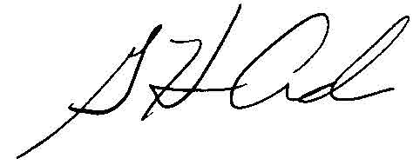  G. Harris Adams,  Interim Director | THE PUBLIC UTILITIES COMMISSION  OF THE STATE OF COLORADO  G. HARRIS ADAMS  ________________________________  Interim Director

