Decision No. C23-0768
BEFORE THE PUBLIC UTILITIES COMMISSION OF THE STATE OF COLORADO
PROCEEDING NO. 22AL-0348G
IN THE MATTER OF ADVICE LETTER NO. 584 filed by atmos energy corporation to revise its colorado p.u.c. no. 7 tariff to place into effect changes to the company’s annual revenues and recovery of rate case expenses, to become effective september 5, 2022.

PROCEEDING NO. 23AL-0235G

IN THE MATTER OF COMPLIANCE ADVICE LETTER NO. 595 FILED BY ATMOS ENERGY CORPORATION IN COMPLIANCE WITH DECISION NO. C23-0293 IN PROCEEDING NO. 22AL-0348G TO IMPLEMENT A BASE RATE REVENUE REQUIREMENT TO DECREASE EXPENSES, TO BECOME EFFECTIVE MAY 13, 2023.
COMMISSION DECISION STAYING
RECOMMENDED DECISION No. R23-0755
Mailed Date: November 17, 2023
Adopted Date: November 15, 2023

BY THE COMMISSION

Statement, Findings, and Conclusions
- On November 9, 2023, Administrative Law Judge (ALJ) Conor F. Farley issued Decision No. R23-0755 which resolves certain issues remanded to the ALJ for disposition.
- Pursuant to § 40-6-109(2), C.R.S., the Commission stays Recommended Decision No. R23-0755. This Decision does not affect the timeline for exceptions.

ORDER

The Commission Orders That:
- In accordance with the provisions of § 40-6-109(2), C.R.S., Decision No.
R23-0755, mailed November 9, 2023, is stayed.
- This Order is effective upon its Mailed Date.

ADOPTED IN COMMISSIONERS’ WEEKLY MEETING
November 15, 2023.
(S E A L)    ATTEST: A TRUE COPY  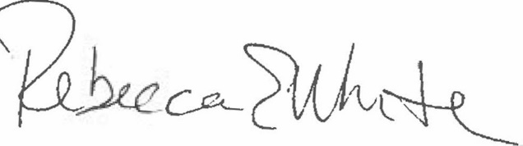  Rebecca E. White,  Director | THE PUBLIC UTILITIES COMMISSION  OF THE STATE OF COLORADO  ERIC BLANK  ________________________________  MEGAN M. GILMAN  ________________________________  TOM PLANT  ________________________________  Commissioners

