Decision No. C23-0689
BEFORE THE PUBLIC UTILITIES COMMISSION OF THE STATE OF COLORADO
PROCEEDING NO. 23M-0005E
IN THE MATTER OF THE YEAR 2023 FILINGS BY COLORADO ELECTRIC UTILITIES IN ACCORDANCE WITH 4 CCR 723-3-3206 FOR THE DESIGNATION OF ELECTRIC UTILITY TRANSMISSION FACILITIES WHETHER THE FACILITIES ARE IN THE NORMAL COURSE OF BUSINESS OR AN APPLICATION TO OBTAIN A CERTIFICATE OF PUBLIC CONVENIENCE AND NECESSITY IS REQUIRED.
commission decision setting response deadline to STAFF RECOMMENDATIONS
Mailed Date: October 12, 2023
Adopted Date: October 11, 2023

BY THE COMMISSION

Statement, Discussion, and Findings
- Rule 3206(d) of the Commission’s Rules Regulating Electric Utilities,
4 Code of Colorado Regulations (CCR) 723-3, requires each Colorado electric utility to file with the Commission, no later than April 30 of each year, information on its proposed new construction or extensions of transmission facilities for the next three calendar years. Rule 3206(d)(II)(B) directs Commission staff to review the filings and comments, and to make recommendations to the Commission by July 1.
- Through Decision No. C23-0434, issued July 6, 2023, the Commission extended the deadline for staff to make recommendations to the Commission to August 3, 2023. Through Decision No. C23-0525, the deadline for recommendations was further extended to
September 27, 2023.
- Commission Staff (Staff) filed Recommendations in this proceeding on September 27, 2023, in accordance with Decision No. C23-0525. The filing was deleted from E-Filings due to administrative difficulties, and Staff re-filed its Recommendations on
September 29, 2023.
- The Commission recognizes that in past annual Rule 3206(d) proceedings, written staff recommendations were not filed. However, in this year’s proceeding, we appreciate the additional transparency that written staff recommendations provide. The Commission will take up Staff’s Recommendations at a future Commissioners’ Weekly Meeting, with the assistance of advisory staff as necessary. We do not anticipate that future annual Rule 3206(d) proceedings will necessarily follow this process.
- The Commission directs that any responses to Staff’s Recommendations be filed by October 19, 2023.

ORDER

It Is Ordered That:
- Responses to the Recommendations of Commission Staff, filed on
September 27, 2023, and re-filed on September 29, 2023, are due by October 20, 2023.
- This Decision is effective upon its Mailed Date.

ADOPTED IN COMMISSIONERS’ WEEKLY MEETING
October 11, 2023.
(S E A L)    ATTEST: A TRUE COPY  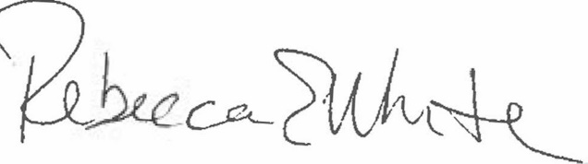  Rebecca E. White,  Director | THE PUBLIC UTILITIES COMMISSION  OF THE STATE OF COLORADO  ERIC BLANK  ________________________________  MEGAN M. GILMAN  ________________________________  TOM PLANT  ________________________________  Commissioners

