Decision No. C23-0680
BEFORE THE PUBLIC UTILITIES COMMISSION OF THE STATE OF COLORADO
PROCEEDING NO. 23M-0501T
in the matter of setting the annual telemarketer fees for administration of the colorado no-call list
COMMISSION DECISION setting
fees for calendar year 2024
Mailed Date: October 11, 2023
Adopted Date: October 4, 2023

BY THE COMMISSION

Statement
- Section 6-1-901, C.R.S., et seq., and Rules 2890 through 2899 of the Rules Regulating Telecommunications Services and Providers of Telecommunications Services,
4 Code of Colorado Regulations 723-2 (Rules), govern the Colorado No-Call List program. The Rules require telephone solicitors to register and submit an annual registration fee to the Designated Agent for the Colorado No-Call List program. Moneys from the fees collected by the Designated Agent are intended to cover the direct and indirect costs of the Colorado No-Call List program. These costs include the contractual expenses to pay the Designated Agent to administer the program and the legislative appropriation to the Department of Law to enforce the program requirements.
- Rule 2892(b) requires that the Commission set the annual registration fees on a sliding scale between $0.00 and $500.00 to ensure that the required revenues are raised annually. The maximum fee is applicable to those companies, persons, or entities with more than 1,000 employees. Companies, persons, or entities with fewer than five employees are not required to pay a registration fee.
- Maximum fees are statutorily capped, and the Commission is mandated to set the registration fees on a sliding scale. To best meet the needs of the program, we establish the following telemarketer registration fees for the Colorado No-Call List for calendar year 2024:
2024 Telemarketer Registration Fees
No. of Employees | Fee Amount
1-4 Employees | No Fee
5-10 Employees | $350
11-50 Employees | $450
51-100 Employees | $480
101-250 Employees | $485
251-400 Employees | $490
401-1000 Employees | $495
1001 or Greater Employees | $500

ORDER

The Commission Orders That:
- The Colorado No-Call List Annual Registration Fees are hereby set as specified above, effective January 1, 2024, through December 31, 2024.
- The 20-day period provided for in § 40-6-114, C.R.S., within which to file applications for rehearing, reargument, or reconsideration begins on the first day following the effective date of this Decision.
- This Order is effective on its Mailed Date.

ADOPTED IN COMMISSIONERS’ WEEKLY MEETING
October 4, 2023.
(S E A L)    ATTEST: A TRUE COPY  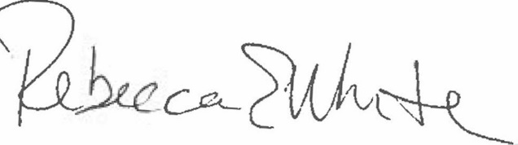  Rebecca E. White,  Interim Director | THE PUBLIC UTILITIES COMMISSION  OF THE STATE OF COLORADO  ERIC BLANK  ________________________________  MEGAN M. GILMAN  ________________________________  TOM PLANT  ________________________________  Commissioners

