Decision No. C23-0645
BEFORE THE PUBLIC UTILITIES COMMISSION OF THE STATE OF COLORADO
PROCEEDING NO. 23L-0463ST
IN THE MATTER OF THE APPLICATION OF PUBLIC SERVICE COMPANY OF COLORADO FOR AN ORDER AUTHORIZING IT TO REVISE ITS STEAM COST ADJUSTMENT TO BECOME EFFECTIVE OCTOBER 1, 2023, ON LESS THAN STATUTORY NOTICE.
commission decision authorizing
revisions of gas rates
Mailed Date: September 28, 2023
Adopted Date: September 27, 2023

BY THE COMMISSION

Statements
- Public Service Company of Colorado d/b/a Xcel Energy (PSCo or Applicant) filed a verified application to update its Steam Cost Adjustment (SCA) rates. PSCo seeks a Commission order authorizing it, without a formal hearing and on less-than-statutory notice, to place into effect on October 1, 2023, a tariff resulting in an overall increase to its existing Steam rates on file with the Commission.
- The proposed tariff is attached to the application and affects the Applicant's customers.
- PSCo acknowledges that it has read and agrees to abide by the provisions of Rules 4002(b)(IV) through (VI) and Rules 4002(b)(XI)(A) through (C) of the Rules Regulating Steam Utility Operators, 4 Code of Colorado Regulations (CCR) 723-8.

Findings of Fact
- The Applicant is an operating public utility subject to the jurisdiction of this Commission and is engaged in, inter alia, the purchase, distribution, transportation, and sale of Steam for public use in the Denver metro area.
- The purpose of the revisions of the Applicant's gas rates is to effectuate increases for PSCo’s Steam Customers, in the level of natural gas costs charged to the Applicant based on prices to be in effect as of October 1, 2023. The referenced prices are illustrated in Appendix A, attached to the Decision.
- The effect of the above revisions is an overall increase of $482,693 to the Applicant's customers and reflected in Appendix A. This increase represented a steam cost adjustment from $3.80 per Mlb to $4.817 per Mlb.
- Pursuant to Rule 1206(f)(I), Rules of Practice and Procedure 4 CCR 723-1, PSCo acknowledges its obligation to publish notice of the subject filing within three days after the filing of this application.
- The Commission finds good cause to allow the proposed overall decrease on
less-than-statutory notice.

ORDER

The Commission Orders That:
- The verified application filed by PSCo is deemed complete.
- Atmos is authorized to file, on not less than two days’ notice; the tariff attached as Appendix A and made a part of this Decision. The tariff shall be effective for Steam gas sales on or after their effective date of October 1, 2023.
- The 20-day time period provided by § 40-6-114, C.R.S., to file an application for rehearing, reargument, or reconsideration shall begin on the first day after the effective date of this Decision.
- This Decision is effective on its Mailed Date.

ADOPTED IN COMMISSIONERS’ WEEKLY MEETING
September 27, 2023.
(S E A L)    ATTEST: A TRUE COPY  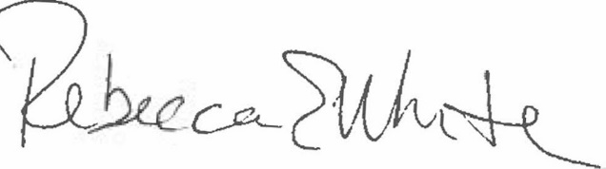  Rebecca E. White,  Director | THE PUBLIC UTILITIES COMMISSION  OF THE STATE OF COLORADO  ERIC BLANK  ________________________________  MEGAN M. GILMAN  ________________________________  TOM PLANT  ________________________________  Commissioners

