Decision No. C23-0619
BEFORE THE PUBLIC UTILITIES COMMISSION OF THE STATE OF COLORADO
PROCEEDING NO. 23M-0459EG
In the matter of energy assistance system benefit charge for 2023-2024 pursuant to 4 ccr 723-3-3412 and 4 ccr 723-4-4412 to be effective October 1, 2023
COMMISSION DECISION AUTHORIZING
REVISIONS OF ENERGY ASSISTANCE SYSTEM BENEFIT CHARGE RATES
Mailed Date: September 15, 2023
Adopted Date: September 6, 2023

BY THE COMMISSION

Statement
- The Energy Assistance System Benefit Charge (EASBC) is a fixed monthly charge collected by the regulated electric and gas utilities from all ratepayers unless they opt-out or are otherwise exempted. The EASBC was enacted as a result of Colorado House Bill 21-1105 and is codified in statute at §40-8.7- 104(2.5), C.R.S. EASBC provides financial funding for income-qualified energy assistance programs.
- The Rule 4412 (m) of the Rules Regulating Gas Utilities 4 CCR 723-4 and
Rule 3412 (m) of the Rules Regulating Electric Utilities 4 CCR 723-3, provide for the Energy Assistance System Benefit Charge to be adjusted for inflation annually in accordance with changes in the United States Department of Labor’s Bureau of Labor Statistics Consumer Price Index for Denver-Aurora-Lakewood beginning on October 1, 2023.
- The Rule 4412 (m) (I) of the Rules Regulating Gas Utilities 4 CCR 723-4 and Rule 3412 (m) (I) of the Rules Regulating Electric Utilities 4 CCR 723-3 directs Commission staff to compute the charge adjusted by the index and to send a letter to each utility stating the EASBC charge to be paid by customers during the next calendar year.

Findings of Facts
- Staff has considered inflation in accordance with changes in the
United States Department of Labor’s Bureau of Labor Statistics Consumer Price Index for Denver-Aurora-Lakewood for All Items, for the latest available period of July 2022 to
July 2023, at 4.7percent(Reference https://www.bls.gov/regions/mountain-plains/news-release/consumerpriceindex_denver.htm).
- The EASBC, therefore, is computed as USD 0.79 (US Cents Seventy-Nine) for period starting October 1, 2023.
- The following table summarizes the applicable EASBC charge:
Effective On and After | Rate Schedules | EASBC - Monthly Charge
October 1, 2021 | All | $0.50
October 1, 2022 | All | $0.75
October 1, 2023 | All | $0.79
- The increase in monthly EASBC is, thus, $0.04.

ORDER

The Commission Orders That
- A new miscellaneous proceedings document (M-docket) be opened.
- New monthly EASBC of $0.79 be approved. This shall be effective from
October 1, 2023.
- PUC Director be directed to issue a letter notifying the EASBC for 2023-24 and that be filed in the new M-docket opened.

ADOPTED IN COMMISSIONERS’ WEEKLY MEETING
September 6, 2023.
(S E A L)    ATTEST: A TRUE COPY  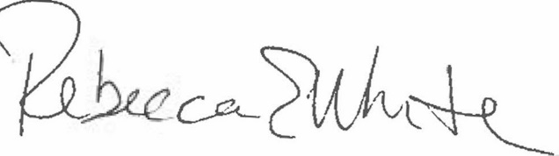  Rebecca E. White,  Director | THE PUBLIC UTILITIES COMMISSION  OF THE STATE OF COLORADO  ERIC BLANK  ________________________________  MEGAN M. GILMAN  ________________________________  TOM PLANT  ________________________________  Commissioners

