Decision No. C23-0525
BEFORE THE PUBLIC UTILITIES COMMISSION OF THE STATE OF COLORADO
PROCEEDING NO. 23M-0005E
IN THE MATTER OF THE YEAR 2023 AMMENDED FILING BY PUBLIC SERVICE COMPANY OF COLORADO IN ACCORDANCE WITH RULE 4 CCR 723-3-3206 FOR THE DESIGNATION OF ELECTRIC UTILITY TRANSMISSION FACILITIES WHETHER THE FACILITIES ARE IN THE NORMAL COURSE OF BUSINESS OR AN APPLICATION TO OBTAIN A CERTIFICATE OF PUBLIC CONVENIENCE AND NECESSITY IS REQUIRED
commission decision EXtending deadline
for STAFF RECOMMENDATIONS
Mailed Date: August 8, 2023
Adopted Date: August 2, 2023

BY THE COMMISSION

Statement, Discussion, and Findings
- Rule 3206(c) of the Commission’s Rules Regulating Electric Utilities, 4 Code of Colorado Regulations (CCR) 723-3, requires each Colorado electric utility to file with the Commission, no later than April 30 of each year, information on its proposed new construction or extensions of transmission facilities for the next three calendar years. Rule 3206(d)(II)(B) directs Commission Staff (Staff) to review the filings and comments, and to make recommendations to the Commission by July 1.
- Through Decision No. C23-0434, issued July 6, 2023, the Commission extended the deadline for Staff to make recommendations to the Commission to August 3, 2023.
- We provide for a further variance from Rule 3206(d)(II)(B) and Decision No. C23-0434, on our own motion, and extend the deadline for Staff to make recommendations in this proceeding to September 27, 2023.

ORDER

It Is Ordered That:
- On the Commission’s own motion, a variance is provided from the
August 9, 2023 deadline for Staff to provide recommendations in this Proceeding.
- Staff shall make recommendations to the Commission by September 27, 2023, unless modified by future order.
- This Decision is effective upon its Mailed Date.

ADOPTED IN COMMISSIONERS’ WEEKLY MEETING
August 2, 2023.
(S E A L)    ATTEST: A TRUE COPY  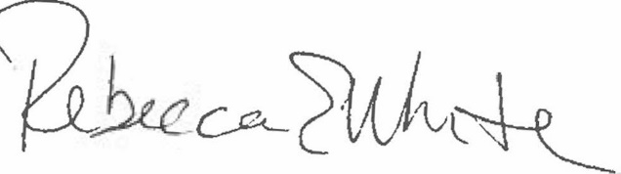  Rebecca E. White,  Director | THE PUBLIC UTILITIES COMMISSION  OF THE STATE OF COLORADO  ERIC BLANK  ________________________________  MEGAN M. GILMAN  ________________________________  TOM PLANT  ________________________________  Commissioners

